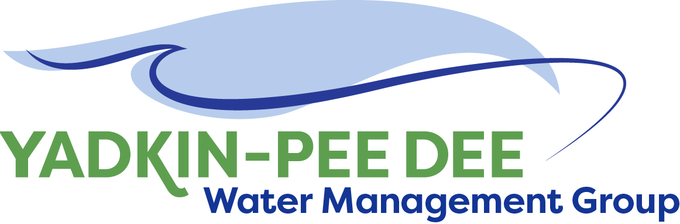
Yadkin-Pee Dee Water Management Group

AGENDA
Yadkin-Pee Dee Water Management Group Meeting
12PM to 2:30PM, April 30, 2020
Virtual Meeting (Zoom)
City of Albemarle
Water & Sewer Authority of Cabarrus County
City of Charlotte
City of Concord
Cube Yadkin Generation
Davidson County
Davidson Water, Inc.
Davie County
Duke Energy
City of Kannapolis
City of Monroe
Montgomery County
Town of Norwood
Rowan County
Salisbury-Rowan Utilities
City of Statesville
Union County
Town of Wilkesboro
City of Winston-Salem/
Forsyth County

Welcome and Review of Agenda Jim Behmer, Chair
- Lunch will be provided
- Approve minutes from December 2019 meeting

Approval and Review of Meeting Report All

Round Table Discussion All

HDR Updates – Stakeholder Advisory Group J. Williams
& Scenarios

Discuss OASIS Presentation & DEQ Progress on Modeling Warren Miller/All

Administrative Items Jim Behmer/All

Group Member and Other Updates Jim Behmer/All

Discussion of Next Meeting Agenda All

