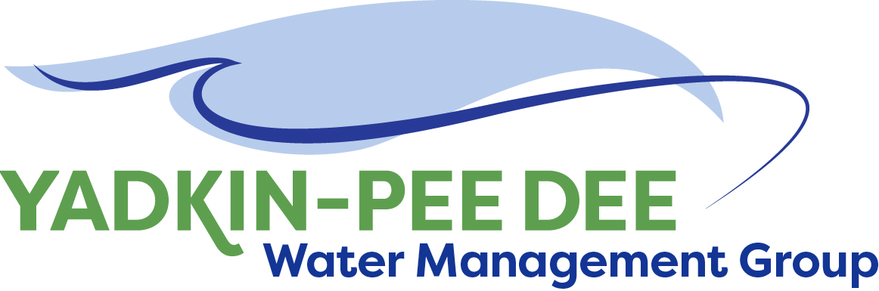
Yadkin-Pee Dee Water Management Group

AGENDA
Yadkin-Pee Dee Water Management Group Meeting
12PM to 2:30PM, January 4, 2018
Salisbury – Rowan Utilities
1 Water Street, Salisbury, NC
City of Albemarle
Water & Sewer Authority of Cabarrus County
City of Charlotte
City of Concord
Cube Yadkin Generation
Davidson County
Davidson Water, Inc.
Davie County
Duke Energy
City of Kannapolis
City of Monroe
Town of Norwood
Rowan County
Salisbury-Rowan Utilities
City of Statesville
Union County
Town of Wilkesboro
City of Winston-Salem/
Forsyth County

Welcome and Review of Agenda Christie Putnam, Chair
- Lunch will be provided
- Approve minutes from October 26, 2017 meeting

YPDWMG Member Interviews Warren Miller
- Brief review member interviews and surveys

Presentation of Local Water Supply Plan Summary Leila Goodwin
- Brief presentation and Q&A

2018 Game Plan for YPDWMG Warren Miller/ All
- Facilitated discussion to develop 2018 work plan

Administrative Items Courtney Driver
- YPDWMG financial update

Group Member and Other Updates All
- Roundtable updates from individual members

Discussion of Next Meeting Agenda All

