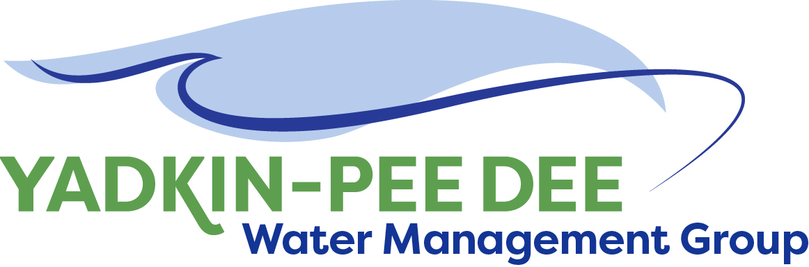
Yadkin-Pee Dee Water Management Group

AGENDA
Yadkin-Pee Dee Water Management Group Meeting
12PM to 2:30PM, January 10th, 2019
Salisbury – Rowan Utilities
1 Water Street, Salisbury, NC
City of Albemarle
Water & Sewer Authority of Cabarrus County
City of Charlotte
City of Concord
Cube Yadkin Generation
Davidson County
Davidson Water, Inc.
Davie County
Duke Energy
City of Kannapolis
City of Monroe
Town of Norwood
Rowan County
Salisbury-Rowan Utilities
City of Statesville
Union County
Town of Wilkesboro
City of Winston-Salem/
Forsyth County

Welcome and Review of Agenda Bill Brewer, Chair
- Lunch will be provided
- Approve minutes from August 2018 meeting

Yadkin-Pee Dee Water Supply Master Plan Jonathan Williams/All
- Water Supply Master Plan Visioning and Framework
  - Review of logistics for upcoming regional stakeholder meetings
  - Update on project schedule and next steps following stakeholder meetings
  - Identify timeframe for full basin-wide follow-up meeting
  - Follow-up on “homework” assignment to the YPDWMG

- Water Demand Projection Update
  - Update on project status (work completed and work upcoming)
  - Discussion of methods for vetting and reviewing projections with YPDWMG members and stakeholders

- Continued Coordination and Discussion with NCDWR on Modeling

New Member outreach Warren Miller/All

Administrative Items Warren Miller
- YPDWMG financial update

Group Member and Other Updates Bill Brewer/ All
- October 10th presentation to Centralina COG
- Roundtable updates from individual members

Discussion of Next Meeting Agenda All

