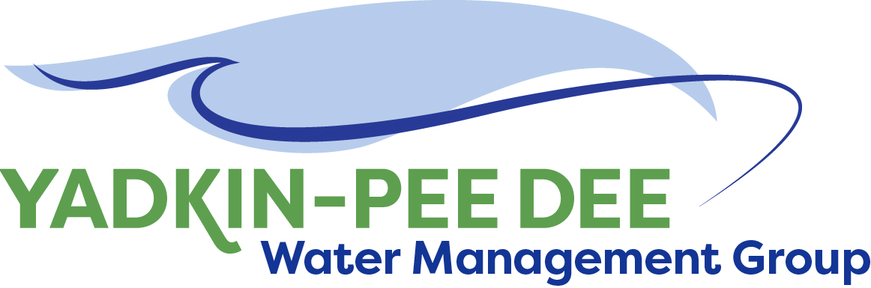
Yadkin-Pee Dee Water Management Group

AGENDA
Yadkin-Pee Dee Water Management Group Kickoff Meeting
12PM to 2:30PM, January 19, 2017
Salisbury-Rowan Utilities Office
1 Water Street, Salisbury, NC
City of Albemarle
Alcoa Power Generating
City of Charlotte
City of Concord
Davidson County
Davidson Water, Inc.
Duke Energy
City of Kannapolis
City of Monroe
City of Salisbury
City of Statesville
Union County
Town of Wilkesboro
City of Winston-Salem/
Forsyth County

Welcome and Review of Agenda Christie Putnam, Chair
- Lunch will be provided
- Approve minutes from November 30, 2016 meeting

State Perspective on Local Water Supply Plans Linwood Peele, DEQ
- Common shortcomings with local water supply plans
- Group Questions
- Discussion: Creating a regional water supply plan built from local water supply plans

Administrative Items All
- financial update (City of Winston-Salem)
- Voting on New Members
-- (Rowan County, Davie County, Water and Sewer Authority of Cabarrus County)

Group Member Updates All
- Roundtable updates from individual members

Discussion of March Meeting Agenda All

