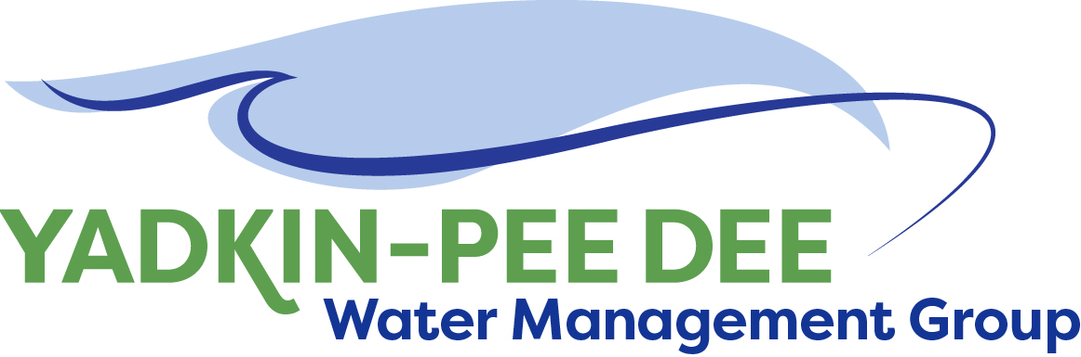
Yadkin-Pee Dee Water Management Group

AGENDA
Yadkin-Pee Dee Water Management Group Meeting
12PM to 2:30PM, Feb 14th, 2019
Salisbury – Rowan Utilities
1 Water Street, Salisbury, NC
City of Albemarle
Water & Sewer Authority of Cabarrus County
City of Charlotte
City of Concord
Cube Yadkin Generation
Davidson County
Davidson Water, Inc.
Davie County
Duke Energy
City of Kannapolis
City of Monroe
Montgomery County
Town of Norwood
Rowan County
Salisbury-Rowan Utilities
City of Statesville
Union County
Town of Wilkesboro
City of Winston-Salem/
Forsyth County

Welcome and Review of Agenda Bill Brewer, Chair
- Lunch will be provided
- Approve minutes from January 2019 meeting

Yadkin-Pee Dee Water Supply Master Plan Jonathan Williams/All
- Water Supply Master Plan Visioning and Framework
  - Review of regional stakeholder meetings
    - Key themes from stakeholder input
    - Feedback from YPDWMG attendees
  - Planning for basin-wide stakeholder meeting
    - YPDWMG input on potential dates (late March)
    - YPDWMG on potential venues
    - Notification process
    - HDR’s proposed facilitation plan
  - Framework Document
    - YPDWMG feedback from draft document of key points from last meeting
- Water Demand Forecast Update
  - Review of current HDR progress and existing water use summary
  - Proposed YPDWMG vetting process for data and projections
- YPD Modeling
  - Define next steps and develop action plan

New Member Outreach Warren Miller/All

Administrative Items Bill Brewer
- YPDWMG financial update
  - Supplemental billings for project work

Group Member and Other Updates Bill Brewer/ All
- Roundtable updates from individual members

Discussion of Next Meeting Agenda All

