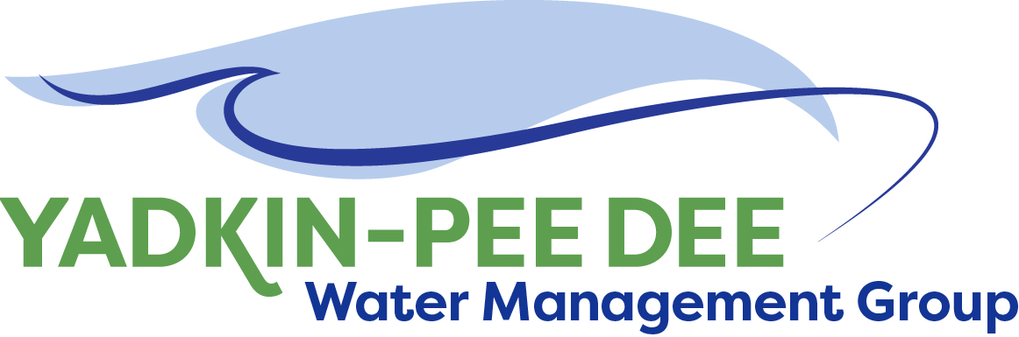
Yadkin-Pee Dee Water Management Group

AGENDA
Yadkin-Pee Dee Water Management Group Meeting
12PM to 2:30PM, February 15, 2018
Salisbury – Rowan Utilities
1 Water Street, Salisbury, NC
City of Albemarle
Water & Sewer Authority of Cabarrus County
City of Charlotte
City of Concord
Cube Yadkin Generation
Davidson County
Davidson Water, Inc.
Davie County
Duke Energy
City of Kannapolis
City of Monroe
Town of Norwood
Rowan County
Salisbury-Rowan Utilities
City of Statesville
Union County
Town of Wilkesboro
City of Winston-Salem/
Forsyth County

Welcome and Review of Agenda Christie Putnam, Chair
- Lunch will be provided
- Approve minutes from January 4, 2018 meeting

YPDWMG Strategic Activities Work Plan Warren Miller/
- Review and discuss draft work plan for the Group Adam Sharpe, HDR

Basin Hydrologic Model Update Jonathan Williams, HDR
- Presentation and Discussion

Administrative Items Warren Miller/ Bill Brewer
- Local Water Supply Plan final report
- YPDWMG financial update

Group Member and Other Updates All
- Roundtable updates from individual members

Discussion of Next Meeting Agenda All

