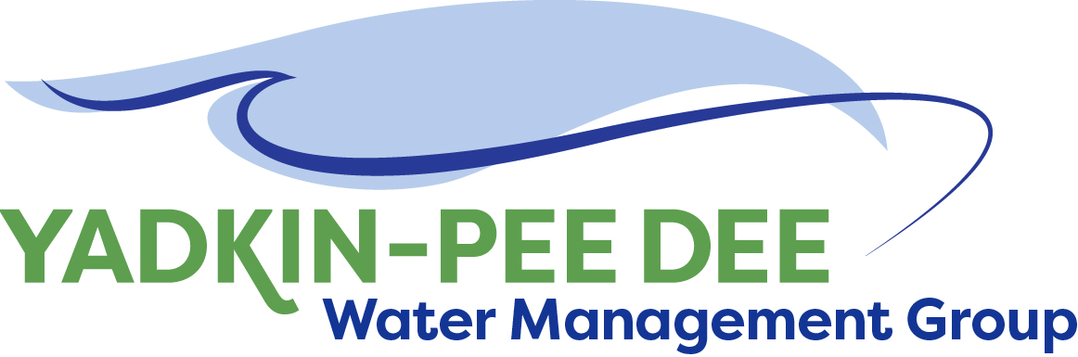
Yadkin-Pee Dee Water Management Group

Meeting Summary
Yadkin-Pee Dee Water Management Group Meeting
12PM to 2:30PM, February 14, 2019
Salisbury-Rowan Utilities
1 Water Street, Salisbury, NC

Action Items
The following action items were identified by the Group at the meeting:
- B. Brewer & W. Miller to send out email to partners regarding fees for special projects.
- HDR to set up meeting with DEQ in February to discuss plan for hydrologic modeling.
- HDR to develop and send out doodle poll for the final stakeholder workshop meeting times/days
- HDR will send out the master plan key objectives and goals document for the YPDWMG to review again
- Per request from Jeff Lineberger, HDR to provide recommendation to the YPDWMG on what future master plan tasks HDR can advance in 2019-2020 before CHEOPS model enhancements. HDR will develop a scope document for work that may be advanced prior to model updates.
- The next YPDWMG Meeting will be held on Thursday April 11th, 2019.
- Members who have agreed to reach out to potential new members should do so by end of March.
- W. Miller will explore potential grant opportunities for the YPDWMG continue its water supply master planning work.

Welcome and Approval of Minutes
Chair Bill Brewer called the meeting to order at 12:10 pm. The Group approved the meeting minutes from the January 10th, 2019 meeting.

Administrative Items
- Scott Harder of South Carolina Department of Natural Resources introduced himself to group. Mr. Harder shared the following on behalf of SCDNR:
- His agency has been tasked with leading state’s water planning efforts.
- Plan came out in 2004 and SCDNR has formed a State Advisory Committee.
- A framework for conducting regional planning in the state of South Carolina. They are drafting document for this process and will be forming Councils.
- Pee Dee will be doing planning in a couple of years. Will not be one of the first basins.
- Here to encourage cooperation and planning efforts between the two groups.
- It was noted that SC uses the SWAM model platform – some similarities and differences to CHIOPS and OASIS.

- YPDWMG financial update
  - Supplemental billings for project work was discussed. Bill Brewer will provide an updated finance spreadsheet.
    - Members will be asked to volunteer to set aside additional monies for the future project work that the group wants to work on in 2019-2020. W. Miller and B. Brewer will be sending out an email to members with the projected cost per member should they decide to participate in the project.
  - Do we want to pursue other additional funding?
    - Members want to pursue additional grant funding. W. Miller will explore potential grant options for YPDWMG.

Water Supply Master Plan
Jonathan Williams of HDR reviewed the following with the Yadkin-Pee Dee Group Members. (additional slides are included here and on the YPDWMG website.)
Water Supply Master Plan Visioning and Framework
  - Review of regional stakeholder meetings
    - Key themes from stakeholder input, please see slides in PPT mentioned above.
    - Feedback from YPDWMG attendees Group felt sessions were productive and there was good participation from stakeholders
  - Planning for basin-wide stakeholder meeting
    - YPDWMG gathered input on potential dates. It was decided to be held late March or early April.
    - YPDWMG on potential venues Salisbury. Suggestions included Civic Center, schools, churches.
    - Notification process similar to regional workshop notifications; HDR will need individual YPDWMG members to reach out to their local elected officials to try and get them to attend the session.
    - HDR’s proposed facilitation plan: brief introductory presentation(s), review of key themes from regional stakeholder meetings, naming activity for the master plan, break-out groups that will dive into the key themes and develop specific initiatives and action items for evaluation and analysis as part of the master plan.
  - Framework Document
    - YPDWMG reviewed feedback from draft water supply master plan document of key points from last meeting.
- Water Demand Forecast Update
  - Review of current HDR progress and existing water use summary. HDR is about 60% done with existing data incorporation into the database and initial projections for future water use. HDR will be finalizing this effort, QCing the database, and developing preliminary summary results to then have YPDWMG vet data (see next bullet below). HDR expects the initial database work to be completed by the end of February and moving forward with review and vetting in March.
  - Proposed YPDWMG vetting process for data and projections HDR plans to have individual YPDWMG member organizations first review their own data and projections, and then facilitate a peer review process where YPDWMG organizations review each other’s projections.
- YPD Modeling
  - Define next steps and develop action plan - HDR – sit down with DEQ – what they need to feel comfortable with in order to support funding a CHIOPS model- some YPD members. Next step: Set up the scenarios and other pieces we can get done before we start modeling.

Member Updates
Salisbury – Do not have our permit for the water plant yet. Hoping to get permits in next 2 weeks.
Norwood – 600 AMI meters are in. We will have engineering work on eliminating lift station. Work on waste treatment plant continues.
Duke Energy – We are seeing high bids on construction projects.
Montgomery – We are in process of bidding 2 pumps stations and a water line replacement project. Upgrades going on at water plant. Two merger regionalization studies are underway.
Davidson Water – $75M of projects over last 5 years. Currently doing an office rehab.
Winston-Salem - We see high bid prices for everything. Plugging along – getting AMI proposals out.
Wilkesboro – Currently working on clarifier project. Finishing a distribution project. Planning upgrades.
Rowan – We have a long record of working with city on extensions – recently we have partnered with Kannapolis.

Non-Member Updates
DEQ (non-member) – working on the Yadkin plan. They would like feedback on the plan once they have the draft ready.
King (non-member) – lagoons replaced at water plant. 4 or 5 water line replacement projects.

Adjournment
The meeting adjourned at 2:30 pm.

Meeting Attendees
Karen Baldwin, Cube Yadkin Generation
Ron Sink, Davidson Water
Jeff Lineberger, Duke Energy
Chris Hildreth, Montgomery County
John Mullis, Town of Norwood
Greg Greene, Rowan County
Jim Behmer, Salisbury-Rowan Utilities
Sam Call, Town of Wilkesboro
Courtney Driver, City of Winston-Salem
Bill Brewer, City of Winston-Salem

Non- Member Attendees:
Warren Miller, Fountainworks
Jonathan Williams, HDR, Inc.
Nicola Hill, HDR, Inc.
Virginia Baker, DEQ
Scott Harder, SC DNR
Andy Utt, City of Mt. Airy

