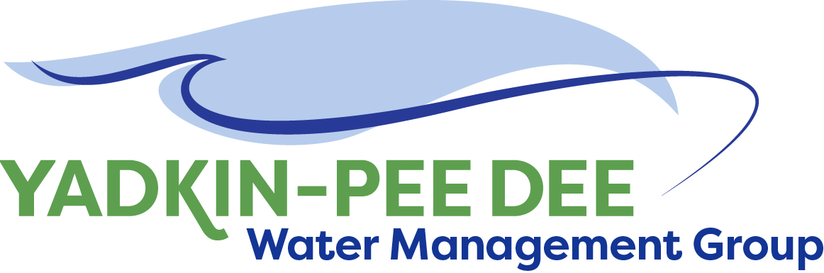
Yadkin-Pee Dee Water Management Group

AGENDA
Yadkin-Pee Dee Water Management Group Kickoff Meeting
12PM to 2:30PM, March 23, 2017
Salisbury-Rowan Utilities Office
1 Water Street, Salisbury, NC
City of Albemarle
Alcoa Power Generating
City of Charlotte
City of Concord
Davidson County
Davidson Water, Inc.
Duke Energy
City of Kannapolis
City of Monroe
City of Salisbury
City of Statesville
Union County
Town of Wilkesboro
City of Winston-Salem/
Forsyth County

Welcome and Review of Agenda Christie Putnam, Chair
- Lunch will be provided
- Approve minutes from January 19, 2017 meeting

Review of Technical Meeting Local Water Supply Plans Jeff Jones, Salisbury-Rowan
- Review of outputs from meeting
- Discussion of key takeaways from meeting

Discussion of Proposals from Fountainworks Christie Putnam/ All
- Local Water Supply Plan Proposal
- Water Shortage Response Plan Proposal

Administrative Items All
- Financial update (City of Winston-Salem)
- Other items

Group Member Updates All
- Roundtable updates from individual members

Discussion of March Meeting Agenda All

