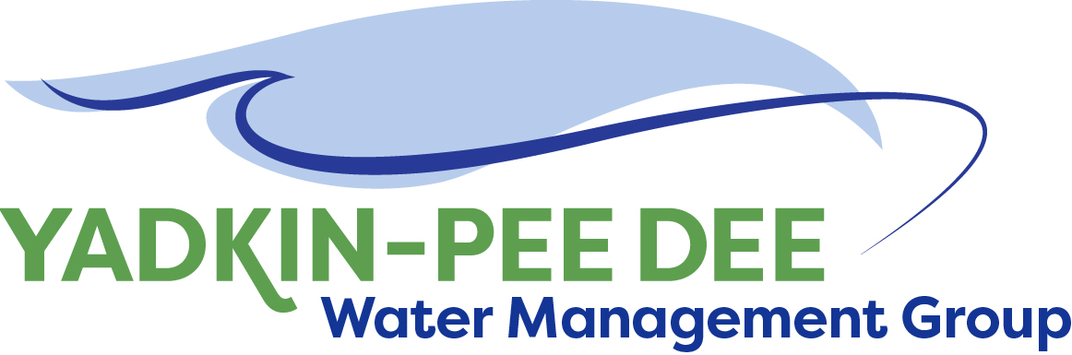
Yadkin-Pee Dee Water Management Group

AGENDA
Yadkin-Pee Dee Water Management Group Meeting
12PM to 2:30PM, April 11, 2019
Salisbury – Rowan Utilities
1 Water Street, Salisbury, NC
City of Albemarle
Water & Sewer Authority of Cabarrus County
City of Charlotte
City of Concord
Cube Yadkin Generation
Davidson County
Davidson Water, Inc.
Davie County
Duke Energy
City of Kannapolis
City of Monroe
Montgomery County
Town of Norwood
Rowan County
Salisbury-Rowan Utilities
City of Statesville
Union County
Town of Wilkesboro
City of Winston-Salem/
Forsyth County

Welcome and Review of Agenda Bill Brewer, Chair
- Lunch will be provided
- Approve minutes from February 2019 meeting

Yadkin-Pee Dee Water Supply Master Plan Jonathan Williams/All
- Review Results of Basin Wide Stakeholder Meeting
- Review Preliminary Water Demand Forecast Update
- Master Plan Communications Plan
- Master Plan Preliminary Scope Items

Hydrologic Model Funding
- Outreach Warren Miller

New Member Outreach Warren Miller/All

Administrative Items Bill Brewer
- YPDWMG financial update
- Approve payment to Mr. Hutchins for his sound operator
time at Stakeholder Meetings.

Group Member and Other Updates Bill Brewer/ All
- Training to learn more about the HDR model Aubrey Lofton
- Roundtable updates from individual members

Discussion of Next Meeting Agenda All

