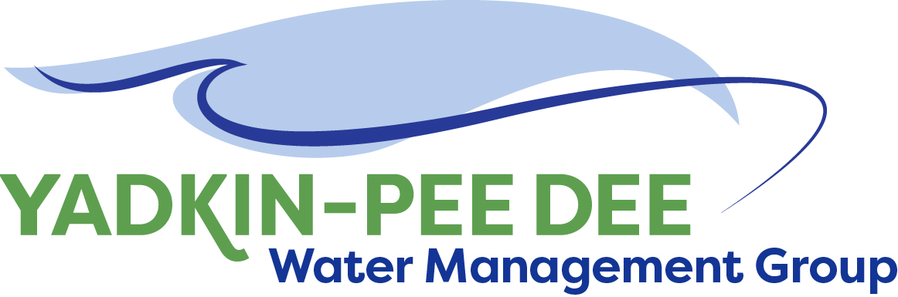
Yadkin-Pee Dee Water Management Group

AGENDA
Yadkin-Pee Dee Water Management Group Meeting
12PM to 2:30PM, April 12, 2018
Salisbury – Rowan Utilities
1 Water Street, Salisbury, NC
City of Albemarle
Water & Sewer Authority of Cabarrus County
City of Charlotte
City of Concord
Cube Yadkin Generation
Davidson County
Davidson Water, Inc.
Davie County
Duke Energy
City of Kannapolis
City of Monroe
Town of Norwood
Rowan County
Salisbury-Rowan Utilities
City of Statesville
Union County
Town of Wilkesboro
City of Winston-Salem/
Forsyth County

Welcome and Review of Agenda Christie Putnam, Chair
- Lunch will be provided
- Approve minutes from February 2018 meeting

Update and Discussion from DWR Meeting Christie Putnam
- Review outcomes from meeting
- Discuss next steps with Hydrologic model update and activities

YPDWMG Strategic Activities Work Plan Warren Miller/ All
- Formalize Strategic Plan
- Discuss and Confirm near term tasks

Administrative Items Bill Brewer/ All
- YPDWMG financial update
- Update on interested new members

Group Member and Other Updates All
- Roundtable updates from individual members

Discussion of Next Meeting Agenda All

