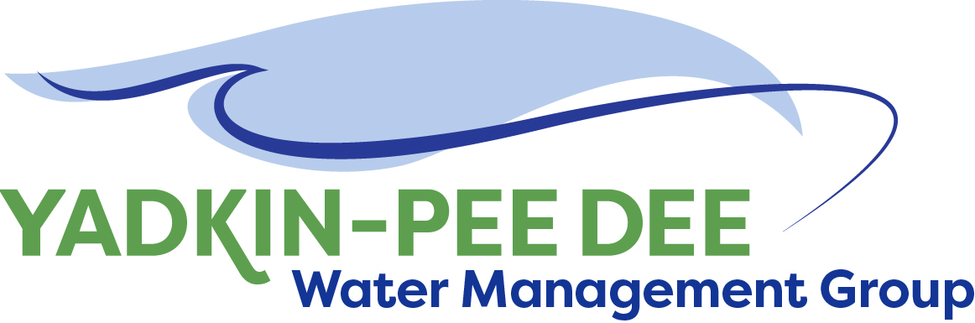
Yadkin-Pee Dee Water Management Group

AGENDA
Yadkin-Pee Dee Water Management Group Meeting
12PM to 2:30PM, June 20, 2018
Salisbury – Rowan Utilities
1 Water Street, Salisbury, NC
City of Albemarle
Water & Sewer Authority of Cabarrus County
City of Charlotte
City of Concord
Cube Yadkin Generation
Davidson County
Davidson Water, Inc.
Davie County
Duke Energy
City of Kannapolis
City of Monroe
Town of Norwood
Rowan County
Salisbury-Rowan Utilities
City of Statesville
Union County
Town of Wilkesboro
City of Winston-Salem/
Forsyth County

Welcome and Review of Agenda Christie Putnam, Chair
- Lunch will be provided
- Approve minutes from April 2018 meeting

YPDWMG Goals for Hydrologic Technical Group Christie Putnam
- Review outcomes from meeting (discuss questions re: meeting notes)
- Discuss YPDWMG goals and positions for hydrologic modeling
- Volunteer to serve as YPDWMG liaison to Technical Group
- Review timeline and next steps for Technical Group

YPDWMG Strategic Activities: HDR Proposal Warren Miller/ All
- YPDWMG financial update (Bill Brewer)
- Duke Energy Water Resource Fund Proposal update
- Review and discuss HDR proposal (3 tasks)

Administrative Items Christie Putnam/ All
- Nominees for 2018-19 YPDWMG Chair and Vice Chair
- Fountainworks proposal to provide management support to YPDWMG
- September 12 joint presentation with CWWMG at Centralina COG

Group Member and Other Updates All
- Roundtable updates from individual members

Discussion of Next Meeting Agenda All

