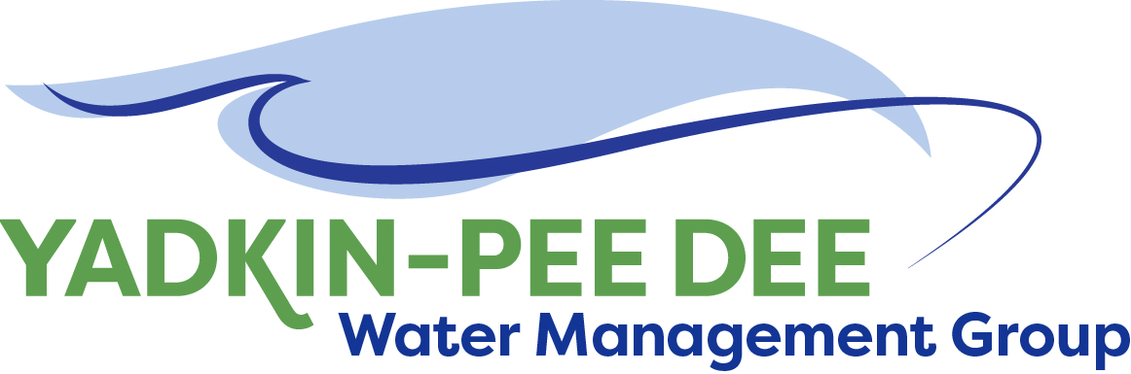
Yadkin-Pee Dee Water Management Group

AGENDA
Yadkin-Pee Dee Water Management Group Kickoff Meeting
12PM to 2:30PM, June 22, 2017
Salisbury-Rowan Utilities Office
1 Water Street, Salisbury, NC
City of Albemarle
Water & Sewer Authority of Cabarrus County
City of Charlotte
City of Concord
Cube Yadkin Generation
Davidson County
Davidson Water, Inc.
Davie County
Duke Energy
City of Kannapolis
City of Monroe
Rowan County
Salisbury-Rowan Utilities
City of Statesville
Union County
Town of Wilkesboro
City of Winston-Salem/
Forsyth County

Welcome and Review of Agenda Christie Putnam, Chair
- Lunch will be provided
- Approve minutes from March 23, 2017 meeting

Update on Water Shortage Response Plan Warren Miller
- Project status report

W. Kerr Scott Dam and Reservoir Discussion Kevin Heape, USACE
- Operations plan
- Process for raising the level of the reservoir
- Update on current of future studies

Administrative Items Warren Miller/ All
- Local Water Supply Plan revised scope of work
- YPDWMG members for small jurisdictions

Group Member Updates All
- Roundtable updates from individual members

Discussion of Next Meeting Agenda All

