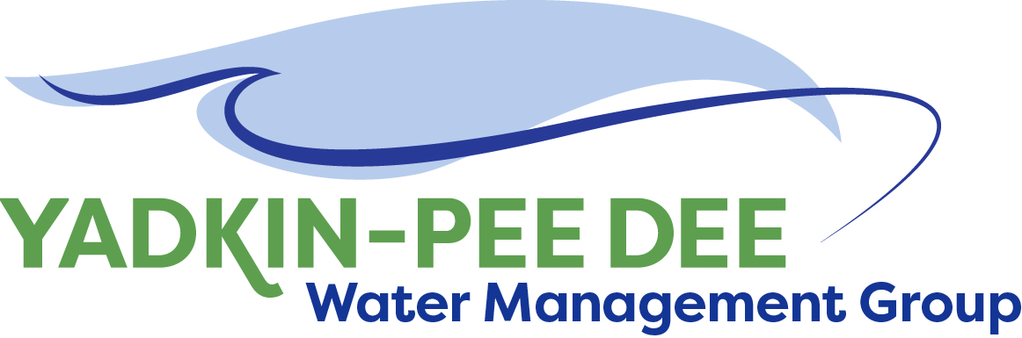
Yadkin-Pee Dee Water Management Group

AGENDA
Yadkin-Pee Dee Water Management Group Meeting
12PM to 2:30PM, August 8th, 2019
Salisbury – Rowan Utilities
1 Water Street, Salisbury, NC
City of Albemarle
Water & Sewer Authority of Cabarrus County
City of Charlotte
City of Concord
Cube Yadkin Generation
Davidson County
Davidson Water, Inc.
Davie County
Duke Energy
City of Kannapolis
City of Monroe
Montgomery County
Town of Norwood
Rowan County
Salisbury-Rowan Utilities
City of Statesville
Union County
Town of Wilkesboro
City of Winston-Salem/
Forsyth County

Welcome and Review of Agenda Bill Brewer, Chair
- Lunch will be provided
- Approve minutes from June 2019 meeting

Yadkin-Pee Dee Water Supply Master Plan Jonathan Williams/All
- Wrap-up of Water Resources Plan Phase 1
- Recap of meeting with NCDWR on modeling
- Presentation of scope and fee for Water Resources Plan Phase 2
- Americas Water Infrastructure Act of 2018 and North Carolina Surface Water Protection Plan requirements

New Member Outreach Warren Miller/All

Administrative Items Bill Brewer
- YPDWMG financial update
- Fountainworks’ services

Group Member and Other Updates Bill Brewer
- Roundtable updates from individual members

Discussion of Next Meeting Agenda All

