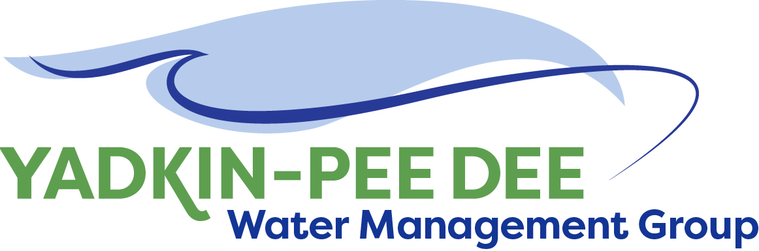
Yadkin-Pee Dee Water Management Group

AGENDA
Yadkin-Pee Dee Water Management Group Meeting
12PM to 2:30PM, August 9, 2018
Salisbury – Rowan Utilities
1 Water Street, Salisbury, NC
City of Albemarle
Water & Sewer Authority of Cabarrus County
City of Charlotte
City of Concord
Cube Yadkin Generation
Davidson County
Davidson Water, Inc.
Davie County
Duke Energy
City of Kannapolis
City of Monroe
Town of Norwood
Rowan County
Salisbury-Rowan Utilities
City of Statesville
Union County
Town of Wilkesboro
City of Winston-Salem/
Forsyth County

Welcome and Review of Agenda Christie Putnam, Chair
- Lunch will be provided
- Approve minutes from June 2018 meeting

YPDWMG Strategic Activities: HDR Proposal Jonathan Williams/All
- Review and discuss HDR proposal
- Follow up with DWR to discuss the Group’s preferred direction for hydrologic
modeling
- Discussion of next steps

Administrative Items All
- Nominees for 2018-19 YPDWMG Chair and Vice Chair
- Duke Energy Water Resource Fund Proposal update
- October 10th presentation to Centralina COG

Group Member and Other Updates All
- Roundtable updates from individual members

Discussion of Next Meeting Agenda All

