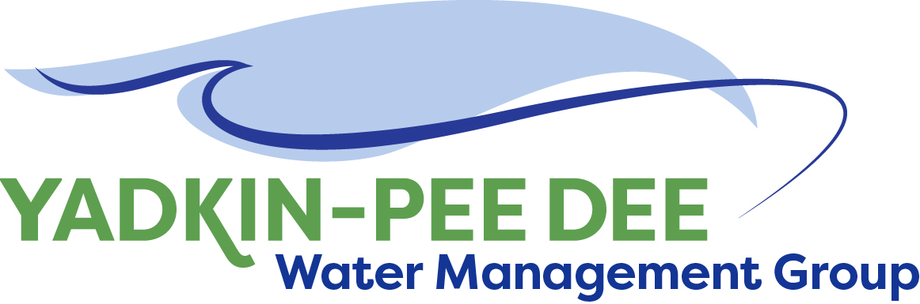
Yadkin-Pee Dee Water Management Group

Meeting Summary
Yadkin-Pee Dee Water Management Group Kickoff Meeting
12PM to 2:30PM, Wednesday, September 28, 2016
Salisbury-Rowan Utilities Office
1 Water Street, Salisbury, NC

Action Items
The following action items were identified by the Group at the meeting
- Winston-Salem will issue invoices to each Group member in October
- Each Group member will review the draft YPDWMG website and provide feedback and suggestions to Warren Miller by October 15th http://ypdwater1.weebly.com/
- W. Miller will draft a letter to inform Tom Fransen with NC Division of Water Resources, that the Group had officially launched. The letter will be signed by Christie Putnam.
- W. Miller will invite Tom Fransen to speak at the next Group meeting in November.
- W. Miller will draft a letter to potential YPDWMG members from Christie Putnam as Group chair inviting them to join and attend the next meeting
- Next YPDWMG meeting – November 30th 12pm – 2:30pm – Salisbury-Rowan Utilities offices

Update on status of MOU signings
After introductions to start the meeting, each Group member provided an update on the status of their MOU signings. As of September 30th all MOUs had been signed. This includes the following:
- City of Albemarle; Alcoa Power Generating; City of Charlotte; City of Concord; Davidson Water Inc.; Duke Energy; City of Kannapolis; City of Monroe; City of Salisbury; City of Statesville; Union County; Town of Wilkesboro; City of Winston-Salem

Review of Bylaws
- The group then reviewed member roles and responsibilities outlined in the MOU. This included the following key points:
- Chair and Vice-Chair must be elected (simple majority)
- One vote per member
- Chair convenes meetings but has no additional authority
- Quorum of 1/3 of members required for a ‘valid’ meeting
- Required to meet annually (must give 72 hours notice)
- Winston-Salem will serve as the administrative agency (invoices and contracts)
- Dues will be paid annually. Winston-Salem will issue invoices for current fiscal year in October.
- Each project shall have a specified lead agency
- Requires ¾ majority to approve new members

Election of Officers
Next the Group elected its Chair and Vice-Chair
- Christie Putnam, City of Concord, was elected Chair
- Ron Hargrove, City of Charlotte, was elected Vice-Chair

Review of Group website
Warren Miller shared the draft Group website - http://ypdwater1.weebly.com/ The website will provide information about the Group and its members; store meeting notes and contact information and serve as a space for group collaboration. The Group was asked to provide W. Miller with any feedback or suggestions on the website by mid-October.

Discussion of Potential Group Projects
The Group discussed the benefits of the projects outlined in the MOU. These projects include
  - Hydrologic and/or Hydraulic Modeling of the Yadkin-Pee Dee River Basin;
  - Regional Water Supply Master Plan;
  - Study of Additional Water Supply Resource Opportunities within the Yadkin-Pee Dee River Basin; and
  - Coordinated Drought Response Plan.

The Group decided to invite Tom Fransen, NC Division of Water Resources, to speak at their next meeting in November to share his perspective on when and how the State plans to move forward on Hydrologic Modeling. This discussion would help inform the Group’s next project work. W. Miller was also asked to draft a letter to Tom Fransen to notify the state that the Group had officially launched. The letter will be signed by Christie Putnam.

Discussion of Potential New Members
The Group was informed that Davidson County wished to join. (Davidson County signed its MOU on September 30th)
The Group decided that all entities that meet the requirements of the MOU would be invited join and asked W. Miller to prepare a letter from Christie Putnam as Group chair inviting them to join and attend the next meeting in November. These potential new members include:
- Anson County, Wilkes County, City of Asheboro, Richmond County, City of Lexington, Davie County, Rowan County, Montgomery County, City of Mt. Airy, Town of North Wilkesboro, City of Thomasville, City of Rockingham, City of King, Energy United Water, Town of Denton, City of Hamlet, Town of Mocksville, Town of Yadkinville, Town of Wadesboro, Town of Elkin, Town of Norwood, Town of Jonesville, Water and Sewer Authority of Cabarrus County, Town of Pilot Mountain.

Project Management and Administrative Items
The Group decided to utilize Warren Miller of Fountainworks, Inc. to provide facilitation, communications and project management support to the Group for the next year. W. Miller will provide a scope of work and costs for review.

The Group will initially plan to meet every other month. In the January 2017 meeting, the Group discussed having each member share a brief overview of their local water supply plan to provide a general understanding of the range of methodologies that are being used and whether there is a need to get outside consulting support to improve consistency across Group members.

Group Member Updates
Alcoa Power Generating: Alcoa will be changing its name to Cube Hydro Carolinas. Other than the name change, everything else will remain the same.

Duke Energy
- Jeff Lineberger advised the group of a stakeholder effort ongoing in the Pee Dee River Basin (from Blewett Falls Dam downstream) to investigate needs and options to conserve land and protect water quality.
- The effort is called the Pee Dee Clean Water Study Group. It is led by American Rivers and The Nature Conservancy and is patterned after a previous effort in the lower Savannah River Basin.
- Involved stakeholders represent state agencies, water utilities, industry and environmental organizations. Duke Energy is also participating.
- The group is still collecting information at the present time and the next meeting is expected later this year.

Union County:
- Ed Goscicki provided an overview of the Yadkin Regional Water Supply Project -- a collaborative effort between Union County and the Town of Norwood, in Stanly County, to provide a new water supply source to Union County’s Yadkin River Basin residents and new infrastructure to the Town of Norwood.
- This project will include a new water intake and pump station in Norwood to access Lake Tillery and a 21 mile pipeline to bring that water to Union County residents in the Yadkin River Basin.
- More information about the project can be found at yadkinwater.com

Meeting Attendees:
Michael Leonas, City of Albemarle
Karen Baldwin, Alcoa Power Generating
Ron Hargrove, City of Charlotte
Christie Putnam, City of Concord
Ron Sink, Davidson Water, Inc.
Jeff Lineberger, Duke Energy
Ed Bruce, Duke Energy
Russell Colbath, City of Monroe
Jim Behmer, City of Salisbury
Jeff Jones, City of Salisbury
Joe Hudson, City of Statesville
Ed Goscicki, Union County
Sam Call, Town of Wilkesboro
Courtney Driver, City of Winston-Salem
Bill Brewer, City of Winston-Salem
Warren Miller, Fountainworks

