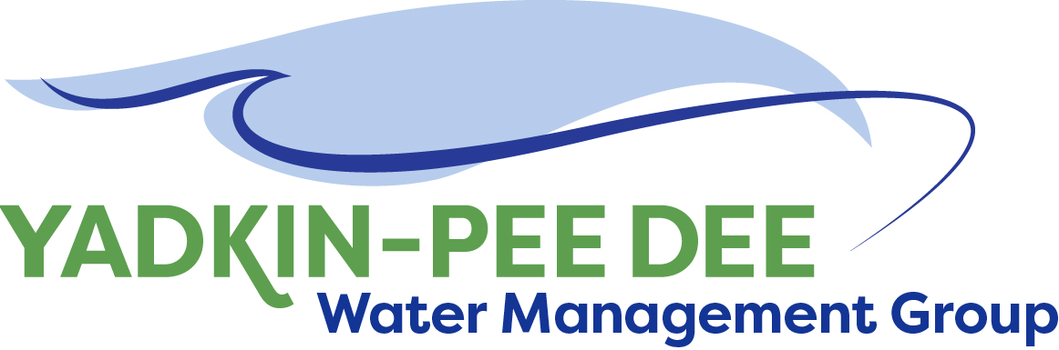
Yadkin-Pee Dee Water Management Group

AGENDA
Yadkin-Pee Dee Water Management Group Meeting
12PM to 2:30PM, October 25, 2018
Salisbury – Rowan Utilities
1 Water Street, Salisbury, NC
City of Albemarle
Water & Sewer Authority of Cabarrus County
City of Charlotte
City of Concord
Cube Yadkin Generation
Davidson County
Davidson Water, Inc.
Davie County
Duke Energy
City of Kannapolis
City of Monroe
Town of Norwood
Rowan County
Salisbury-Rowan Utilities
City of Statesville
Union County
Town of Wilkesboro
City of Winston-Salem/
Forsyth County

Welcome and Review of Agenda Bill Brewer, Chair
- Lunch will be provided
- Approve minutes from August 2018 meeting

Administrative Items Warren Miller
- New YPDWMG member
- Duke Energy Water Resource Fund grant
- YPDWMG financial update

Yadkin-Pee Dee Water Supply Master Plan Jonathan Williams/All
- Identify regional workshop locations, dates, stakeholders
- Discussion of next steps

Lessons Learned from Catawba-Wateree Water Barry Gullet
Management Group
- Interactive Discussion

Group Member and Other Updates Bill Brewer/ All
- October 10th presentation to Centralina COG
- Roundtable updates from individual members

Discussion of Next Meeting Agenda All

