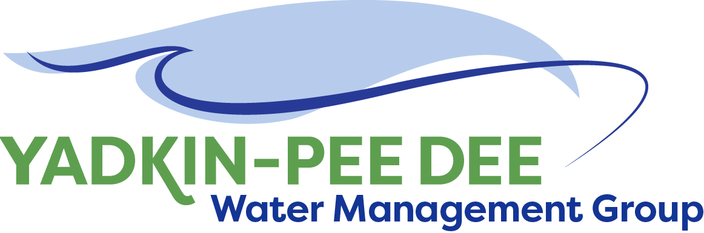
Yadkin-Pee Dee Water Management Group

AGENDA
Yadkin-Pee Dee Water Management Group Meeting
12PM to 2:30PM, October 26, 2017
Salisbury – Rowan Utilities
1 Water Street, Salisbury, NC
City of Albemarle
Water & Sewer Authority of Cabarrus County
City of Charlotte
City of Concord
Cube Yadkin Generation
Davidson County
Davidson Water, Inc.
Davie County
Duke Energy
City of Kannapolis
City of Monroe
Town of Norwood
Rowan County
Salisbury-Rowan Utilities
City of Statesville
Union County
Town of Wilkesboro
City of Winston-Salem/
Forsyth County

Welcome and Review of Agenda Christie Putnam, Chair
- Lunch will be provided
- Approve minutes from August 18, 2017 meeting

Presentation: NC Conservation Trust Bill Holman, State Director –
- Guest Speaker Conservation Fund

Local Water Supply Plan Leila Goodwin/Fountainworks
- Presentation of Draft

Water Shortage Response Plan Leila Goodwin/Fountainworks
- Review of Final Draft

Administrative Items All
- Outreach to potential new members

Group Member and Other Updates All
- Roundtable updates from individual members

Discussion of Next Meeting Agenda All

