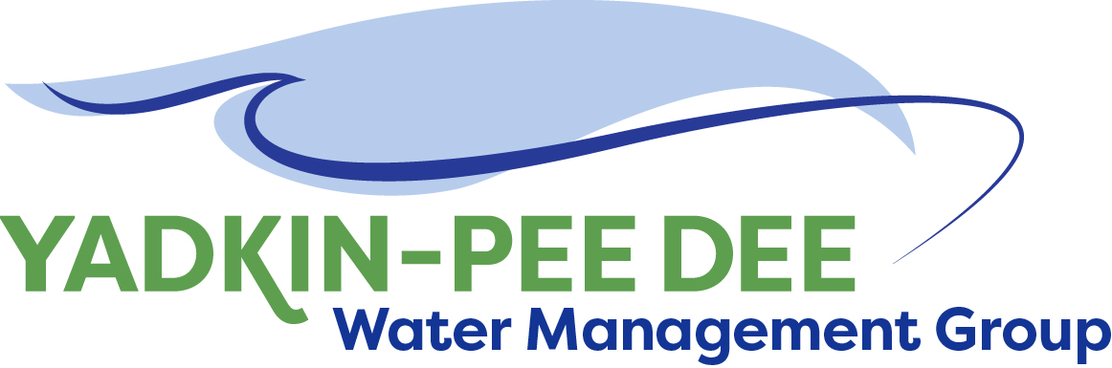
Yadkin-Pee Dee Water Management Group

Meeting Summary
Yadkin-Pee Dee Water Management Group Meeting
12PM to 2:30PM, October 25, 2018
Salisbury-Rowan Utilities
1 Water Street, Salisbury, NC

Action Items
The following action items were identified by the Group at the meeting:
- HDR will begin working on Tasks 1 and 2 of their scope of work incorporating feedback from YPDWMG members.
- W. Miller will update the list of potential YPDWMG members and ask for members to volunteer to reach out to them and invite them to participate in the YPDWMG.
- W. Miller will prepare talking points which can be used to communicate with potential YPDWMG members.
- The next YPDWMG Steering Committee call will be held at 11am on November 16th.
- W. Miller will send out a meeting poll to explore rescheduling the next full YPDWMG meeting. (Note: several members have conflict with the current December 13th date.

Welcome and Approval of Minutes
Chair Bill Brewer called the meeting to order at 12:05 pm. The Group approved the meeting minutes from the August 9, 2018 meeting.

Administrative Items
- Montgomery County will be joining the YPDWMG. Matthew Morris and Chris Hildreth will be the representatives from Montgomery County.

- YPDWMG received a $100,000 grant from the Duke Energy Water Resources Fund. This grant will be used to support the water supply master plan work over the next 18 months.

- Winston-Salem provided an update on the Group’s financial accounts. Details are posted on the Group website under meetings.

Water Supply Master Plan Framework and Water Demand Projections
- The YPDWMG discussed timing of regional workshops. The group recommended holding workshops no earlier than January 2019, targeting the 2nd through 4th weeks of the month.
- The YPDWMG suggested HDR coordinate with NCDWR to get concurrence on agenda and endorsement from NCDWR on regional workshops. Having their support and name on the stakeholder invitations and having them involved in this process will be important for stakeholder interest and participation. HDR agreed to coordinate with NCDWR and try to schedule time on the agenda to have a representative from NCDWR present on the state’s water supply planning goals as part of the workshop.
- In the invitations for workshops, HDR should define what a basin-wide master plan means (in generalized terms for the public) to make the topic relevant and relatable.
- The group discussed, at length, whether it made sense to hold the master plan visioning regional workshops combined with the water demand forecasting workshops, as originally scoped by HDR. The group ultimately decided there will be two somewhat different stakeholder groups for these topics and agreed to only hold regional workshops for the master plan visioning process initially. Discussion of how to handle workshops for regional water demand forecasting will be held until a later date.
- Stakeholders receiving invitations should generally follow the NCDWR notification lists, but include all entities in the basin with a Local Water Supply Plan, water intake owners (0.1 MGD or greater), wholesale water customers (with Local Water Supply Plans), industries, golf courses, agriculture interests, lake operators (USACE, Duke Energy, Cube Hydro), economic development groups (COG, Chambers of Commerce), and the public.
- The group suggested structuring the regional workshops to lay out a clear purpose of the plan/need for the plan. (Topics discussed included reservoir operation during drought, long-term water availability for the region, interbasin transfers, economic growth/development, etc.). It was noted part of the purpose of the initial workshops will be to solicit input from stakeholders on what they perceive to be the key issues with water resources in the Yadkin-Pee Dee River Basin, which can ultimately be addressed through a water supply master plan.
- The group discussed potential locations for the regional workshops. The group decided to hold one in the upper basin (in the Winston-Salem area), one in the central basin (in the Salisbury area), and one in the lower basin (in the Montgomery or Richmond County area). The group discussed the importance of holding the lower basin workshop on the eastern side of the river to engage stakeholders in this area. HDR will coordinate with Bill Brewer (Winston-Salem) for the upper meeting venue, with Jim Behmer (Salisbury) for the central meeting venue, and John Mullis (Norwood) for the lower basin meeting venue. HDR will develop the workshop invitations such that they are open to stakeholders throughout the basin, and not advertise these as regional (upper, central, lower) meetings. Rather, they will be considered basin-wide meetings.
- Regional workshops will include an overview from NCDWR of state water planning, an overview from the YPDWMG of their organization, purpose, and goals, and then an overview of the master planning purpose and process by HDR, followed by stakeholder input into water resources needs or concerns in the basin.
- Following the regional workshops, results of the sessions will be compiled and presented several months afterwards in a basin-wide workshop, to further refine the key objectives and scope of the Yadkin-Pee Dee Water Supply Master Plan.
- HDR will begin work planning for these initial regional workshops during November. HDR will coordinate with NCDWR and develop a draft stakeholder list. HDR will prepare a draft agenda. HDR will coordinate event venue details. HDR will provide this information to the YPDWMG steering committee for review and concurrence on each of these items prior to finalizing dates, scheduling venues, and sending invitations to stakeholders.
- The target timeline for this initial work is regional workshop planning in November, stakeholder notification in December, and regional workshops in January.
- HDR will also begin moving forward with the existing data collection, review, and compilation for water demand projections in the Basin over the next several months.

Lessons Learned from Catawba-Wateree Water Management Group
Barry Gullet, President of Catawba Consulting and one of the founders and former Chair of the Catawba-Wateree Water Management Group (CWWMG) shared lessons learned from their Water Supply Master Plan (WSMP) work.
- The CWWMG focused first on water quantity work, with other components being done later.
- We (CWWMG) are now just doing water quality components. Next, we will be doing the economics of the plan.
- We received some criticism when the WSMP was published in 2014 about the project and process. The YPDWMG should look at criticism we received. We didn’t have enough engagement with certain stakeholders. When we finished our published report – criticism was that it didn’t go far enough. We wanted to make sure the plan had actionable items. We didn’t want to put things in the plan that would disrupt quality of life, economy, didn’t want a one size fits all strategy.
- We only used solutions where technology exists today and were proven to work in the utility industry in the southeast today. We had folks that had a single interest and didn’t want to work with matrix of multiple interests. The YPDWMG should remember that it’s a multi-interest environment and you must expect that in stakeholder processes.
- When the WSMP was completed, we took it to every member organization and asked every elected board to support the plan. Every elected board provided a resolution supporting the plan. The Centralina Council of Governments also supported it.
- You will need to consider the scenarios you wish to model. For example, do you want to deal with climate change? In the Catawba-Wateree plan 26 scenarios were modeled. The recommendation that was adopted did not give the highest safe yield result. The one that gave the highest safe yield was considered too disruptive.
- We looked at many scenarios. For example, cloud seeding was considered and opponents cited that as a criticism.
- Remember that it is hard to get people to understand the technical issues. Be careful about words you use in meetings and reports. Be sure to explain everything.
- Follow the Stephen Covey principle: – begin with the end in mind and then work toward that end. Make sure the process gets toward that end.
- Be prepared for someone to get the wrong impression about what we’re trying to do.
- Some of your members will be a lightning rod for criticism – make sure you have a strategy around the attention they will draw. It is important to show that a single member of the YPDWMG is not driving this.
- Group comment: This is our first opportunity to make a first impression. We need to communicate early and often with these groups.
- It’s important to have a communications strategy up front. If you do a great planning effort and no one knows about it, what’s the benefit?
- When reaching out to potential YPDWMG members, tell them ‘We need your input.’ The City-County Managers Conference in February may be a good opportunity to connect with potential members.

Member Updates
Group Member Update
No member updates were given

Adjournment
The meeting adjourned at 2:35 pm.

Meeting Attendees
Michael Leonas, City of Albemarle
Jeff Corely, City of Concord
Karen Baldwin, Cube Yadkin Generation
Ron Sink, Davidson Water
Ed Bruce, Duke Energy
Jeff Lineberger, Duke Energy
John Mullis, Town of Norwood
Jim Behmer, Salisbury-Rowan Utilities
Andy Smith, City of Statesville
Bill Brewer, City of Winston-Salem

Non- Member Attendees:
Warren Miller, Fountainworks
Jonathan Williams, HDR, Inc.
Barry Gullet, Catawba Consulting

