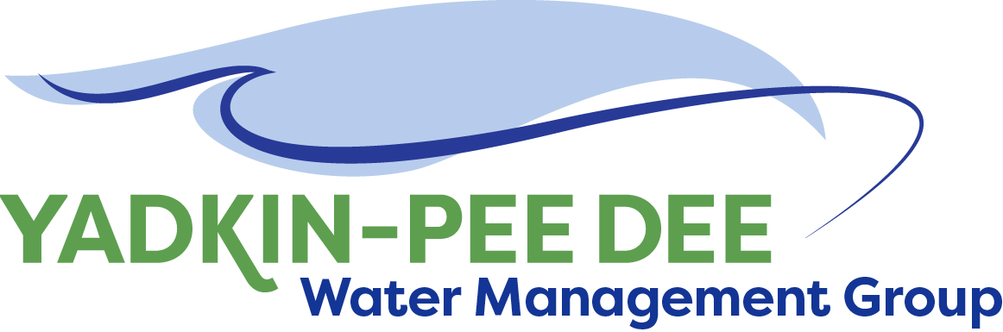
Yadkin-Pee Dee Water Management Group

Meeting Summary
Yadkin-Pee Dee Water Management Group Kickoff Meeting
12PM to 2:30PM, Wednesday, November 30, 2016
Salisbury-Rowan Utilities Office
1 Water Street, Salisbury, NC

Action Items
The following action items were identified by the Group at the meeting:
- W. Miller will send meeting poll to schedule next Group meeting in January. (W. Miller will coordinate with DWR so they can also attend the meeting)
- A conference call will be held in early January to plan the agenda for the next Group meeting. All Group members will be invited to participate in the planning call.
- Winston-Salem will follow up with Group members who have not paid membership dues.
- The Group was asked to provide W. Miller with any feedback or suggestions on the website.
- W. Miller will follow up with other non-member meeting attendees to see if they wish to join the Group.

Welcome and Introductions
Warren Miller called the meeting to order at 12:15 pm. This meeting included current members of the Group as well as local governments who were invited to join the meeting and participate in the Group. The meeting began at 12:05 PM with lunch followed by each participant explaining their interests and expectations for the Group.

Presentation from Tom Fransen, North Carolina Department of Environmental Quality (NC DEQ) Division of Water Resources (DWR)
Mr. Fransen was asked to present the State’s perspective on hydrologic modeling in order to help guide the Group’s future project work. The State strongly supports regional planning efforts. Mr. Fransen provided examples of how the State is supporting other river basins in regional planning and the tools it has developed that can be utilized by regional partners for this work. Mr. Fransen noted that the Group will need to consider whether it wants to model the Yadkin-Pee Dee River Basin alone or combine it with the Catawba- Wateree River Basin model as well as the Lumber River Basin model. The Group will also need to consider which modeling approach to use – Oasis or CHEOPS™. DWR is currently scheduled to complete the Yadkin-Pee Dee River water quantity model in 2018. The full PPT presentation is available at www.ypdwater.org/meetings

As a next step, Mr. Fransen offered for DWR staff to participate in the Group’s January meeting to provide additional background on the local water supply plans and answer questions. The Group will also use the meeting to better understand individual member’s approaches to local water supply planning. Melanie Williams will serve as DWR’s point person to the Group.

Review of Group website
Warren Miller shared the draft Group website - ypdwater.org. The website will provide information about the Group and its members; store meeting notes and contact information and serve as a space for Group collaboration. The Group was asked to provide W. Miller with any feedback or suggestions on the website.

Discussion of New Members
Rowan County stated they will be sending a letter requesting to join the Group. W. Miller will follow up with other non-member meeting attendees to see if they wish to join the Group.

Project Management and Administrative Items
The Group voted to utilize Warren Miller of Fountainworks, Inc. to provide facilitation and project management support to the Group for the next calendar year.

City of Winston-Salem provided an update on member dues invoices sent out and payments received. As of November 30th, ten members have paid their annual membership dues.

Adjournment
The meeting adjourned at 2:06 PM.

Meeting Attendees:

Membership Organization | Primary Representative | Alternate Representative
City of Albemarle
Alcoa Power Generating | Mark Gross | Karen Baldwin
City of Charlotte
City of Concord
Davidson County | Zeb Hanner
Davidson Water, Inc. | Ron Sink
Duke Energy | Jeff Linberger | Ed Bruce
City of Kannapolis |  | Alex Anderson
City of Monroe | Russell Colbath
City of Salisbury |  | Jeff Jones
City of Statesville
Union County | Edward Goscicki
Town of Wilkesboro | Sam Call
City of Winston-Salem | Courtney Driver | Bill Brewer

Roger Jones, City of Lexington
Wes Kimbrell, City of Lexington
Tom Fransen, NC DEQ
Ian McMillan, NC DEQ
Melanie Williams, NC DEQ
John Millis, Town of Norwood
Aaron Church, Rowan County
Will Scott, Yadkin River Keeper

Warren Miller, Fountainworks

