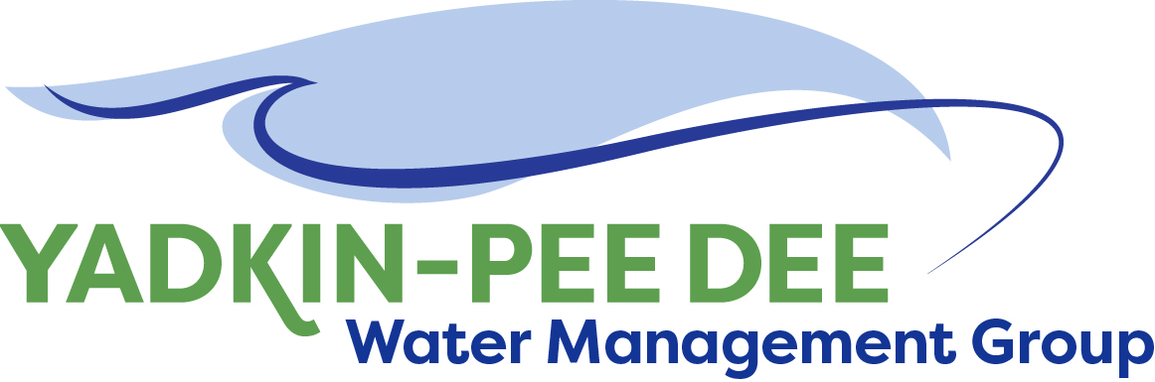
Yadkin-Pee Dee Water Management Group

Meeting Summary
Yadkin-Pee Dee Water Management Group Meeting
12PM to 2:30PM, January 4, 2018
Salisbury-Rowan Utilities
1 Water Street, Salisbury, NC

Action Items
The following action items were identified by the Group at the meeting:
- Provide comments on Local Water Supply Summary to Leila Goodwin by January 31. (All)
- W. Miller will coordinate with HDR to participate on next Steering Committee call.

Welcome and Approval of Minutes
Chair Christie Putnam called the meeting to order at 12:10 pm. The Group approved the meeting minutes from the October 26, 2017 meeting. The Group approved extending Fountainworks contract with the Group until June 30, 2018

Presentation on Local Water Supply Plan Project
Leila Goodwin presented the YPDWMG with an update on the Water Supply Summary. The draft report is available on the Group website: www.ypdwater.org (under ‘group’ link)
Water Supply Summary Next Steps
- Group members will provide L. Goodwin with edits by January 31, 2018.
- A final report will be distributed to Group members prior to the February Group meeting.

Administrative Items
- Winston-Salem has sent annual dues invoices to Group members for the fiscal year 2017-2018
- YPDWMG currently has projected revenue totals thru FY18 of $167,500. Projected committed expense totals thru FY 18 of $113,300.
- Several group members agreed to contact those local jurisdictions that are eligible to join the Group with the goal of increasing overall membership. This outreach is ongoing. Warren Miller can provide materials about YPDWMG to members who are involved in the outreach.
- The next YPDWMG meeting will be held 12pm – 2:30pm on February 15, 2018 at Salisbury-Rowan Utilities offices.

YPDWMG Work Plan
W. Miller led a facilitated discussion with the Group – sharing feedback from member interviews and surveys about what members want the organization to work on over the next several years as well as near term action steps to accomplish this. Key points from the conversation include:

YPDWMG goals (3-4 years):
- Develop a basin-wide water supply plan
- Develop a coordinated drought response plan
- Study additional water supply resource opportunities
- Identify source water protection issues
- Build YPDWMG Group and basin-wide collaboration

Context for YPDWMG
- The hydrologic model is not the objective – the objective is to have a model as a decision support tool for other things (e.g. water master planning and coordinated drought response)
- The state is currently expected to begin the modeling process for the basin in 2019.
- Both the water supply plan and coordinated drought response planning hinge on modeling.
- In order to get the most from the state’s modeling the YPDWMG needs to do its homework before the process gets started.
- This will benefit all YPDWMG members – including those without time sensitive needs.

Potential Work Plan Items
- Prepare for hydrologic model update (use existing Union Co model for some preliminary work)
- Drought response – standardize terminology– look at Kerr-Scott and at YPDLIP
- Drought response –potentially streamline triggers – look at Kerr-Scott and at YPDLIP; use existing model to evaluate
- Water Supply Plans – Peer review to develop some common definitions/terminology for preparing plans – some standardization / base level
- Summarize existing source water protection documents and efforts by members and/or the state, maybe other agencies as well.

Other Key Issues
- Union County clarified that they own the input data for the hydrologic model and that the group is welcome to use it.
- The primary updates to the hydrologic model prepared for Union County will be expanding the model to tributaries and updating withdrawals.
- Question to HDR: How will you ensure the model can be used to evaluate drought response?
- Cost will need to be determined. YPDWMG has some funds in its current fiscal budget ending June 2018 to get started with work. And some funds to support additional work in its FY 2019 under current dues. However, YPDWMG will need significant additional dollars to pay for the above work plan items. Costs TBD.
- What are the differences between the OASIS and CHEOPS model? (Do not want to spend money on CHEOPS if state isn’t going to use it.)
- Integration of the Yadkin-Pee and Catawba models is important.

Action Items:
- W. Miller will work with HDR to brief the Steering Committee and full Group in February on what a potential multi-year work plan looks like – including cost estimates for these projects.
- Each YPDWMG member will budget double their annual dues (i.e. $5,000) as a placeholder to fund work plan items in FY 2018-19.
- YPDWMG to meet with NC DEQ in February (about the timeline and expectations for the basin modeling)

Member Updates
Group Member Updates
Albemarle – 70-year-old Water Treatment Plan renovation is complete. Currently we are averaging 2-3 water main breaks per week.

Charlotte: Very busy – population is growing and wants to live in apartments. There is a perception that we’re out of sewer capacity. That’s not the case. We have a challenge with single family homes being redeveloped into apartments because the existing pipes do not have the needed capacity. We have new City Council members and a new department director – Angela Lee.

Concord – We published our systems development fee study. We did not receive any public comments

Cube Yadkin Generation – We have been swamped with follow up from relicensing

Davidson Water – Only 58 customers opted out of our water loss protection program – program has been successful. We are undergoing rebranding program. Davidson County Community College designed the logo – we gave a donation to graphic design department

Davie County –Very few public comments on system development fees study. We have a couple of big projects underway. We are almost out of sewer capacity and we have new projects to address this. We have an RFQ out for our aging water treatment plant.

Duke Energy -- Duke has been doing outreach and communications on the maintenance at Tillery. There will be a 6 foot to 8 foot draw down. During this time it will also provide an opportunity for owners to make modifications to their docks. This will occur sometime next fall and will be about 3 weeks long. We will be doing dam safety modifications and installing fish passage facilities at Blewett Falls Dam. Construction for this will be in 2019-20. We suggest having our project manager make a presentation to the group.

Monroe–Even given our successful water main replacement program and overall reduction of water main breaks – we had 8 yesterday. We are making upgrades to our water plant. We have several new Council members. We have received an AIA grant for developing an MMS

Norwood – Our sewer plant needs upgrades. Hired chuck Willis to do an assessment to see what we need for the plant to give us 20 more years. Hope that we will soon pull trigger on AMI project. (Pilot program has been very successful.)

Rowan County – We are building a water system. – The County will own it and Salisbury-Rowan Utilities will operate it.

Salisbury-Rowan Utilities: 99% done with AMI – will do ROI presentation to Council. Jeff Jones is being reassigned to engineering. Will be doing a presentation on asbestos in piping.

Union County – There is pressure and interest to expand our water system to rural areas. It’s becoming a real challenge because of the costs. We are interested in best practices for a water line extension program

Winston-Salem – We are kicking off scoping for our AMI. There is a city-wide push to consolidate how we do capital projects and we are looking at a software to support us. Our contract on Kerr-Scott comes up for renewal in a couple of years and we have begun talking with the Army Corp of Engineers about it.

Other Updates
Several members of the YPDWMG participated in a second meeting with other Basin Groups in November, including Catawba-Wateree and Jordan Lake Partnership. The meeting provided an opportunity to update each other on current activities as well as where there might be synergies for collaboration. Representatives from the Basins Group plan participate in a ‘Basins Group’ panel discussion at the 2018 WRRI Conference.

Adjournment
The meeting adjourned at 2:30pm.

Meeting Attendees
Michael Leonas, City of Albemarle
Karen Baldwin, Cube Yadkin Generation
Ron Sink, Davidson Water, Inc.
Christie Putnam, City of Concord
Ron Sink, Davidson Water
Johnny Lambert, Davie County
Jeff Lineberger, Duke Energy
Ed Bruce, Duke Energy
Russell Colbath, City of Monroe
John Mullis, Norwood
Ed Greene, Rowan County
Jim Behmer, Salisbury-Rowan Utilities
Ed Goscicki, Union County
Aubrey Lofton, Union County
Bill Brewer, Winston-Salem

Non- Member Attendees:
Warren Miller, Fountainworks
Leila Goodwin, Fountainworks
Brian Fannon, Yadkin Riverkeeper

