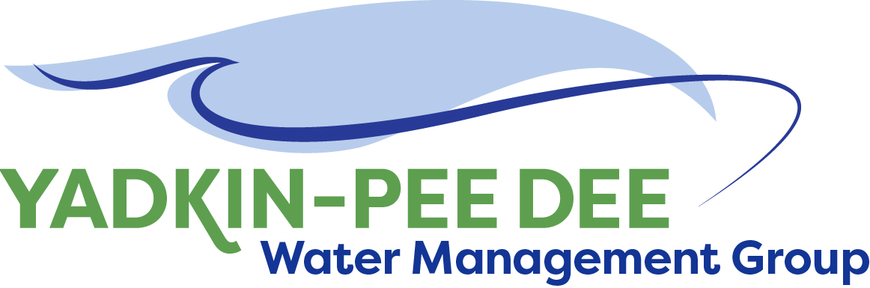
Yadkin-Pee Dee Water Management Group

Meeting Summary
Yadkin-Pee Dee Water Management Group Meeting
12PM to 2:30PM, February 15, 2018
Salisbury-Rowan Utilities
1 Water Street, Salisbury, NC

Action Items
The following action items were identified by the Group at the meeting:
- W. Miller will coordinate a meeting with NCDWR to discuss next steps with the basin hydrologic model.
- W. Miller will prepare a 1-2 page summary of YPDWMG goals and strategic activities

Welcome and Approval of Minutes
Chair Christie Putnam called the meeting to order at 12:10 pm. The Group approved the meeting minutes from the January 4, 2018 meeting.

Strategic Activities Work Plan
Adam Sharpe of HDR walked through a draft strategic activities work plan with potential costs. The 3-year plan included Hydrologic Model Update and Development; Basin-wide Water Demand and Wastewater Return Forecast; Baseline Hydrologic Conditions Analysis; Coordinated Regional Drought Response Planning; and Water Supply Master Plan. The activities plan is available on the Group website: www.ypdwater.org (under meetings link).

Additionally, a longer term work plan was shared which included additional projects that could be carried out over 5 years or more.

Group Reactions
- Group members agreed these proposed activities represented the most pressing near-term activities.
- The Group recognized the cost for carrying out these activities would require stretching the proposed timeframe to work within the current dues structure or they would need to find additional sources of revenue.
- The Group noted the current MOU expires June 30, 2021 and they should be thinking about what they want to accomplish before this timeframe.

A proposed set of 2018 activities was also presented. This included:
- Determine the Group’s preferred path forward for the hydrologic model platform
- Meet with NCDWR on preferred path forward for the model and seek their support
- Formalize YPDWMG strategic plan (1-2 page guiding document, mirror off of MOU)
- Identify outside funding source(s) to support technical work (complete application process?)
- Complete the review/update of the basin-wide water demand and wastewater flow forecast
- Start the model update process (first gaining concurrence from NCDWR on scope of updates)

Group Reactions
- Group members agreed meeting with NCDWR was an immediate priority. This meeting will determine a path forward for the hydrologic model platform.
- Additionally, the Group asked W. Miller to prepare a 1-2 page handout which summarizes the Group’s goals and strategic activities. This handout would also be used to share with other jurisdictions who are interested in joining the YPDWMG.

Basin Hydrologic Model Update
Jonathan Williams of HDR presented a history of hydrologic modeling in the basin and gave a detailed comparison of the CHEOPS and OASIS models. The full presentation is available at ypdwater.org (under meetings link). Currently, the model update is scheduled to begin in 2019. It was noted it will likely take 2 years to complete the model update from start to finish.

Administrative Items
- Winston-Salem will be sending out annual dues invoices to Group members for the fiscal year 2018-2019.
- YPDWMG currently has projected revenue totals thru FY18 of $167,500. Projected committed expense totals thru FY 18 of $116,300.
- The Group agreed each member should plan on budgeting for double its annual dues payment in FY19 to provide extra funding for project activities. (This would be in addition to the annual membership dues.) This would give the Group flexibility to take on additional project work next year if they choose to do so.
- The next YPDWMG meeting will be held 12pm – 2:30pm on April 12, 2018 at Salisbury-Rowan Utilities offices.

Member Updates
Group Member Updates
Albemarle – Design documents for phase II sanitary sewer rehabilitation. Have received qualifications for firms for our rate study.

Charlotte: We are still recovering from the freeze earlier this year. We had 3000 leaks/breaks over a 20-day period. We have a lot of big projects underway. We have a pilot project to convert a treatment plant into one that can carry out a fermenting process. We have a new WWTP interlocal agreement. We are educating our Council about stormwater. We are also working hard to include many stakeholders in our decision-making process.

Concord – No updates

Cube Yadkin Generation – No updates

Davidson Water – We are rehabbing our old water treatment plant to provide redundancy. As a result of the recent winter storms, we will be developing an overtime policy.

Duke Energy – On February 20th, the US Supreme Court will decide whether or not to take up the petition by American Rivers and the City of Rockingham on our FERC relicensing. Also, Duke has been doing outreach and communications on the planned maintenance drawdown at Lake Tillery. There will be a 6 foot to 8 foot draw down (weather permitting), providing an opportunity for lake neighbors to make modifications to their docks and shoreline, provided they receive lake use permits from Duke Energy before doing the work. The drawdown is planned to begin on October 8th and the lake should be held 6-8 feet down from October 15th through November 9th.
Monroe–We have completed our system development fee study. Overall our revenue is stable. We are making upgrades to our water plant.

Norwood – AMI Project - Council has approved the change out of our water meters. It will be a full services contract. We are having issues at our treatment plant.

Salisbury-Rowan Utilities: We are extending our water lines and working with the County. AMI – the meters are in place. We had 54 breaks during the recent storms – all were cast iron pipes.

Statesville – We have had some equipment failure. On the wastewater side, heavy rains have caused issues with I&I.

Union County – Have received RFQs for our water supply plan project.

Winston-Salem – Overall our revenues are down. Our system development fees are lower. We are working with Raftelis on the implications of this. We have hired UtiliWorks for our AMI project.

Other Updates
Representatives from the Basins Group plan to participate in a ‘Basins Group’ panel discussion at the 2018 WRRI Conference.

Adjournment
The meeting adjourned at 2:35pm.

Meeting Attendees
Michael Leonas, City of Albemarle
Karen Baldwin, Cube Yadkin Generation
Ron Hargrove, Charlotte Water
Christie Putnam, City of Concord
Ron Sink, Davidson Water
Jeff Lineberger, Duke Energy
Ed Bruce, Duke Energy
Gerald F, City of Kannapolis
Russell Colbath, City of Monroe
John Mullis, Norwood
Jim Behmer, Salisbury-Rowan Utilities
Jason Green, City of Statesville
Ed Goscicki, Union County
Aubrey Lofton, Union County
Courtney Driver, Winston-Salem

Non- Member Attendees:
Warren Miller, Fountainworks
Brian Fannon, Yadkin Riverkeeper
Ginny Baker, NC DWR
Michelle Raquet, NC DWR
Jenbery Feyyisa, NC DWR
Jonathan Williams, HDR, Inc.
Adam Sharpe, HDR, Inc.

