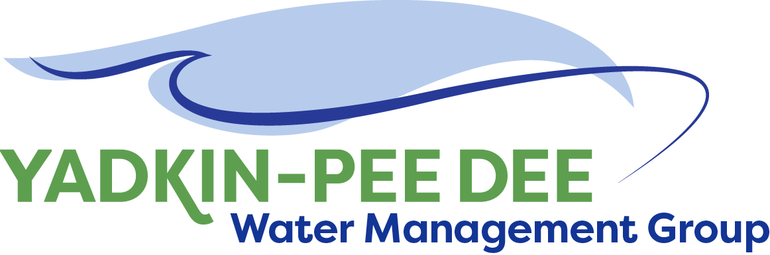 **Yadkin-Pee Dee Water Management Group**

***Meeting Summary***

**Yadkin-Pee Dee Water Management Group Meeting**

12PM to 2:30PM, Thursday, March 23, 2017

*Salisbury-Rowan Utilities Office*

1 Water Street, Salisbury, NC

##### *Action Items*

The following action items were identified by the Group at the meeting:

* **B. Brewer will invite Army Corp of Engineers to speak at May meeting**
* **W. Miller will prepare an amended proposal for the Local Water Supply Plan summary for members to discuss and vote on at May meeting.**
* **W. Miller will work with members to develop recommendation for small municipalities located in the Yadkin-Pee Dee that are interested in joining YPDWMG**
* **W. Miller to send Winston-Salem updated member list and post on YPDWMG website**

##### *Welcome and Approval of Minutes*

Vice Chair Ron Hargrove called the meeting to order at 12:10 pm and the Group approved the January 19 meeting minutes.

##### *Review of Technical Meeting Local Water Supply Plans*

On March 7th a YPDWMG technical team meeting was held to provide a forum for Group members to share demands and methodologies used in developing their local water supply plans. Jeff Jones of the City of Salisbury reviewed the outputs from the meeting and the Group discussed key takeaways and comments.

* Group members had similar methodologies and used similar techniques to develop numbers.
* 2060 projections were done differently, but showed similar long-term growth.
* When we plan for modeling, we need to review the Union County IBT modeling inputs and consider updates to assumptions for member existing and projected water use currently in the model.
* We need to make sure we are including all water users in the basin, including non-members, above a certain withdrawal threshold.



**Surface Water Withdrawal**

**Yadkin-Pee Dee Basin**

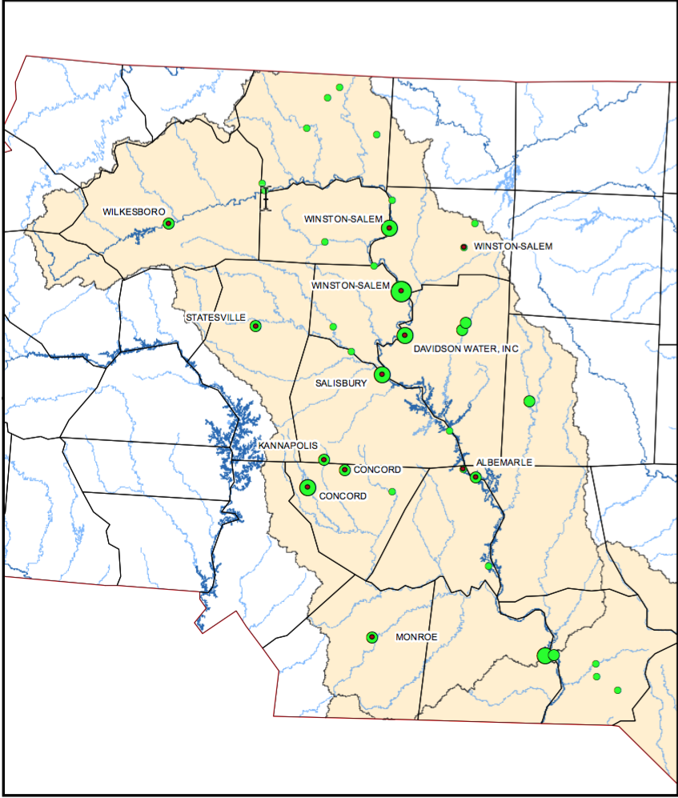

##### *Discussion of Proposals from Fountainworks*

Ron Hargrove led a discussion on two proposals from Fountainworks: (These proposals are included in the members’ link page of the YPDWMG website.)

* Local Water Supply Plan Proposal
* Water Shortage Response Plan Proposal

Actions: The Group unanimously approved contracting with Fountainworks to complete the Drought Response Plan.

Actions: The Group asked that Fountainworks amend the scope of the Local Water Supply Plan proposal to include all municipal water users in the Yadkin-Pee Dee River Basin (not just YPDWMG members) and to include Ag and Industrial users of at least 1MGD/day. Fountainworks will prepare a revised scope for the Group to review at its May meeting.

##### *Administrative Items*

The City of Winston-Salem provided a financial update. All Group members invoiced have paid. Invoices will be going out to Water and Sewer Authority of Cabarrus County, Rowan County and Davie County.

Other items for discussion included:

* Bill Brewer suggested that the Group invite the US Army Corp of Engineers (USACE) to the next Group meeting and asked for a list of topics they would like to hear from the USACE about concerning upstream operations within the YPD River Basin.

Potential questions of interest include: What is the low flow release plan? What is the science behind that? Does the USACE have aquatic habitat requirements they are trying to accomplish? If the basin does not have enough water to meet demands could it be added somewhere? What is the process for raising the level of the reservoir?

* Ron Sink shared USDA/NRCS/RCPP Funding Opportunities with Group to gauge interest and determine the appropriate entity that could pursue these. The Group suggested the Yadkin-Pee Dee River Basin Association as the best group to pursue this funding. City of Winston-Salem will coordinate with Davidson Water Inc. to share the information with that association.
* The Town of Norwood would like to join the Group and asked if there could be a provision for small municipalities to join at a reduced cost or join as an associate member. The Group asked W. Miller to form a committee to develop a recommendation at the next Group meeting in May.

##### *Group Member Updates*

***Davidson Water Inc***. – We’re seeing the most growth since 2008. We are implementing a water loss protection program

***Charlotte Water*** - Catawba Wateree met on March 14th and wants to have a joint meeting of North Carolina water supply planning groups (i.e. Catawba, Yadkin, Jordan) in the summer in Greensboro. The meeting would focus on what each group is doing, goals, where each group is headed.

Other Catawba Wateree updates:

* Held a water loss prevention workshop
* Have started a couple of new projects including land conservation to add quantity to water supply and a phase 3 water quality study.

Legislature is in session: A bill has been introduced that would prohibit municipalities from charging impact fees for development

**Duke Energy** - Suggested asking NCSU Masters Candidate (Kelly Suttles) to present at a future YPDWMG meeting. Suttles selected various sub-basins in the Yadkin Basin and projected what would happen to streamflow (on average) due to both climate change and Land Use (separate and combined).  She picked out an urban watershed near Winston Salem, a “middle of the road” watershed and one in the Uwharrie National Forest.  Each one responded differently.

**Salisbury-Rowan** - Working on our smart meter project. City Council awarded project. By end of October we will have all of our water meters changed.

**Other Updates**

**Yadkin River Keeper** - NC Soil Water Conservation Foundation –have source water protection efforts going

**Town of Norwood** – Town has embarked on a smart meter pilot program

##### *Future Meeting Discussions*

* The next meetings will be on May 25th and August 10th.

##### *Adjournment*

The meeting adjourned at 2:40 PM.

##### *Meeting Attendees*

|  |  |  |  |  |
| --- | --- | --- | --- | --- |
| **Membership Organization** | **Primary Representative** | **Attended** | **Alternate Representative** | **Attended** |
| City of Albemarle | Michael Leonas |  |  |  |
| Cube Yadkin Generation | Mark Gross |  | Karen Baldwin |  |
| Cabarrus County Water & Sewer Authority | Michael Wilson | X |  |  |
| City of Charlotte | Barry Gullet |  | Ron Hargrove | X |
| City of Concord | Christie Putnam |  |  |  |
| Davidson County | Zeb M. Hanner |  |  |  |
| Davidson Water, Inc. | Ron Sink | X |  |  |
| Davie County | Johnny Lambert |  |  |  |
| Duke Energy | Jeff Lineberger |  | Edward D. Bruce | X |
| City of Kannapolis | Wilmer Melton |  | Donald Jackson | X |
| City of Monroe | Russell Colbath | X |  |  |
| Rowan County | Aaron Church |  | Ed Muire  Greg Greene | X |
| City of Salisbury | Jim Behmer |  | Jeff Jones | X |
| City of Statesville | Joe Hudson |  | Jerry Byerly |  |
| Union County | Edward Goscicki |  | Aubrey Lofton  Andy Neff |  |
| Town of Wilkesboro | Sam Call | X |  |  |
| City of Winston-Salem | Courtney Driver | X | Bill Brewer | X |

**Non- Member Attendees:**

|  |  |  |  |
| --- | --- | --- | --- |
| **Organization** | **Representative** | **Email Address** | **Attended** |
| Town of Norwood | John Mullis | townofnorwood@norwoodgov.com | X |
| Yadkin Riverkeeper | Will Scott | [will@yadkinriverkeeper.org](mailto:will@yadkinriverkeeper.org) | X |
| Fountainworks | Warren Miller | [warren@fountainworks.com](mailto:warren@fountainworks.com) | X |