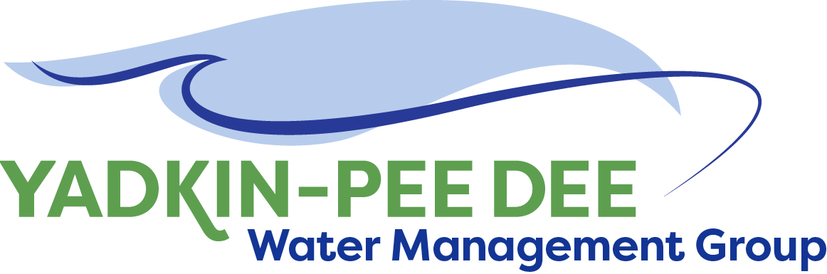
Yadkin-Pee Dee Water Management Group

Meeting Summary
Yadkin-Pee Dee Water Management Group Meeting
12PM to 2:30PM, April 12, 2018
Salisbury-Rowan Utilities
1 Water Street, Salisbury, NC

Action Items
The following action items were identified by the Group at the meeting:
- W. Miller will coordinate with Group members to submit a grant proposal to Duke Energy Water Resources Fund to support the development of the hydrologic model for the basin.
- W. Miller will make final edits to YPDWMG strategic plan and post on Group website
- C. Putnam (w/ W. Miller support): Group will make a written request to have Union County’s permission to utilize the hydrologic model developed as a part of its IBT Certificate pursuit.
- Get costs for HDR to provide technical support in upcoming meetings with DWR on hydrologic modeling.
- W. Miller will send out a doodle poll to look at potential alternatives to current June 14th 12pm YPDWMG meeting time
- W. Miller will develop a list of potential outside resources to support funding for hydrologic modeling and water supply planning.

Welcome and Approval of Minutes
Vice Chair Ron Hargrove called the meeting to order at 12:12 pm. The Group approved the meeting minutes from the February 15, 2018 meeting with the following amendment.
- Change: The Group agreed each member should plan on budgeting for double its annual dues payment in FY19 to provide extra funding for project activities. (This would be in addition to the annual membership dues.) This would give the Group flexibility to take on additional project work next year if they choose to do so.
- Change to: The group agreed that each member should plan on budgeting an amount of money equal to its annual dues payment in FY19 in the event the Group collectively decides to fund additional project activities next fiscal year. (This would be in addition to the annual membership dues.) This would give the Group flexibility to take on additional project work next year if they choose to do so.

Update from YPDWMG Meeting with DWR
C. Driver provided an update from the YPDWMG 3/28/18 meeting with DWR to discuss next steps with hydrologic model update. Following is an overview of key points from the 3/28/18 meeting:

The Group provided DWR officials with an overview of the YPDWMG including the strategic plan for the organization. The Group explained that it prefers the CHEOPS model because it believes it will work best and will be most cost effective to update. And it is also the model the Catawba-Wateree utilizes. The Group asked DWR to fund this model and support this effort.

DWR Response:
- We were ready to do it a few years ago and you weren’t.
- We are now modeling in the west. We will be meeting internally to look at our budget and determine what we can fund next year.
- There is an opportunity to pause and determine which platform will work best.
- We are using OASIS with the western basin planning.
- At the end of the day we may be talking about a combination of the two platforms.
- OASIS is better at water shortage response plans.
- May want to form a technical group to look at this. I can see real advantages to linking the Catawba and Yadkin.
- Will do the Lumber at the same time. – I see this as a minor add in.
- We’re on an aggressive schedule to have new platform updated – 3 western basins and upgrades to existing basins.
- Think the initial cost could be lower. Inflow record has been done (through 20003).

YPDWMG expressed concerns about moving forward with 2 models and DWR agreed.

Additional Comments by DEQ:
- We would prefer an integrated model. What that means is that we still need to figure it out.
- In the Catawba-Wateree agreement with SC in the US Supreme Court case, it says we will use CHEOPS unless several identified parties agree to use a different model.
- We have to look at all water users – poultry has doubled in last 10 years
- We tell small systems – we want all water users to be in this 50-year plan. Ask the COGs if they can help with the smaller jurisdictions.

What YPDWMG Can Do Now
- Review and update its forecasts

Next Steps
- Schedule a technical committee meeting in May to begin discussing how the two hydrologic models might be integrated. (Note: this meeting has been scheduled for 12pm – 2pm on May 14th at Salisbury-Rowan Utilities.)

YPDWMG Strategic Plan
The Group approved the YPDWMG strategic plan with edits. This plan, which includes a statement of purpose, values, goals, strategic activities and 2018 action items. Plan will be available on the Group website under meetings link: www.ypdwater.org

Administrative Items
- Winston-Salem provided an update on the Group’s financial accounts. Details are posted on the Group website under meetings.
- The Group agreed to pursue a grant request to the Duke Energy Water Resources Fund. The grant request is due May 1, 2018 with final funding decision made in September. The Group brainstormed additional funding sources and asked W. Miller to compile a working list and additional information about these resources.
- Group members provided updates on outreach efforts made to potential new members of YPDWMG.
- The next YPDWMG meeting will be held 12pm – 2:30pm on June 20, 2018 at Salisbury-Rowan Utilities offices.

Member Updates
Group Member Updates
Albemarle – We saw a 3-4% reduction in revenue for water and sewer in our service area.

Charlotte - We are issuing 4th largest bond issue in state’s history - $412 million. The rate will be 3%. We updated our Council on wastewater capacity. We have to build a new wastewater treatment plan – a 15mgd plant. Cost will be $300 million
Cube Yadkin Generation – We are very busy. We went up on rates for pier permits. We received our license in September and a lot of things coming due because of the license.

Davidson County – We are supporting our Egger plant - a $700 million investment

Duke Energy – On February 20th, the US Supreme Court decided to deny a petition by American Rivers and the City of Rockingham on our FERC relicensing. The New License is final now. Also, Duke has been doing outreach and communications on the planned maintenance drawdown at Lake Tillery. There will be a 6 foot to 8 foot drawdown (weather permitting), providing an opportunity for lake neighbors to make modifications to their docks and shoreline, provided they receive lake use permits from Duke Energy before doing the work. We learned of a major festival, so we pushed our drawdown date back to October 29 – November 16.
Monroe– upgrades at both treatment plants. Pipe bursting project working with DOT. Costs are lower. Doing 12-13 thousand feet per year. System development fee study has been approved. 3.2% increase on water and sewer.

Norwood – AMI Project - will start installing our new meters by July. A new public service announcement on this. Still have a big issue with our clarifier at our waste water plant. Applying for state funds for loans and grants. Going to apply for an SOC – will help our chance for grants. Dealing with aging infrastructure.

Rowan - We are involved in partially funding the extension of water line.
Salisbury-Rowan Utilities: We will be increasing our rates 2 – 2.5 %. We are evaluating our AMI (seeing a 6% increase in registration.) In final design for wastewater plant

Statesville – We have had some equipment failure. On the wastewater side, heavy rains have caused issues with I&I.

Union County –Ed Goscicki is retiring at the end of May. We are in a good spot with our rates – we are moving into year 2 of a 3-year rate ordinance. Our water supply project from Lake Tillery will be a design build project. We are including a full replacement of our SCADA system in our 6-year CIP. We are taking back operations of our 5 wastewater treatment plants from Charlotte and are in the early stages of permitting a new wastewater plant.
Winston-Salem – Revenues are down and consumption is down. There will be an 8% rate increase. We are getting close to procurement with our automated metering project. Designing upgrades to one of our water treatment plants. We will be doing a strategic plan.

Other Updates
Yadkin Riverkeeper – Brian Fannon is now the interim river keeper and will be doing a lot of work on High Rock Lake. The organization is looking for a digital file of the lakebed elevations of High Rock Lake at its formation.

Adjournment
The meeting adjourned at 2:30 pm.

Notes from June meeting

Meeting Attendees
Michael Leonas, City of Albemarle
Karen Baldwin, Cube Yadkin Generation
Ron Hargrove, Charlotte Water
Zeb Hanner, Davidson County
Jeff Lineberger, Duke Energy
Ed Bruce, Duke Energy
Gerald Faulkner, City of Kannapolis
Russell Colbath, City of Monroe
John Mullis, Norwood
Greg Greene, Rowan County
Jim Behmer, Salisbury-Rowan Utilities
Chuck Smith, City of Statesville
Aubrey Lofton, Union County
Courtney Driver, Winston-Salem
Bill Brewer, Winston-Salem

Non- Member Attendees:
Warren Miller, Fountainworks
Brian Fannon, Yadkin Riverkeeper
Ginny Baker, NC DWR
Jonathan Williams, HDR, Inc.
Adam Sharpe, HDR, Inc.

