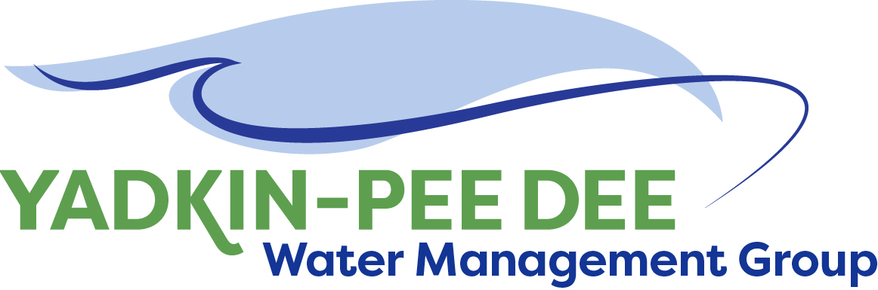
Yadkin-Pee Dee Water Management Group

Meeting Summary
Yadkin-Pee Dee Water Management Group Meeting
12PM to 2:30PM, June 20, 2018
Salisbury-Rowan Utilities
1 Water Street, Salisbury, NC

Action Items
The following action items were identified by the Group at the meeting:
- HDR will provide an updated proposal to support the Group.
- The Steering Committee and Technical Committee members will meet on July 20th at 11am in Salisbury to review the HDR proposal and make a recommendation to the full Group.
- W. Miller will send out a doodle poll to look at potential meeting times for follow up meeting with DWR in August or September to discuss the Group’s preferred direction for hydrologic modeling
- W. Miller will continue to monitor status of Group members’ grant proposal to Duke Energy Water Resources Fund.

Welcome and Approval of Minutes
Acting Chair Bill Brewer called the meeting to order at 12:10 pm. The Group approved the meeting minutes from the April 12, 2018 meeting with the following amendments.
- Change: On page two clarify that the inflow record has been completed through 2003. Note it is not current.
- Change: Note that the June meeting date was changed to be held on June 20th
- Change: name of Davidson’s development: change to Egger plant.

YPDWMG Hydrologic Modeling Meeting with DWR
Full notes from the 5/14/18 YPDWMG hydrologic modeling technical meeting are available on ypdwater.org. The following were key points discussed by Group members about the meeting and implications for next steps.

- DWR envisions moving forward with a contract for the hydrologic model at earliest on January 2020.
- DWR would prefer OASIS as the default model but is willing to work with YPDWMG on the model and its functionality.
- DWR is checking with Cube Hydro to see if legalities regarding access to OASIS have been lifted. (Note: Cube Hydro has not yet heard from DWR)
- DWR is willing to help fund the model.
- Members noted that CHEOPS will always be more accurate with reservoirs and OASIS will be more accurate with tributary activity.

YPDWMG members discussed their Preferred Path Forward:
- We don’t want two models in the future.
- We want to be THE resource and drive this process while continuing to work in partnership with the state.
- We want to make sure we check all the boxes that the state requires.
- We wish to move forward with ‘an enhanced’ CHEOPS model with an emphasis on rectifying its cons.
- We still have some concern about CHEOPS lacking the ability to do operational forecasting that OASIS can do.
- Cube Hydro: We do not plan on using the OASIS model going forward.

Next Steps
- Aubrey Lofton agreed to serve as a liaison for the Group for any technical meetings/ contacts with DWR regarding the hydrologic modeling.
- Ask HDR to revise its proposal: drop task 1 and add an additional task proposing scope and costs for updating the hydrologic model.
- In place of July Steering Committee phone call, YPDWMG Steering Committee and Technical Committee members will meet (July 20th) at 11am – 1pm in Salisbury to review HDR’s proposal
- Full group YPDWMG meeting on August 9th to discuss and decide on HDR proposal
- Meet with DWR and Hydrologics in late August/ early September to share YPDWMG preferred path forward and discuss next steps.

Administrative Items
- Winston-Salem provided an update on the Group’s financial accounts. Details are posted on the Group website under meetings.
- W. Miller provided an update on the Group’s grant request to the Duke Energy Water Resources Fund. The group is still being considered for this grant and final funding decisions made in September.
- W. Miller shared a working list and additional information about potential grants that the YPDWMG may be eligible for. The Group suggested exploring grant opportunities with Foundation for the Carolinas and Water Research Foundation.
- YPDWMG will be making a presentation with Catawba Wateree Water Management Group to the Centralina COG on September 12th to update them on the group and its activities.
- The Group voted to approve Fountainworks’ contract to facilitate and manage YPDWMG during FY 18-19.
- The next full YPDWMG meeting will be held 12pm – 2:30pm on August 9, 2018 at Salisbury-Rowan Utilities offices.
- Nominees for FY 18-19 Chair and Vice Chair will be discussed at the August YPDWMG meeting

Member Updates
Group Member Update
The members decided to forego individual updates due to time constraints.

Adjournment
The meeting adjourned at 2:35 pm.

Meeting Attendees
Michael Leonas, City of Albemarle
Mark Gross, Cube Yadkin Generation
Ron Sink, Davidson Water
Ed Bruce, Duke Energy
Gerald Faulkner, City of Kannapolis
David Rankin, City of Monroe
John Mullis, Norwood
Greg Greene, Rowan County
Jim Behmer, Salisbury-Rowan Utilities
Andy Smith, City of Statesville
Jason Green, City of Statesville
Aubrey Lofton, Union County
Bill Brewer, Winston-Salem

Non- Member Attendees:
Warren Miller, Fountainworks
Jonathan Williams, HDR, Inc.

