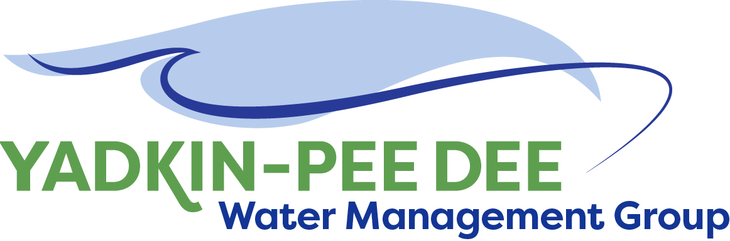
Yadkin-Pee Dee Water Management Group

Meeting Summary
Yadkin-Pee Dee Water Management Group Meeting
12PM to 2:30PM, August 9, 2018
Salisbury-Rowan Utilities
1 Water Street, Salisbury, NC

Action Items
The following action items were identified by the Group at the meeting:
- HDR will work with the City of Winston-Salem to develop a contract for Tasks 1 and 2 of their proposal.
- The Group will decide at its October meeting whether to recommend invoicing members for additional funds to pay for future project work. (Note: notification for the Duke Water Resources grant will be sent in September)
- The Group will invite EMC members Dr. Stan Meiburg and Gerard Carroll to attend the October YPDWMG meeting.
- HDR will coordinate with DWR as part of the stakeholder outreach meetings in Task 1 of the project scope. (note: purpose is to ensure DWR staff has a role on the meeting agenda)
- The next YPDWMG Steering Committee call will be held at 11am on September 21st
- W. Miller will coordinate with J. Williams and Centralina COG to prepare a joint presentation to its Board on October 10th.
- The next full YPDWMG meeting will be held at 12pm on October 11th.

Welcome and Approval of Minutes
Chair Christie Putnam called the meeting to order at 12:10 pm. The Group approved the meeting minutes from the June 20, 2018 meeting.

HDR Proposal
Jonathan Williams of HDR, Inc. reviewed the firm’s updated proposal to support the Group in updating a basin-wide hydrologic model and developing the Yadkin-Pee Dee Water Supply Master Plan. This proposal incorporated recommendations made by the YPDWMG Steering Committee. (A copy of this proposal is available on the Group website at ypdwater.org.)

The Group also asked Tom Fransen of NC DWR for his comments on this proposal. Following is an overview of his comments:

      - Wants to be sure the stakeholder outreach aspects of the proposal would meet state’s guidance for engagement with NCDWR model updates. J. Williams clarified that the scope would include engagement of stakeholders outside the YPDWMG. Note, the current model development scope includes a single stakeholder training. Additional stakeholder meetings may be needed to align with NCDWR’s standard process (model kickoff and interim informational session).
- Indicated that the Group could use this work as a vehicle to support changes in reservoir operation. (e.g. working with USACOE on Kerr-Scott operations)
- Indicated that the state will want to include Lumber River as part of their Yadkin-Pee Dee model update.
- Was still unsure how NCDEQ will adapt CHEOPS to the new state IT requirements for SQL server hosting. Details of this compatibility likely won’t be known for several months.
- Believes the OASIS model is easier for his staff to manage. It is what they are trained on and use more frequently.
- DWR will recommend funding for modeling in its upcoming budget for FY 19-20. (Amount requested will be made in coordination with the Group.) The Group should be involved in supporting this request once it’s made.

Following the discussion with T. Fransen and J. Williams the YPDWMG members made the following decisions:
- Voted unanimously to approve HDR’s proposal for Task 1 (including optional services) and Task 2.
- Asked HDR to consider making the following edits to Task 3 of its proposal. Note: YPDWMG and HDR in coordination with DWR will continue to explore changes to Task 3 over the next couple of months.
- Extension of hydrology from 2013 to 2018
- Need explore/clarify connection between this NC model effort and the SWAM models that have been developed in SC
- Recommended waiting until after the results of the Duke Water Resources Grant request are determined before deciding on whether any additional funds will be need from Group members for projects.

Administrative Items
- The Group unanimously approved electing Bill Brewer of Winston-Salem to serve as Chair for 2018-19.
- The Group unanimously approved electing Jim Behmer of Salisbury-Rowan Utilities to serve as Vice Chair for 2018-19.
- Winston-Salem provided an update on the Group’s financial accounts. Details are posted on the Group website under meetings.
- W. Miller provided an update on the Group’s grant request to the Duke Energy Water Resources Fund. The Group is still being considered for this grant and final funding decisions will be made in September.
- YPDWMG will be making a joint presentation with Catawba-Wateree Water Management Group to the Centralina COG on October 10th to update them on the Group and its activities.

Member Updates
Group Member Update
Charlotte – Very busy. Have issued an rfp for 15 design build projects that are all line work. Construction prices escalating at 10% per year. Within 30 days of agreement with Mount Holly, Charlotte will take their waste water into our system. Starts us on the process to build new waste water plant. Looking at an agreement with Belmont and exploring other future agreements. Water demands have been up with dry conditions -- 140mgd per day. Keep finding broken valves in our system. Water not moving in system the way it should. Getting ready in uptown for 2020 RNC convention.
Concord – Very negative experience with our contractor on the AMI project. We are making a significant pressure zone changes.
Cube Hydro – No updates
Davidson County – A ground breaking at Wilcox bridge.
Duke Energy – Still planning draw down on lake Tillery in late October and into early November
Monroe – Multiple upgrade projects at our plants. Collections distribution work. Pipe bursting programs. Conducting an enterprise pay plan study.
Norwood -- Water main replacement work. Applying for loans and grants for this work.
Rowan – Continuing to hook up customers
Salisbury-Rowan –We are getting good data from our smart meters. Conducting water auditing and learning a lot about our system
Statesville – Replacing major valves in plant site. Streamlining raw water intake pumps. Statesville has a new City Manager.
Union County – Getting close to expansion of our Catawba plant. Looking at AMI.
Winston-Salem – Our largest water treatment plant is getting a major overhaul. We are 90% done with design. We are a year into AMI plan. Getting procurement contracts in place -- 4 years into construction contract at waste water plant.

Other Updates
DWR – EMC has started a new “adopt a basin” plan. Each commissioner has adopted a basin. They will be visiting the basin. That way at least one Commissioner will be engaged in each basin. Dr. Stan Meiburg has been assigned the Yadkin. T. Fransen suggested inviting Dr. Meiburg to a future YPDWMG meeting.
September 13-14 – annual confluence conference in Greenville, SC. http://www.confluence.cc/

Adjournment
The meeting adjourned at 2:20 pm.

Meeting Attendees
Ron Hargrove, City of Charlotte
Christie Putnam, City of Concord
Karen Baldwin, Cube Yadkin Generation
Zeb Hanner, Davidson County
Ed Bruce, Duke Energy
Jeff Lineberger, Duke Energy
Russell Colbath, City of Monroe
John Mullis, Town of Norwood
Greg Greene, Rowan County
Jim Behmer, Salisbury-Rowan Utilities
Andy Smith, City of Statesville
Aubrey Lofton, Union County
Bill Brewer, City of Winston-Salem
Courtney Driver, City of Winston-Salem

Non- Member Attendees:
Warren Miller, Fountainworks
Jonathan Williams, HDR, Inc.
Tom Fransen, NC DWR

