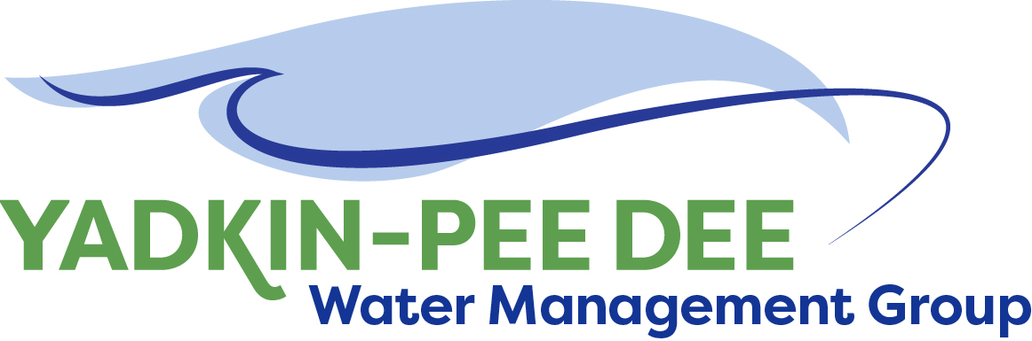
Yadkin-Pee Dee Water Management Group

AGENDA
Yadkin-Pee Dee Water Management Group Meeting
12PM to 2:30PM, March 4, 2020
Salisbury – Rowan Utilities
City of Albemarle
Water & Sewer Authority of Cabarrus County
City of Charlotte
City of Concord
Cube Yadkin Generation
Davidson County
Davidson Water, Inc.
Davie County
Duke Energy
City of Kannapolis
City of Monroe
Montgomery County
Town of Norwood
Rowan County
Salisbury-Rowan Utilities
City of Statesville
Union County
Town of Wilkesboro
City of Winston-Salem/
Forsyth County

1 Water Street, Salisbury, NC

Welcome and Review of Agenda Jim Behmer, Chair
- Lunch will be provided
- Approve minutes from December 2019 meeting

HDR Updates – Stakeholder Advisory Group J. Williams
& Scenarios

Discuss OASIS Presentation & DEQ Progress on Modeling Warren Miller/All

New Member Outreach Updates Warren Miller/All
- SCAWWA Environmental Conference
- NC Outreach

Infrastructure Security Discussion Jim Behmer/All

Administrative Items Jim Behmer/All
- YPDWMG financial update
- Discussion of what group members want from meetings this year

Group Member and Other Updates Jim Behmer/All

Discussion of Next Meeting Agenda All

