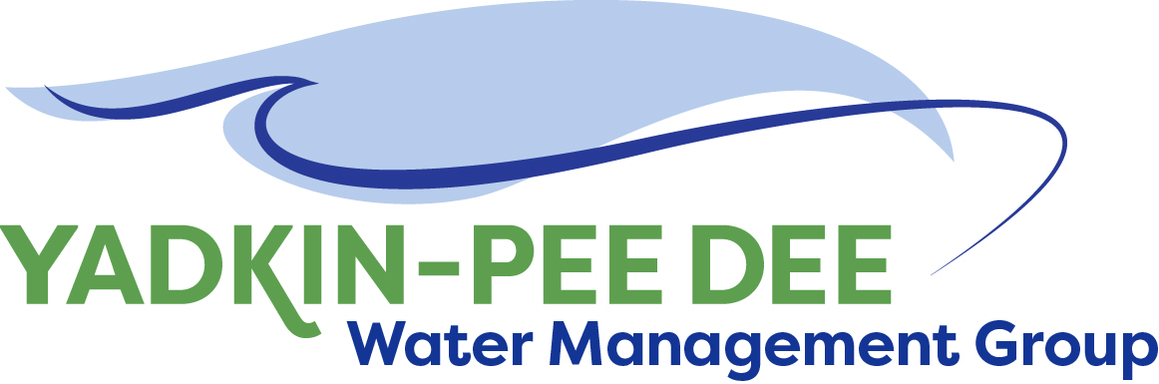
Yadkin-Pee Dee Water Management Group

AGENDA
Yadkin-Pee Dee Water Management Group Meeting
12PM to 2:30PM, June 13, 2019
Salisbury – Rowan Utilities
1 Water Street, Salisbury, NC
City of Albemarle
Water & Sewer Authority of Cabarrus County
City of Charlotte
City of Concord
Cube Yadkin Generation
Davidson County
Davidson Water, Inc.
Davie County
Duke Energy
City of Kannapolis
City of Monroe
Montgomery County
Town of Norwood
Rowan County
Salisbury-Rowan Utilities
City of Statesville
Union County
Town of Wilkesboro
City of Winston-Salem/
Forsyth County

Welcome and Review of Agenda Bill Brewer, Chair
- Lunch will be provided
- Approve minutes from April 2019 meeting

Hydrologic Model Funding
- Outreach Warren Miller

Yadkin-Pee Dee Water Supply Master Plan Jonathan Williams/All
  - Water Resources Plan Visioning and Planning Task – Final summary presentation of the Planning and Visioning guide and recommendations
  - Phase 2 proposal – we will review the Phase 2 proposal with the full group membership
  - Water Demand Forecast Updates Task –Final review of the water demand projections, with the feedback incorporated during the YPDWMG’s review process.

Presentation by Yadkin River Keeper Edgar Miller
- YRK/HRL Nutrient Assessment Tool

New Member Outreach Warren Miller/All

Administrative Items Bill Brewer
- YPDWMG financial update

Group Member and Other Updates Bill Brewer
- Roundtable updates from individual members

Discussion of Next Meeting Agenda All

