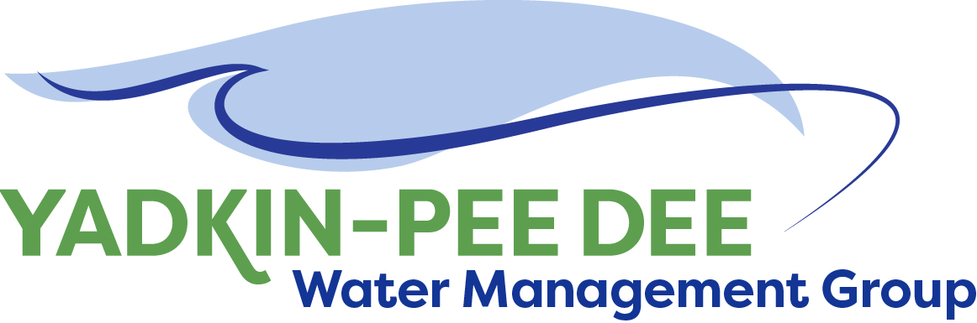
Yadkin-Pee Dee Water Management Group

Meeting Summary
Yadkin-Pee Dee Water Management Group Meeting
12PM to 2:30PM, June 13, 2019
Salisbury-Rowan Utilities
1 Water Street, Salisbury, NC

Action Items
The following action items were identified by the Group at the meeting:
- The next YPDWMG Meeting will be held on Thursday August 8, 2019.
- W. Miller to send out email to partners with the report from the Yadkin Riverkeeper.
- Obtain feedback from YPDWMG on Water Resource Plan scope framework by end of June.
- Meeting with Linda Culpepper 2 pm Tuesday June 18th.
- Give any questions to be answered by the model to DEQ by the beginning of August (per Tom Fransen’s request).

Welcome and Approval of Minutes
Chair Bill Brewer called the meeting to order at 12:05 pm. The Group approved the meeting minutes from the April 11th, 2019 meeting.

Hydrologic Model
Bill Brewer: We talked about a shared agreement with DEQ to fund the CHEOPS model. A couple of weeks ago I called Tom Fransen (DEQ) and was advised he was pursuing a change order to an existing contract with HydroLogics to fully fund the model using OASIS instead of CHEOPS. My concerns are as follows:
- This represents a significant departure from the direction we have previously discussed with NC DEQ DWR staff. Tom is fully funding the model. At this point we don’t exactly know what features are going to be in this model to allow us to do our work in the master planning process.
- The steering committee discussed this and has concerns regarding how this has transpired.
- There has been no communication or discussion between our group and the State.
- The direction changing at the last minute doesn’t feel right and transparent.
- YPDWMG needs to communicate with the leadership at DEQ so they understand our concern with what transpired and why this is so concerning to our group and I think (Linda Culpepper) will understand, but it needs to be explained.
- YPDWMG needs to come to a consensus of how hard we want to push back on DWR regarding the change from CHEOPS to OASIS.
  - The downside to pursuing the CHEOPS model would be having to fund the model, which would be a significant financial burden for YPDWMG. What is the best way to navigate this and get a product out of the model that will allow us to complete our work and develop a solid master plan for the basin?

Open Floor for Discussion:
Bill: I think it would help our case in the long run if we could be as open with Linda at our meeting (Tues 6/18/19). We need to tell Tom we want to speak separately with Linda.
Bill: We can take a hard line and say we advocated for the CHEOPS model – that approach has risks. At an absolute minimum I would want to get a firm commitment that we can get the OASIS model configured so that we can do our work and get the best product out of the master plan that we can. That’s part of what we need to decide. If we have a sit down with Director Culpepper, what are our goals?
Bill: Once you start to use OASIS and State analysis, you become limited in how much leeway you have in keeping it up to date. I think the logistics of the model would probably be okay for our group. We don’t know the developer, but we do know he has a set amount of money and he can’t do everything we’d like for him to do. I don’t know how well that would work for us.

Bill: Tom said he budgeted $340K and he told me that the model will be available to the public to run scenarios at their discretion. He said the cost is actually for the interpretation of the data. The only reason I say that is based on my understanding that’s what we would be responsible for. Having someone run a scenario and interpreting the data.
  - I’d be more concerned with the model being stuck on their server. What does it really do? I know the model is pretty good. But it is limited to that department.
Jeff: I’m concerned about what future water demands do to reservoirs. CHEOPS does a much better job at some things. From the reservoir standpoint, OASIS would not be the best model (CHEOPS is better).

Q&A with Tom Fransen (DEQ):

Ed: What is in there for hydro unit performance? How does the OASIS model handle hydro unit operation? And what about the low inflow protocol, can OASIS handle the low inflow protocol?
Tom:
- Unit information would have to be revamped with regard to hydro unit performance
- Low inflow protocol, per Tom, a Water Shortage Response Plan will be incorporated

Jeff: The state gave $400K to develop CHEOPS on the Catawba-Wateree River. That funding commitment was handled with a letter exchange so why can’t this basin’s model be done the same way?
Tom:
- There was already a commitment by the State via the SC v. NC US Supreme Court Case Settlement Agreement to help fund the CHEOPS model.

Jeff: The NC General Statute that addresses water quantity models says the State should use an existing model if one already exists. Since the YPD already has a CHEOPS model that the State has used for decision-making (e.g., Union County IBT), how does starting a new OASIS model square with that General Statute?
Tom:
- CHEOPS was not a complete model
- We will have a common platform (OASIS) across the State

Bill: What assurances do we have that we will be heard in the model development process?
Tom:
- We want models to be useful to stakeholders in the basin. We will work with all stakeholders – we will have the kickoff and training.

Aubrey: Was $340K in budget request? And if model costs run over, what then?
Tom:
- It was not in Governor’s budget.
- We expect to complete within budget.

Ed: There are numerous scenarios to be run, so who pays for that?
Tom:
- We create base case scenarios – then basin groups can tweak and run scenarios. HDR will be responsible for running scenarios.
- Give us all your questions to be answered by the model at beginning of August.

We will have to pay HDR money to work with the model. We need HDR input on how this affects costs.
- It was noted to have Tom communicate to Linda that we (YPDWMG) will have to put money into this.

Conversation with Tom Fransen concluded.

Items for Linda Culpepper:
Bill: Linda Culpepper needs to be briefed on how we got to where we are today -- that we went down this path with CHEOPS all along, but Tom Fransen apparently thought OASIS was the way it was going to go. We have expended funds based on going down the CHEOPS road and it’s going to cost us additional money moving forward. What assurances do we have moving forward?
Related to that, this shifts our timeline significantly. Our activities are dependent on the model and scenarios being run through the model. Now we must adjust our timeline and spending plan in reaction to the way it’s changed.
We need to clarify that Tom has been saying they want the YPDWMG driving this process, but the whole time he was talking it sounded like the State would be driving this process. They’re giving conflicting messages. They want us to be the driver and the stakeholders’ voices to be heard, but in some cases, we aren’t being heard. That ultimately revolves around trust. Right now there’s a trust issue.
We need to ask DEQ for detailed description of what we get for money when we see it and the project timeline. We want a major role as we represent 1.7 million people.

Yadkin River Keeper Presentation
Edgar Miller, Executive Director of the Yadkin Riverkeeper presented on the “Road map to a cleaner Yadkin River: Managing and Reducing Nutrients from Nonpoint Sources”. See the full presentation here.

HDR Update
Jonathan Williams of HDR reviewed the following with the Yadkin-Pee Dee Group members.
- Water Resources Plan Scope Framework
  - Presented a summary of the draft scope and framework documents, previously provided to the group.
  - This will be impacted by flux with model decisions.
  - Get feedback to Jonathan by end of June.
- Water Demand Projection Updates
  - Presented a summary on the updated basin-wide water demand projections with YPDWMG comments and feedback incorporated.
  - A draft memo on water demand projections is expected in early July.
    - Jeff mentioned that this is a process – and once YPDWMG has a plan they will need to revisit it every 5 years because things change.
- Phase II Activities
  - HDR presented the proposed scope for Water Resources Plan Phase 2.
  - Ed brought up combining or coordinating w/ other basin stakeholder groups (e.g. Yadkin Riverkeeper stakeholder group for nutrient loading tool).
  - YPDMWG agreed to hold a conference call to vote on Phase 2 scope the week after July 4th.

Administrative Items
None discussed at this meeting.

Member Updates
None given this meeting.

Adjournment
The meeting adjourned at 2:31 pm.

Meeting Attendees
Karen Baldwin, Cube Yadkin Generation
Ron Sink, Davidson Water, Inc.
Johnny Lambert, Davie County
Jeff Lineberger, Duke Energy
Ed Bruce, Duke Energy
Alex Anderson, City of Kannapolis
Jim Behmer, Salisbury-Rowan Utilities
Andy Smith, City of Statesville
Aubrey Lofton, Union County
Bill Brewer, City of Winston-Salem

Non- Member Attendees:
Warren Miller, Fountainworks
Brian Fannon, Yadkin Riverkeeper
Jonathan Williams, HDR, Inc.
Edgar Miller, Yadkin Riverkeeper
Cameron Colvin, Piedmont Triad Regional Council

