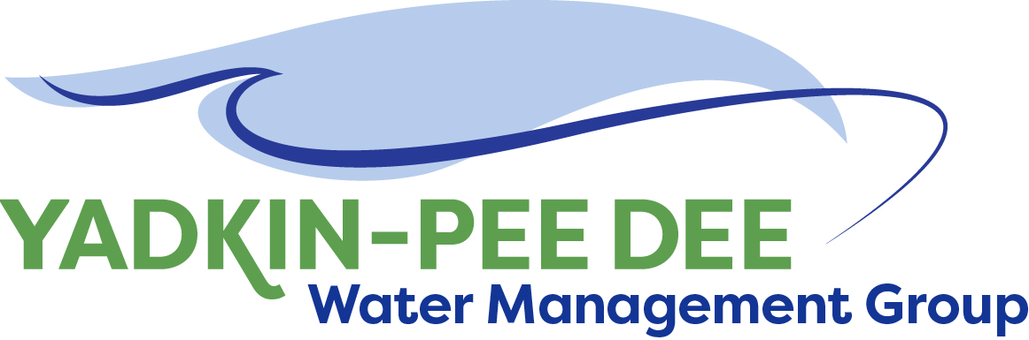
Yadkin-Pee Dee Water Management Group

Meeting Summary
Yadkin-Pee Dee Water Management Group Meeting
12PM to 2:30PM, August 8, 2019
Salisbury-Rowan Utilities
1 Water Street, Salisbury, NC

Action Items
The following action items were identified by the Group at the meeting:
- The next YPDWMG Meeting will be held on Thursday, October 10th, 2019.
- J. Williams to update the date for delivery on the HDR proposal of services for Phase 2 document
- Members to vote via email on two items to reach a quorum:
  - Updated HDR proposal of services for Phase 2 document
  - Fountainworks contract
- W. Miller will begin setting up onsite meetings with local governments in the basin to encourage joining the YPDWMG. Will coordinate with individual members for these meetings
- W. Miller to send out HDR’s Visioning and Planning Guide to the group
- W. Miller to contact Linda Culpepper (DEQ) requesting the State’s letter of commitment to the group

Welcome and Approval of Minutes
Chair Bill Brewer called the meeting to order at 12:15 pm. The members who attended in person approved the meeting minutes from the June 13th, 2019 meeting. There was not a quorum.

Yadkin-Pee Dee Water Supply Master Plan
Jonathan Williams of HDR reviewed the following with the Yadkin-Pee Dee Group Members. (Additional slides are included here).
1) Wrap up of Water Resources Plan Phase 1
- Visioning and Planning Guide
  - HDR incorporated changes for how the model will be handled (OASIS through the NCDEQ modeling contract amendment).
  - 3 scenarios were presented for developing the Water Resources Plan, based on varying funding schedules:
    - Plan A: 2.5 years. FY 19-22. Finished by the end of 2021.
    - Plan B: 3 years. FY 19-22.
    - Plan C: 6.5 years. Longer range plan –7 phases and goes through the end of 2025. Much less outside funding needed. Probably going to end up near this scenario, but will try to find ways to expedite certain tasks.
- The shorter the duration of the plan, the more outside funding is needed. Total estimated fees include the NCDEQ contribution of the model.
      - About $340K estimated funding from the State. The earliest the model development could start is January 2020 and it will take approximately 1 year to develop.
- The group thinks it would be helpful to add a model development column to the summary table of the phasing options, so they can pull out what the State is covering. This would help explain the funding to the members’ governing Boards.
  - Phase 2 will go through model development with the State. After that, the group can decide which phasing plan they want to follow.
- Hazen & Sawyer acquired Hydrologics. They will do the inflow development data for the Yadkin Basin as part of the OASIS model development contract.
- Water Demand Projections
  - HDR delivered the final technical memo to the group. This will serve as the basis of planning going forward in developing the Water Resources Plan.

2) Recap of Meeting with NCDWR on Modeling – J. Williams & V. Baker
- Meeting in Raleigh: A. Lofton (Union County/YPDWMG), J. Williams (HDR/YPDWMG), & Steve Nebiker (HydroLogics) with the NCDEQ-DWR (P. Behm, T. Fransen, V. Baker). The schedule and the technical aspects that the group needs to be included in the model were discussed.
  - T. Fransen (NCDEQ) said he wants the model to be available to stakeholders – training will be available for them once it is set up.
  - One area where there was concern was the 15-minute hydrology time step.
    - Right now OASIS is on a daily time step. For hydro power and river releases a daily time step is not going to capture what’s happening in the river with flows. They want to assess energy and energy load in 15-minute time steps.
        - Duke: Recommend modeling effort consider a daily timestep only instead of 15-minute time step. The inflow data set will be a daily average inflow and any time step less than daily does not add much to accuracy. Hydro plant recreational flow releases are the only flows that would require specialized input for modeling purposes.
  - As part of Phase 2 of the Water Resources Plan, HDR is will be developing performance measures to look at requirements and impacts. It will be a stakeholder driven process to help define the modeling evaluation criteria. When running a model scenario – how does it impact the performance measures? T. Fransen had been advocating for that.
- As part of Phase 2, HDR is proposing to develop a stakeholder advisory committee for Water Resources Plan.
  - When developing hydrology we are trying to evaluate what the natural flow was. HDR worked with Hydrologics to do the un-impairment of historical water use previously. When OASIS was previously developed in the Yadkin-Pee Dee Basin, the un-impairment was not performed. Hazen & Sawyer will be doing this.
- Linda Culpepper (NCDEQ) committed to writing a letter from the State to YPDWMG about the State’s commitment.
  - W. Miller to draft a letter from the group to ask for her acknowledgement.
  - W. Miller will follow up with her to get a letter.

3) HDR Proposal of Services - Phase 2

- HDR incorporated suggestions from the group. Phase 2 is everything we can do in advance of the model being developed.
  - Activity 1 – Funding assistance planning – HDR will identify funding opportunities and help the group with grant applications. Group said that the funding assistance planning wasn’t needed immediately, so this will be optional with the potential for future authorization at a later date.
  - Activity 2 – Strategic Communications Plan. Developing a plan for communicating with stakeholders. No changes in that scope.
  - Activity 3 – Stakeholder Advisory Committee – represents a broad spectrum of water user interests in Yadkin River Basin: neighborhood advocates, representatives from government, hospitality, health care, manufacturing, etc. Limited to 1-2 members from each area. About 15 key stakeholders. Want the YPDWMG’s input if they know of specific people HDR should reach out to. Changed from 3 meetings to up to 6 meetings. Quarterly meeting basis.
  - Activity 4 – Focused on what scenarios to model. Added the concept of the performance measure sheets. Added some clarification on compensation for number of scenarios developed. Rather than doing the contract as a lump sum, it will be on a time and materials basis with a not-to-exceed amount.
  - Activity 5 – Regulatory agency coordination for water quantity model – working with DWR and SCDHEC/DNR.
  - Total Lump Sum – not to exceed: $92,550
- Group has concerns about schedule, everything else is good.
  - From a funding standpoint may make sense to push this out to June 2020 from February 2020.
    - J. Williams will make this change.

4) American Water Infrastructure
- NC Source Water Protection Plans
  - HDR did an evaluation to find due dates for the Source Water Protection Plans of the group. Pictured below is the table showing the due dates for members: 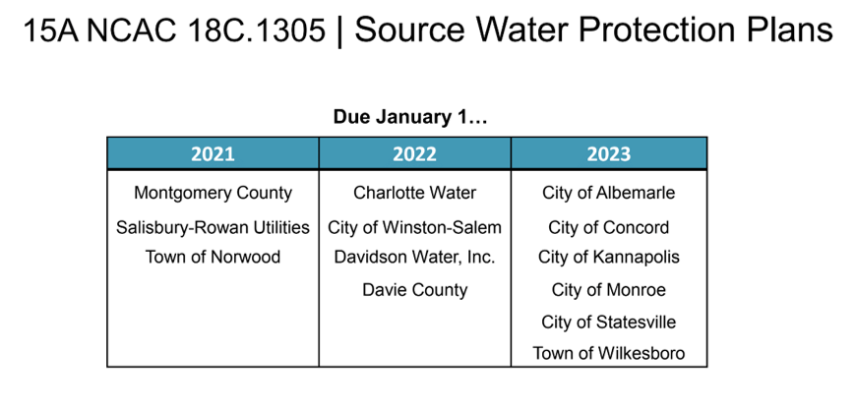
    - Good example: Davidson Water 2008, the state has it on their website for what a strong source water protection plan looks like.
    - Mills River is a good example of collaboration of source water protection where everyone was happy.
      - Winston Salem, Davidson Water, and Davie County intakes are so close that there may be opportunity for collaboration there.
    - Once we get on track with water quantity, we should move to water quality.
  - Has anyone incorporated land conservation?
    - Yes, Davidson Water has some of that. Buffers are part of their water strategy. But nothing enforceable.
    - Good example: Piedmont Triad Regional Water Authority.
- AWIA Requirements – America’s Water Infrastructure Act 2019
  - It is EPA’s responsibility to oversee the program. Three tiers - large, medium, small. Any utility over 3,300 people serviced has to conduct a risk and resiliency assessment and certify an emergency response plan. Service populations (including interconnections/wholesale) count. Large utilities are those who serve over 100,000.
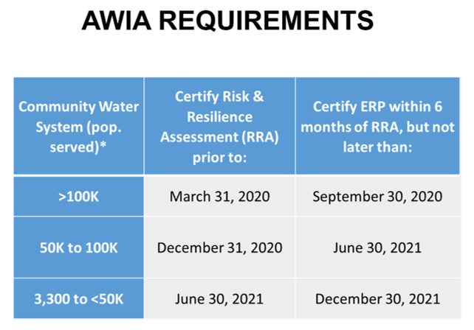

New Member Outreach
- W. Miller: There is interest from potential partners to join, but we’re at the point where we need to have some face to face conversations – a member has volunteered for each of the 20 potential new members.
  - Over the course of the next 6-12 months we’ll be coordinating with individual members to have some face to face meetings.
- R. Sink: Getting a meeting together with SC would not be a problem. The Board Members of Co-Bank, a $140 Billion enterprise – serves the Agri Co-ops and Florida Natural Orange Juice company are interested. Chesterfield County is a good size and they are interested. Marlboro Water Company, SC is interested. They are all in that Basin. Others would also be interested.
  - HDR: Group may want to consider presenting what it’s doing at the SEEC – South Carolina environmental conference AWWA.
    - Charlie with Chesterfield County is the incoming president of SC Rural Water—we need to get him on board with us.

Administrative Updates
- Budget – Bill received a check from Norwood for $2,500 for additional work. The number under operating revenues – that is not accounted for in FY 2019. The $35,000 extra money for special projects will be $37,500. Plugged in anticipated dues for 2020. Plugged in $55K, the same for Fountainworks for this fiscal year. Warren sent a proposal for $48K.
  - Fountainworks is the same fee, but the contract would include 6 days of being out on site to help with member outreach.
  - Have not accounted for HDR’s proposal pending approval. That is an expense that would be taken out of $179,375.
  - A little less than $100K in the bank after commitments to Fountainworks & HDR.
- Decided on standard operating position to have the conference line up at all meetings in order to always reach quorums for voting. We need to remind the members that they can send their alternates. If the member is not here the alternate can vote.
  - W. Miller will reach out to folks before the meetings to make sure that everyone who can come will participate.
  - May be good to have an outside speaker come in on an interesting topic.

Consultants stepped out and group discussed budget and contracts.

Member Updates
Salisbury Rowan: Sent out a request – evaluating training and certification – can send this out to members
Duke: Duke Energy Lake View: Lake level mobile phone app – if you’re interested in lake levels for any Duke Energy hydro lake we have a mobile phone app now that is free. It makes it easy and fast to get lake levels and flow release information, as well as special messages when we’re in a drought, flooding, etc. Also, when we are preparing for or in a high water event it will give projections for lake levels. IT has said that the app will have a feature to sign up to get texts when there is a special message posted for a lake of interest by August 16th.
- Wastewater spill component? Could be incorporated.

Winston-Salem: Our Neilson Plan Upgrade has gotten pushed back. We are moving forward with the normal projects we’ve talked about in the past. The City has named a new Deputy Director for the City-County Utilities Division: Mike Koivisto – an internal candidate that was promoted. Damon Dequenne was in that position and they promoted him to Assistant City Manager. With the position Mike vacated they will create an Operations Deputy Director – over collection distribution system water, wastewater.

Adjournment
The meeting adjourned at 2:17 PM

Meeting Attendees
Ron Sink, Davidson Water, Inc.
Jeff Lineberger, Duke Energy
Ed Bruce, Duke Energy
Greg Greene, Rowan County
Jim Behmer, Salisbury-Rowan Utilities
Bill Brewer, City of Winston-Salem
Gerald Faulkner, City of Kannapolis

Non- Member Attendees:
Warren Miller, Fountainworks
Tara Nattress, Fountainworks
Jonathan Williams, HDR, Inc.
Sarah Yen, HDR, Inc.
Virginia Baker, DEQ

