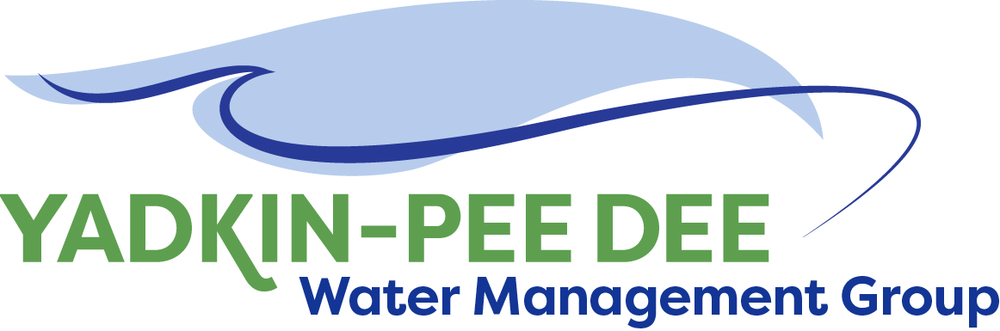
AGENDA
Yadkin-Pee Dee Water Management Group
12:00PM – 1:30PM, October 14, 2021
Via Zoom: Link
City of Albemarle
Water & Sewer Authority of Cabarrus County
Charlotte Water
City of Concord
Cube Yadkin Generation
Davidson County
Davidson Water, Inc.
Davie County
Duke Energy
City of Kannapolis
City of Monroe
Montgomery County
Rowan County
Salisbury-Rowan Utilities
City of Statesville
Union County Water
Town of Wilkesboro
Winston-Salem/
Forsyth County Utilities

Welcome J. Behmer/ All

Roundtable Discussion J. Behmer/ All

Chair & Vice Chair Nominations W. Miller/ All

Updates from HDR J. Williams/S. Yeh/All
- Stakeholder Advisory Committee (SAC) Update
- Final W. Kerr Scott Roadmap and SAC Feedback
- Modeling Update: Model Status, Introduction to Performance Measures, HDR
Model Evaluation Scope

Proposed Site-Specific Chlorophyll a Standards for High Rock Lake J. Behmer/All
- Public Hearing October 28th @ 6pm
- Written comments due November 15th
Should YPDWMG submit written comments?
YPDRBA and NCWQA will both be submitting written comments

Nonprofit Incorporation W. Miller/ All
Volunteers for subcommittee

