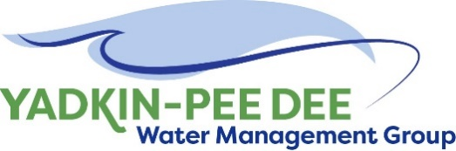
Yadkin-Pee Dee Water Management Group

Meeting Notes
Yadkin-Pee Dee Water Management Group
10:00 AM-12:30PM, October 13, 2022
Hybrid: Zoom & at Tillery Hydroelectric Plant
Agenda
- Welcome
- Roundtable Discussion
- Approval of August Meeting Minutes
- Water Resources Plan Update - HDR
- SC River Basin Council Update
- Nonprofit Incorporation Update
- Aquatic Weeds in the Yadkin River Basin
- Next Steps & Adjourn
Welcome
John Crutchfield of Duke Energy welcomed everyone to the facility and asked his colleague, Dennis Medley, to give a short safety briefing. Chair Aubrey Lofton of Union County began the meeting by thanking everyone and briefly reviewed the agenda for the meeting.
Roundtable
Next, Lofton began roll call and opened the meeting up for the Group’s roundtable discussion. Not all comments were captured, but a few highlights are captured below:
- Josh Canup of Rowan County noted he recently participated in the High Rock Lake rulemaking kickoff meeting and will be involved in the process.
- Jim Behmer of Salisbury-Rowan Utilities noted his organization’s high vacancy rate.
- Ron Sink of Davidson Water shared the supply chain issues they are facing, including an 82-week delay on a generator.
- Lofton noted that Union County is working on a water treatment plan to be completed next summer or fall, as well as a new greenfield wastewater treatment plant. She also noted AMI issues and holds on projects for supply chain delays.
- David Saunders of HDR noted the High Rock Lake nutrient rulemaking process that has recently begun. More information can be found here.
- Keith Larick attended as a new member of the Stakeholder Advisory Committee on behalf of NC Farm Bureau.
- Gerald Faulkner of Kannapolis noted his organization is breaking ground on a 350,000 gallon elevated tank, and remarked that there is lots of recent development happening in his community.
- Alan Fowler introduced himself as the new Water Treatment Plant Superintendent for Winston-Salem and noted that one of their plants is undergoing a major overhaul.
- Joyce Foster of Cube Yadkin noted that High Rock Reservoir will be drawn down during the first couple weeks of December to do some necessary maintenance, and that the agency will be notifying the public about this.
- Hyong Yi noted that Union is proactively conducting PFAS water testing at the Catawba River and future Yadkin River plant proactively so that they will be prepared for new EPA regulations.
- Brooke Czwartacki of the South Carolina Department of Natural Resources (SCDNR) noted the Department is working on state water plans for each of the eight basins in South Carolina, including the Pee Dee Basin. Czwartacki was attending in place of Stakeholder Advisory Committee member Scott Harder.
August Meeting Minutes Approval
Next, Chair Lofton asked for a motion to the approval of minutes from the Group’s August meeting. The minutes were approved unanimously.
Water Resources Plan Update- HDR
Sara Yeh of HDR then provided several brief updates on HDR’s ongoing work. Yeh’s slides are available here.
The focus of Phase 4a is conducting the initial group of future planning scenario analysis, along with ongoing stakeholder communication and outreach. The Stakeholder Advisory Committee met directly following the YPDWMG meeting.
Sabrina Colón and the communications team have made updates to Group’s messaging. A copy was provided to attendees with an updated overview of the Group itself, the Water Resources Plan it is working toward, and details on the stakeholder meetings that drove the roadmap for the plan. The timeline below shows the next several steps.
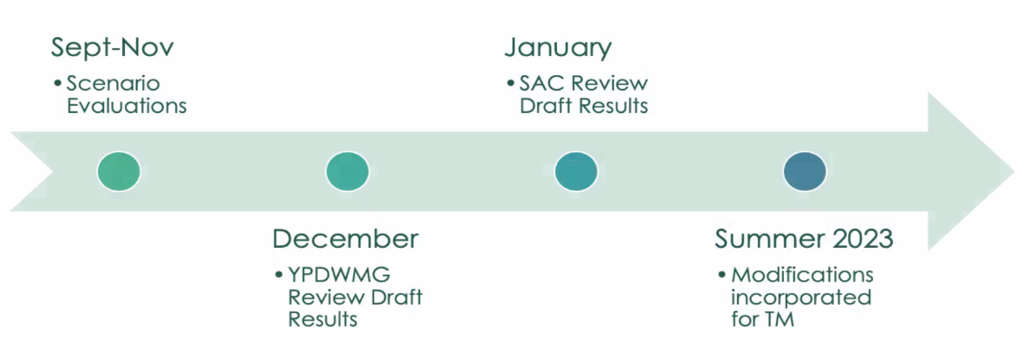
The OASIS model is nearly ready for public access, per NC DIT. HDR plans to present draft results at the Group’s December meeting for review, which will then be shared at the following Stakeholder Advisory Committee meeting in January 2023.
Yeh reviewed the four initial scenarios for modeling in Phase 4a:
- Drought reduces supply
  - Worse-case context of water availability.
  - Projections of reduced streamflow (increased evaporation due to increased temperature, as well as decreased rainfall)
- Sedimentation decreases reservoir storage and/or restricts intake
  - Reduced usable water storage within each reservoir using baseline sedimentation rates
- Increased population growth within the region, which increases demand
  - 75th and 90th percentiles of future demand to test impact of increased population beyond initial estimations
- W. Kerr Scott Reservoir revised flows
  - Evaluate components of the below revised flows through:
    - Outflow matches inflow when above minimum flow requirements
    - Increase water supply storage pool by 5 feet
    - Representative drought plan triggers and operational modification

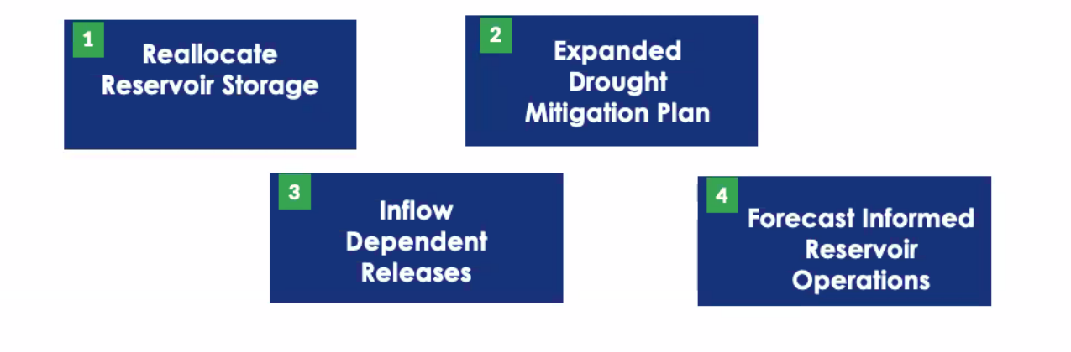
Yeh noted HDR looks forward to sharing initial results in December. A brief discussion followed her presentation.
SC River Basin Council Update
John Crutchfield of Duke Energy provided an update on the SC River Basin Council. The RBC has completed four meetings. So far, the meetings have helped to establish ground rules of how the council will act, bylaws, vision, goals, and a mission statement. They are working with SCDNR to create a statewide water plan and are using USGS stream gauging/monitoring to focus on drought locations and identify areas with low water supply. The council is also referencing the South Carolina water allocation model and ground water model. At the last RBC meeting, Crutchfield gave a presentation to the group about the YPDWMG and how Duke Energy releases water. Chair Aubrey Lofton has also attended these meetings. At the next meeting, the RBC will elect a Chair and Vice Chair.
Brooke Czwartacki noted that SCDNR is still in Phase 1, completing the background information, and will move to Phase 2 to discuss methodologies, demand, and production in December.
Aubrey Lofton presented in August to very engaged group interested in cooperation, who asked to have the future Chair attend YPD meetings virtually to stay informed. These plans are in motion after setbacks caused by the pandemic.
Nonprofit Incorporation Update
Maddie Shea of Fountainworks shared updates on the nonprofit incorporation process. As a reminder, the Group has operated under an MOU, which was renewed in the past year. In the meantime, the Group has voted to move forward with incorporating as a 501(c)(3) nonprofit. A set of draft bylaws has been developed and has been reviewed by Winston-Salem’s attorney and is currently under review by Salisbury’s attorney. Shea has a call with Barry Gullett to learn more about the process members went through when the Catawba Wateree Water Management Group was established as a nonprofit. Shea will share more information as it is available.
Lofton noted that the Group should recognize the incorporation process will come out of the representative’s direct control as they are handing it over to boards, councils, and attorneys to review. She advised members to be intentional in their conversations and review so that they can meet the June 2023 deadline. Lofton also noted that incorporating the group will allow them to pursue grants and other funding opportunities that they are ineligible for at this time. During the August meeting, members voted on a new fee structure.
Aquatic Weeds in the Yadkin River Basin
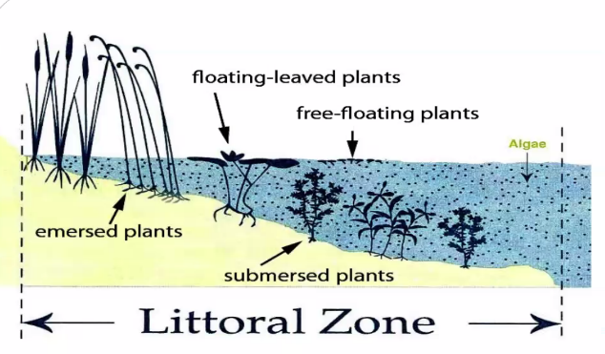
Next, Brett Hartis of Duke Energy presented on invasive aquatic species and their impact to the YPD River Basin. Invasive species are defined as being non-native AND environmentally or ecologically damaging. They are most often introduced accidentally, by improperly vetted control or mitigation strategies (ex: kudzu), because of perceived ornamental or economic value, or as imported species as “pets.”
The image to the right shows a breakdown of definitions for aquatic plants. Examples of each type:
- Emersed plants – Cattails
- Floating leaved plants – American lotus
- Fee floating plants – Duckweed
- Submersed plants - Bladderwort
Common invasive aquatic plants are often introduced through the aquarium and ornamental water garden industry. They are spread through fragmentation, water movement/wind, animals, and human activities.
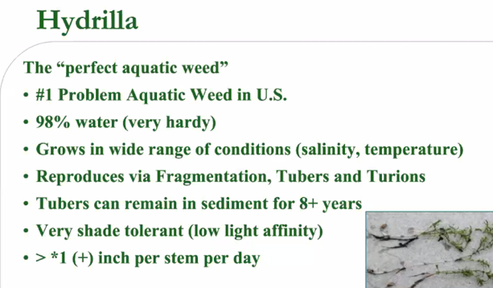
Hartis highlighted the ecological and economic damage that invasive species can have. For example, hydrilla can harbor cyanobacteria, which works its way up the food chain and can kill bald eagles. Invasive species can also outcompete native/beneficial species, create fluctuations in water quality, alter the habitat and food web, clog or damage water control structures, reduce public use of water, and impact local economies.
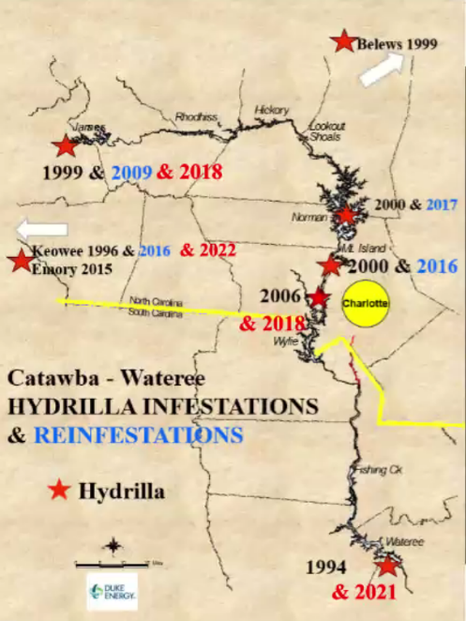
Reservoirs are especially vulnerable to invasive species due to their clear/ shallow water, high level of nutrients, and competitive advantage/lack of enemies. Hartis provided several notable examples, including a hydrilla invasion in St. Stephens Hydro in 1993, which caused a four-month outage and an estimated $5 million in losses.
The screenshot to the right shows hydrilla infestations and reinfestations in North Carolina. High Rock Lake was the first location to have hydrilla in the Yadkin-Pee Dee basin. Hydrilla are especially hard to kill because of their tubers, which can remain active for over eight years.

Hartis went on to explain that aquatic weed management. is allow about partnership. Duke Energy often serves as a facilitator of stakeholder groups, whole NC DEQ is the primary lead. There are cost-match programs available.

Management options include cultural (drawdowns), mechanical/physical, biological (grass carp), chemical, and prevention/EDRR (early detection rapid response). Hartis noted that homeowners are great at early detection. Duke Energy conducts active surveying in its reservoirs.

Hartis encouraged Group members to visit Duke Energy’s website on nuisance aquatic plants and to reach out about volunteer opportunities for invasive aquatic species management. Additional questions can be emailed to aquaticplants@duke-energy.com.
Next Steps and Closing Announcements
Before the meeting closed, Aubrey Lofton reminded members that the next meeting will be held on December 1st. Jim Behmer tentatively offered for Salisbury-Rowan Utilities to host the December meeting. Edgar Miller noted that the Yadkin Riverkeeper is in the process of finalizing a trail map of the Yadkin River State Trail to be released early next year, with the help of Piedmont Triad Regional Council.
The meeting adjourned at 11:49 AM, but many members stayed for a tour of the plant.
Meeting Attendees
Rusty Campbell, City of Concord
Joyce Foster, Cube Yadkin
Ron Sink, Davidson Water
John Crutchfield, Duke Energy
Brett Hartis, Duke Energy
Dennis Medley, Duke Energy
Gerald Faulkner, City of Kannapolis
Jim Behmer, Salisbury-Rowan Utilities
Josh Canup, Rowan County
David Rankin, City of Monroe
Aubrey Lofton, Union County
Hyong Yi, Union County
Allen Fowler, Winston-Salem
Ed Muire, Rowan County

Non-Member Attendees:
Keith Larick, Farm Bureau
Beverly Foster, Fountainworks
Maddie Shea, Fountainworks
Sabrina Colón, HDR
David Saunders, HDR
Sara Yeh, HDR
Klaus Alberton, NC Division of Water Resources
Grace Messinger, Piedmont Triad Regional Council
Brooke Czwartacki, SC Department of Natural Resources
Edgar Miller, Yadkin Riverkeeper

