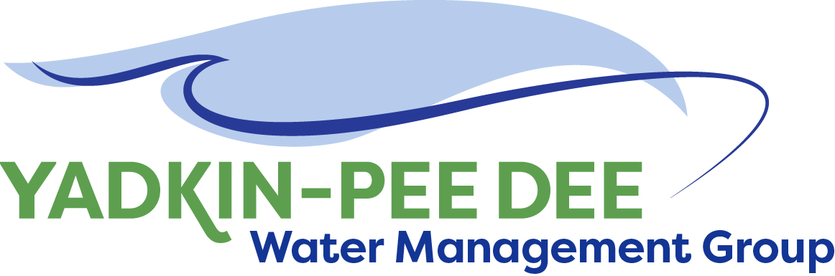
Yadkin-Pee Dee Water Management Group

Meeting Notes
Yadkin-Pee Dee Water Management Group Meeting
1:00PM to 2:30PM, October 8, 2020
Virtual Meeting (Zoom)

Agenda
- Welcome & Review of Agenda
- YPDWMG Strategy Conversation
- HDR Project Update – Jonathan Williams
- Other Updates

Welcome & Review
Jim Behmer opened the meeting. There were no suggested changes on the August meeting minutes, but no quorum was present to approve minutes. A vote for approval will held at the next meeting.

YPDWMG Strategy Conversation
Next, Warren Miller of Fountainworks led a conversation about the overall direction of the Group. Members were asked to address questions:
- Why are you interested in being a part of the Group?
- What are your primary interests in the basin?
- What’s one thing about the Group you value most?
- What’s one thing you might change about the Group?
- What’s your overall evaluation of the Group, based on its mission and MOU?
- What is your vision of the YPDWMG in 5 years?
A summary of responses is captured below:

Why are you interested in being part of the Group?
- We are all using the same resources, AND we need to have a unified voice
- Adding new water supply meant we had to understand issues in the Yadkin Basin
- Peer networking, ensuring future quantity, source water protection, + economic/recreation vitality
- You can do more together & we've seen it work other places
- To be part of a group w/ a common interest in protecting our common water resources
- We don't withdraw except emergencies but want to stay appraised of changes
What are your primary interests in the basin?
- Our decisions benefit not only ourselves but all the utilities along the river
- Sustainable water supply to provide balance of needs, better partnerships with communities
- Ensuring future water supply, economic & recreation vitality, source water protection
- Water supply quality and quantity studies and partnerships
- Safe, sustainable supply of water for all needs
How would you evaluate the YPDWMG based on its mission and goals?
Members were asked to place dots on a scale from “not at all successful” to “highly successful” based on the original goal from the MOU: “collaboratively defining the basin’s role in a long-term sustainable and secure regional water supply for the Yadkin-Pee Dee region.”
Projects include:
- Hydrologic/Hydraulic Modeling
- Regional Water Supply Master Plan
- Study of Additional Water Supply Resource Opportunities w/in the basin
- Coordinated Drought Response Plan
Responses fell between moderately successful and highly successful, as pictured below:
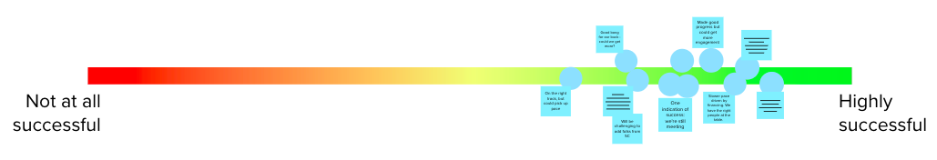
Below is a list of members’ reasoning for their rating, from least to most successful (left to right):
- On the right track, but could pick up the pace
- Good bang for our buck – could we get more?
- On track. Apprehension w/ state’s model. Lots to be proud of, & congenial group!
  - It will be challenging to add folks from South Carolina
- One indication of success is that we’re still meeting
- We’ve made good progress but could get more engagement
- Slower pace driven by financing. We have the right people at the table.
- Good to slow pace. Lots of good discussion on the modeling needs and desires.
- Commitment to transparency increases the group’s legitimacy
Other comments included:
- In absence of a “threat”/major sense of urgency, this group has accomplished a lot and still comes together. We have protocols to prevent what happened in 2002.
- Having an active stakeholder advisory committee for the water resources plan is a big plus

+/∆ - One thing you value, one thing you’d change:
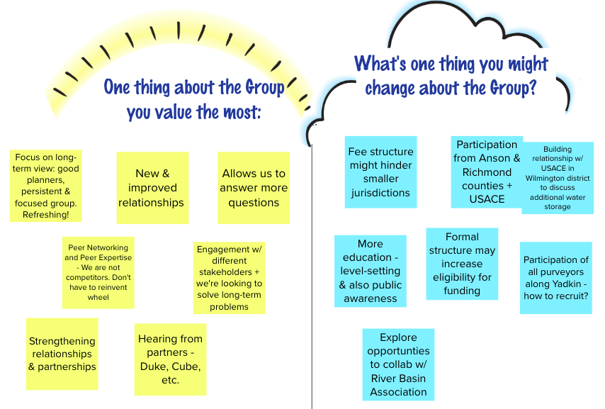

What is your vision of what the YPDWMG has achieved in 5 years?
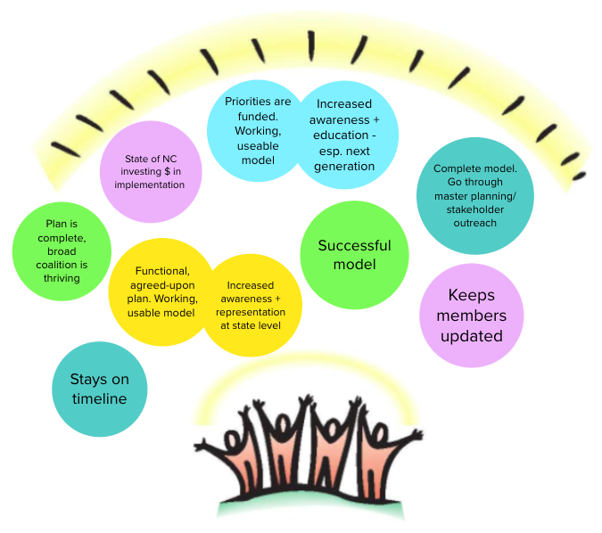

Action Items for 2021
Next, the group brainstormed things they would like to continue to do, start doing, and/or do differently in the next year. After generating ideas, sticky notes were placed on a matrix.
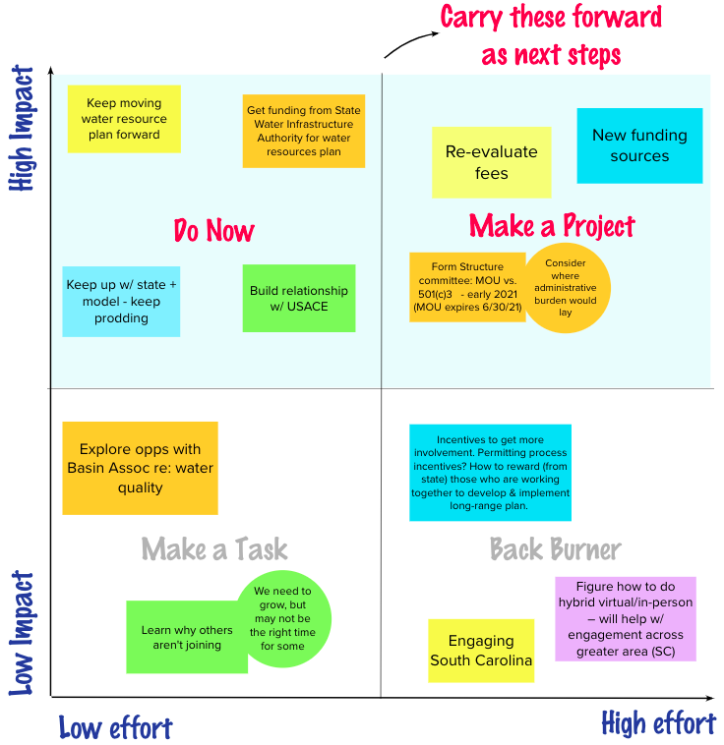

HDR Project Update – Jonathan Williams
Next, Jonathan Williams of HDR provided an update on the HDR Project.

Stakeholder Advisory Committee
- The most recent meeting was the group’s second meeting and was on July 16, 2020.
  - Topics covered:
    - Reviewed final scenarios for future modeling and evaluation
    - Introduced preliminary water quality issues summary and solicited feedback
- The next, and third meeting will be Thursday, October 22, 2020.
  - Agenda:
    - Project update
    - Final Draft Water Quality Technical Memo – get feedback from Committee
    - NCDEQ Basin-wide water quantity model update
    - Setting realistic expectations – teams of 2-3 for breakout sessions. The goal is to get individual user-interest perspective, get them talking to other orgs to set realistic expectations. They will be working with commerce, development, environmental groups, etc.
Water Quality Information Survey
- Received YPDWMG feedback on TM September 11, 2020
- Incorporated YPDWMG comments and issued to SAC for review on September 22, 2020
- Receive feedback from SAC at October 22, 2020 meeting
- Finalize TM and issue to YPDWMG by October 30, 2020
NCDEQ Water Model Technical Review Committee (TRC) Update
- Representatives:
  - From YPDWMG: Aubrey Lofton, Ed Bruce, Mark Gross, and Jonathan Williams
  - US Army Corps of Engineers
  - Yadkin Riverkeeper
  - Lumber Riverkeeper
  - NCWRC
  - USGS
- Meetings:
  - 1st TRC meeting (September 2nd) – Model development overview; schematic review
  - 2nd TRC meeting (October 5th) – Review inflows and operating logic. Jonathan noted that they may need to do more work evaluating how well the operating logic and licensing rules are functioning in the model. There was also a discussion around High Rock Lake & USACE reservoir relative to how to appropriately handle past sediment accumulation.
  - 3rd TRC meeting (late October) – Review base case run results
  - Full stakeholder group meeting #2 (including YPDWMG) (mid-November) – Provide model overview and discuss uses of model and base case run results
  - Full stakeholder group meeting #3 (including YPDWMG) (early December) – Training
- Other notes:
  - Hazen is working to make sure data aligns well; specifically, how to prorate amount of county area within overall basin. They are updating ag irrigation projects to be in line with YPDWMG’s data.
  - They are hoping to wrap up in December with the actual model, but the timeline may run into January.

NCDEQ Water Model TRC Project Timeline
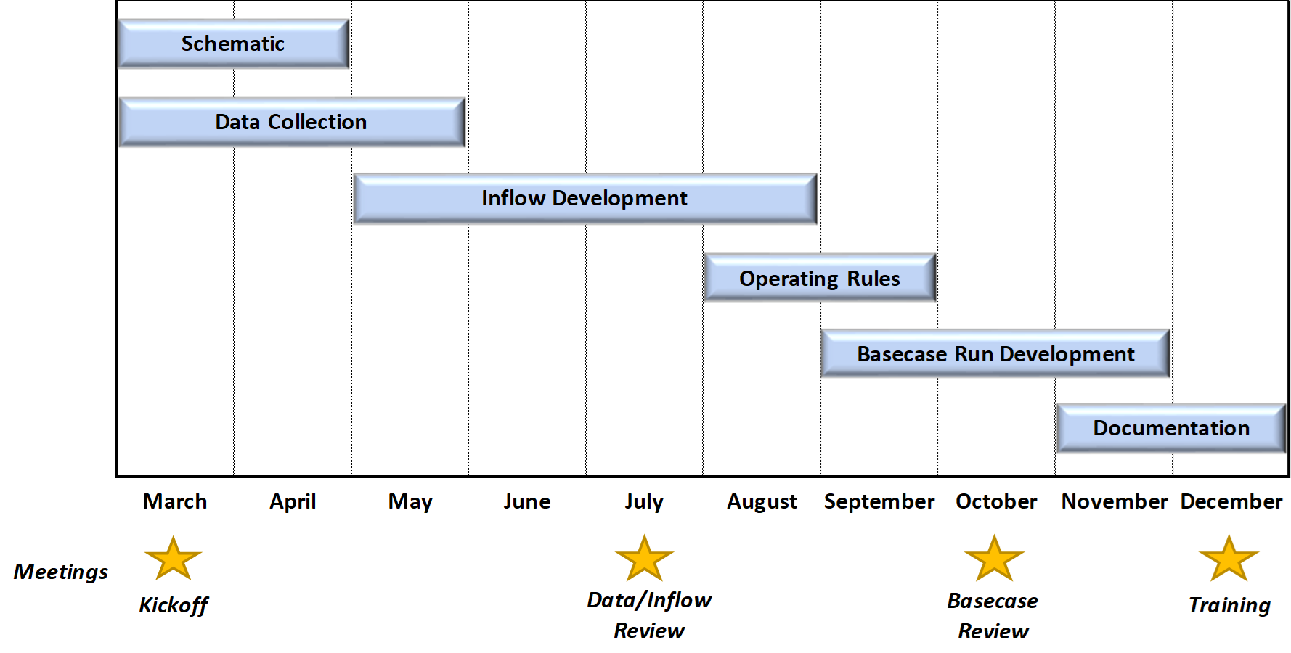

Next Steps – Water Resources Plan
In August, HDR provided proposal with 4 pieces.
- 2 admin tasks
  - 1. Funding Assistance Planning
    - Was previously an optional task, Group hadn’t seen need for that then. Now more of priority. HDR proposed
      - ID potential funding sources
      - Coordinate with reps of funding agencies
      - Complete up to 3 grant apps
  - 2. Ongoing Strategic Communications Support: over next 8-9 months
    - Develop resource library materials
    - Develop water resources plan for website content
    - Develop contact database for outreach
    - Develop social media content & schedule
- 2 technical tasks:
  - 3. W. Kerr Scott Water Supply Allocation Study
    - Evaluate and report on requirements needed to conduct the U.S. Army Corps of Engineers’ (USACE) process to pursue reallocation of the water supply pool from W. Kerr Scot Reservoir for the benefit of downstream users.
    - Benefits and consequences of increasing water supply allocation
    - Regulatory process for increasing the water supply allocation
    - Recommendations for a coordinated approach to water supply reallocation from the reservoir
  - 4. Demand Management & Conservation Evaluation
    - Benchmarking survey – assess current water conservation efforts in Basin compared to other successful regional programs
    - Quantify financial impacts and implications to water utilities
    - Evaluate and report on requirements needed to conduct the U.S. Army Corps of Engineers’ (USACE) process to pursue reallocation of the water supply pool from W. Kerr Scot Reservoir for the benefit of downstream users.
    - Benefits and consequences of increasing water supply allocation
    - Regulatory process for increasing the water supply allocation
    - Recommendations for a coordinated approach to water supply reallocation from the reservoir

The Group expressed interest in moving forward with Activities 1-3, but a quorum was not present to move forward with a vote. Voting members may respond to the email sent by Jim Behmer (jbehm@salisburync.gov) on Friday, October 9th to cast their vote.

Other Updates

Roundtable Updates
- The Technical Review Committee is trying to schedule a meeting for the end of October. NCDWR is hoping to have the model complete by the end of 2021.
- River Basin Plan scheduled to be released for public comment for April 2021. Any comments on water quantity section appreciated before then. Virginia Daniel will share in advance for feedback.
- The Yadkin Riverkeeper has completed the Roadmap for Cleaner Yadkin (link here).
- The City of Kannapolis is replacing a tank and doing lagoon cleanup ending in next few weeks.
- Per Jeff Lineberger of Duke Energy, the Blewett Falls Powerhouse that was flooded in Hurricane Florence had 6 units damaged. Half of the 6 units are back in service and running continuously, and will be recommissioned October 19th. They expect 2 more units to be up and running by Oct 23rd, and all six are expected to be back in service on November 16th.
Bill Brewer – Financial Update
Bill Brewer reported that the Group had $146,453.12 available for project work and facilitation in the last report. After the meeting, the account was reviewed for additional transactions, and there are some revenues that were unaccounted for. As of October 16th, the YPDWMG has $192,491.44 available. This does not include an outstanding $20,000 for unpaid invoices by 4 members, of which 3 are currently being processed.

Meeting Attendees
Ron Hargrove, City of Charlotte
Jim Behmer, Salisbury-Rowan Utilities
Ed Bruce, Duke Energy
Jeff Lineberger, Duke Energy
Bill Brewer, City of Winston-Salem
Gerald Faulkner, City of Kannapolis

Non-Member Attendees:
Warren Miller, Fountainworks
Maddie Shea, Fountainworks
Jonathan Williams, HDR
Brian Fannon, Yadkin Riverkeeper
Edgar Miller, Yadkin Riverkeeper
Virginia Baker, NCDWR
Ian McMillan, NCDEQ

