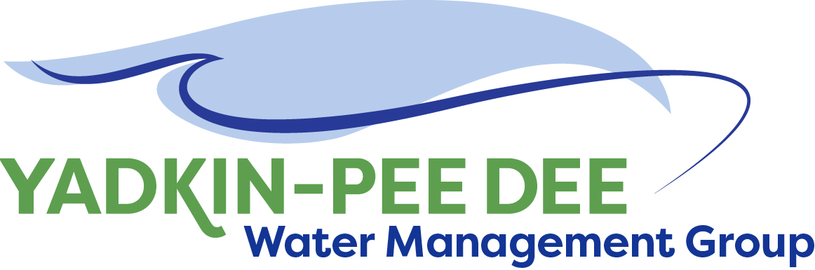
Yadkin-Pee Dee Water Management Group

AGENDA
Yadkin-Pee Dee Water Management Group Meeting
1:00PM to 2:30PM, October 8, 2020
via Zoom: Link
City of Albemarle
Water & Sewer Authority of Cabarrus County
City of Charlotte
City of Concord
Cube Yadkin Generation
Davidson County
Davidson Water, Inc.
Davie County
Duke Energy
City of Kannapolis
City of Monroe
Montgomery County
Rowan County
Salisbury-Rowan Utilities
City of Statesville
Union County
Town of Wilkesboro
City of Winston-Salem/
Forsyth County

Welcome and Review of Agenda Jim Behmer, Chair
- Approve minutes from August meeting

YPDWMG Strategy Conversation Warren Miller / All
- Assessment of organization today
- Strategic priorities for 2021

HDR Update Jonathan Williams
- Water Resources Plan update
- Future work options

Other Updates Bill Brewer/ All
- Roundtable updates from each member
- YPDWMG financial update

Adjourn

