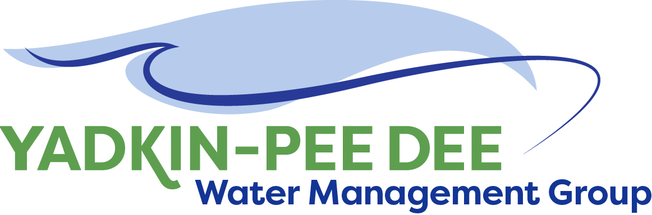
Yadkin-Pee Dee Water Management Group

AGENDA
Yadkin-Pee Dee Water Management Group Meeting
12PM to 2:30PM, October 10, 2019
W. Kerr Scott Dam and Reservoir
499 Reservoir Rd. Wilkesboro, NC 28697
City of Albemarle
Water & Sewer Authority of Cabarrus County
City of Charlotte
City of Concord
Cube Yadkin Generation
Davidson County
Davidson Water, Inc.
Davie County
Duke Energy
City of Kannapolis
City of Monroe
Montgomery County
Town of Norwood
Rowan County
Salisbury-Rowan Utilities
City of Statesville
Union County
Town of Wilkesboro
City of Winston-Salem/
Forsyth County

Welcome and Review of Agenda Bill Brewer, Chair
- Lunch will be provided
- Approve minutes from August 2019 meeting

Funding 5B of the Visioning & Planning Guide Jonathan Williams/All
- Vote to approve as special project

Communication Plan Kick-Off Sabrina Colon, HDR
Gathering input on stakeholder advisory committee

New Member Outreach Warren Miller/All
- Explore the possibility of presenting at the March 2020 South Carolina
Environmental Conference in Myrtle Beach, SC
Administrative Items Bill Brewer
- YPDWMG financial update

Group Member and Other Updates Bill Brewer/All
- Roundtable updates from individual members
- State’s letter of commitment to the group

Discussion of Next Meeting Agenda All

