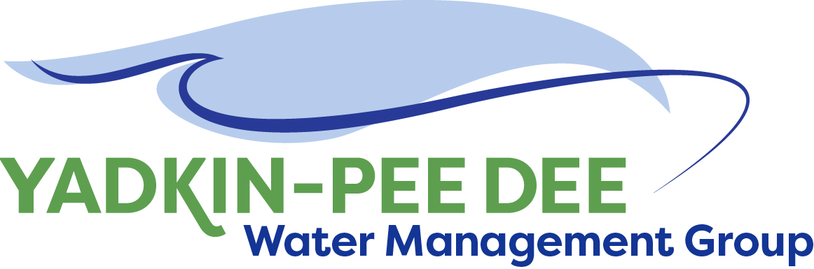
Yadkin-Pee Dee Water Management Group

Meeting Summary
Yadkin-Pee Dee Water Management Group Meeting
12PM to 2:30PM, October 10, 2019
W. Kerr Scott Dam & Reservoir
499 Reservoir Rd. Wilkesboro, NC 28697

Action Items
The following action items were identified by the Group at the meeting:
- The next YPDWMG meeting will be held on Thursday, December 12th, 2019 in Salisbury.
- W. Miller to send out the Communications and Outreach Plan on behalf of HDR via email for feedback and edits.
- W. Miller to get in contact with Scott Harder at SC DNR about speaking at an upcoming meeting.
- HDR to type up notes from the group conversation on the Stakeholder Advisory Committee and send them out via email prior to the next meeting.
- HDR to draft an outline of the Stakeholder Advisory Committee charter and send it out via email for comment and review from the group.
- W. Miller to prepare a draft letter from YPDWMG to Duke confirming the group’s commitment of funding for Phase 5B of the Visioning and Planning Document.

Welcome and Approval of Minutes
Jim Behmer, filling in for Chair Bill Brewer, called the meeting to order at 12:17 pm. The members approved the meeting minutes from the August 8, 2019 meeting.

Funding 5B of the Visioning and Planning Guide
Ed Bruce of Duke Energy and Jonathan Williams of HDR reviewed the following with the Yadkin-Pee Dee Group Members.
Duke Energy identified additional funding for this calendar year budget that the group could use to accelerate the timeline for the Water Resources Plan. J. Lineberger, E. Bruce and B. Brewer, in consultation with J. Williams suggested focusing on Phase 5B of the Visioning and Planning Guide prepared by HDR. J. Williams: High level overview:
  - The benefit of focusing on phase 5B: Advancing the water quality portion will advance the overall process. You can see the full scope by clicking the link above.
  - There will be a technical memorandum in the Water Resources Plan as an appendix. Sabrina Colon (HDR) will be working with the group to assemble a stakeholder advisory committee and HDR could incorporate this work into that process.
    - The Steering Team and Duke Energy thought it was a good idea if Duke Energy could get a small contribution from other members. Duke Energy will provide $20,000 of the $30,000 and if other members match up to $5,000 additional dollars (5 members at $1,000 each) Duke Energy will contribute $25,000. This is a special project. Members are not obligated to participate.
    - Anticipate beginning the project in early 2020 and wrapping it up middle of next year. If the group chooses to move forward with it, as HDR starts to develop those scenarios and modelling, this might help inform some scenarios.
    - The YPDWMG voted to add Phase 5B of HDR’s Visioning and Planning Guide as a special project – G. Greene motioned for the group to move forward. A. Lofton seconded. No one opposed. All in favor.

Action Items:
    - YPDWMG will send a formal letter confirming its financial commitments to Duke Energy so they can authorize a check be sent to the group. This needs to be done by mid-December. YPDWMG will have access to the money in 2019.

Communication Plan Kick-Off
Sabrina Colon of HDR reviewed the following with the YPDWMG. (Additional Slides can be found here under the 10/10 meeting).

YPDWMG understands the importance of fostering open communication between the project and its various audiences to gain productive input, which will lead to better decisions that meet the community’s needs.

- Strategic Communications & Outreach Plan
- YPDWMG is committed to working with the community to ensure their concerns and aspirations are directly reflected and provide feedback on how public input influenced the decision. The group is on board with this commitment.
- Stakeholders- We will have tiers of stakeholders and we will have separate plans for how we coordinate with them. The timeline will put people into different groups.
  - Member organizations and utilities
  - Basin watershed groups
  - Regulatory agencies
  - Municipalities and local elected officials
  - Advocacy
  - Economic development organizations
  - School districts
  - Media
  - Recreational river users
  - General public
    - The group wants to add Agriculture, Industry, Academic and make ‘municipalities’ into ‘local governments.’
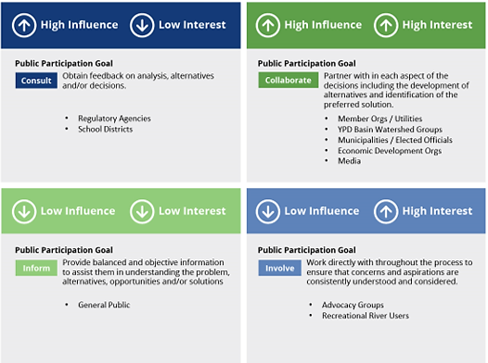
The Stakeholder Matrix

- Communications Tactics
- Categories
- Building Out Internal Ambassadors
- Branding/Messaging Guides
- Elected Officials/Executive Leadership Packets – Getting information to them so they can talk about the issue.
- Project Reports – How are we doing reporting moving forward?
- Online Communication – How are we putting the information on the site? We are going to work with W. Miller to build out the section.
- Community Events – Who is already talking about the things we are discussing here? We can be where people are that are already interested.
- Email and Direct Mail Campaigns
- Targeted Special Outreach
- Social Media - How can we activate our social media presence?
- K-12 Education Series

- What is the amount of money the group has going toward the Strategic Communications Plan?
- HDR included a budget of $8,960 for the Strategic Communications Plan over the next 6 months.

- Stakeholder Advisory Committee
The group identified the criteria for those who will be on the stakeholder advisory committee: Members on the stakeholder advisory committee must have a vested interest in the Basin. These are people who have done work in the Basin and have some level of technical expertise. The group brainstormed the categories that should have representation on the advisory committee. The draft list below shows these categories.
- Agriculture, Forestry, Irrigation Interests
- Local Government – Could include COGS
- Academic – Higher education
- Regulatory Agencies – Soil and Water Districts here
- Industry and Economic Development Interests
- Water Based Recreation Interests
- Environmental Interests – Could include Foundations
- At Large Water Basin Interests – Could include a “SC at Large” Representative and an “NC at Large” Representative

Action Items
- HDR will send out a draft communications plan via Fountainworks for feedback from the Group.
- HDR will type up notes from the group conversation and give the notes to the group prior to the next meeting for reactions and feedback.
- HDR will start working on the outline of the charter for the Stakeholder Advisory Committee and ask for group feedback via email.

New Member Outreach

- W. Miller: At the South Carolina Environmental Conference in March we will try to set up a meet and greet. We will encourage anyone who can come to be there. The purpose of this effort is to talk to South Carolina water managers/utility directors who are in the Pee Dee Basin about joining the YPDWMG.
  - Outreach Plan: Each meeting we will try to meet with the utility director and the manager to tell them about the group and invite them to upcoming meetings.
  - We have scheduled a meeting with Albemarle at the end of this month. We want to make sure we keep our current members, as well as add new members.
- J. Behmer: Rural Water Region 3 is having a meeting at the zoo next Thursday. I will be there to see who I can meet.
- J. Williams: We will be encouraging South Carolina stakeholder committee members to reach out to their folks to come the SC meet and greet in March.

Administrative Updates
- B. Brewer is not present and did not share financial update. Financials will be sent to the group before the next meeting.
- Fountainworks: Group Administration Items
- We will be rescheduling the February 13th meeting because of the Regional Water Summit for the Catawba Basin. The meeting in February will move to the Southern part of the Basin. Union County will host.
- On the steering committee call, the question was posed about the possibility of having a joint meeting with the river basin group. Is there feedback or discussion on that? Is that something the group wants to do?
  - The group thinks it would be good to have a milestone meeting with this group. One option would be when the results of the GAP analysis by HDR is completed.
- Are there speakers the group thinks may be helpful to invite to a YPDWMG meeting next year?
    - Scott Harder or Ken from SC DNR to update the group on the South Carolina river basin planning efforts. They are the convening agency doing this in SC. Fountainworks will reach out to Scott Harder.
- The State Conservationist to share information about the Regional Conservation Partnership Program (RCPP) Funding. If individual members are seeking funding through this process they should reach out to the State Conservationist and talk to them.
- Three Rivers Land Trust – maybe at the same time as state conservationist – to be briefed about their initiatives.
- A speaker to talk about the water resources planning work being done on the Catawba.
- Dr. John E. Wear, Jr., Director of Catawba Center for the Environment

Action Items
- W. Miller to contact Scott Harder at SCDNR about speaking at an upcoming meeting.

Member Updates
Union County: Union County is making progress on the Yadkin water supply project. The estimate was $220 million, and the actual cost is $285 million. The county has a retreat with the Board next month to pitch their proposal to them. Union County cannot grow without that water source. Union County is hoping to schedule the CHEOPS modelling training. As soon as the county can coordinate it everyone in this group would be invited.
Salisbury-Rowan: The water plant is under construction. Almost done with the centrifuge.
Statesville: Jason Green, the water plant supervisor, turned in his resignation last week. Statesville is looking for a new water plant supervisor.
Duke Energy: The South Carolina Planning Process Advisory Committee has finished work on a planning framework for setting up a river basin council and it is on the website for that team – hosted by Clemson Water Resources Center. The Edisto Basin hopes they will have a river basin council established, a facilitator hired, and a process underway by November. An issue: Permitting is required in South Carolina as of 2010. It requires a city or industry to get a permit from the state before they put in an intake. For agricultural use it is only a registration. It is necessary that the Edisto be the first Basin to do the plan. Representatives from the Edisto Basin said they would sponsor the request. SC DNR has $1.3 Million to do River Basin planning. They don’t think it will take $1.3 Million to do the plan for the Edisto. Pee Dee has been talked about as one of the next basins that will develop a plan.
Duke Energy formed a stakeholder team on Lake Tillery as the result of a bad public meeting. We were trying to figure out if there are there things Duke could do by itself or with partners to make the lake more usable to more people more of the time. We are looking at dock modifications or changes to shoreline management guidelines. We want to reach deeper water with the docks. There are lots of floating debris problems with that lake.
Cube Hydro: On September 21st community members around High Rock organized a clean sweep committee. There were 22,000 pounds of trash collected– lots of tires and debris. The water levels are low, especially Baden.
Cube Hydro is now owned by Ontario Power Generating and we are combined with Eagle Creek out of New Jersey. The combination of Eagle Creek Renewable Energy and Cube Hydro makes us Ontario Power Generating’s US platform.
Charlotte: Keeping up with growth and the costs associated continue to be a challenge. Charlotte can’t pay for all the wish list of items. We have some big projects currently. We are going to build a new regional wastewater plant. We made an agreement with a town across the Catawba river to treat their wastewater and take their plant offline. We have an agreement with another town to add to that agreement.
There needs to be a plan for evaluating interconnectivity of systems. Rock Hill, our neighbors to the south, lost a big main in their system and lost their system yesterday. They are connected to Charlotte but we didn’t have an adequate feed to keep them from losing their system. You can plan for emergency connects. We are talking to Union county to try to get one in this week. A lot of the systems around us are trying to connect.
Non-Member Updates
Army Corps: We are interested in the educational outreach YPDWMG is planning. USACE has a mandate to be in all the schools in this county and every county that touches this county. We are already active with the environmental education center. One of our goals is to eventually make a mobile education unit. Our mandate is to engage underserved, underprivileged schools. Regionally that’s most of the schools and counties in the area.

Adjournment
The meeting adjourned at 2:37 PM

Meeting Attendees
Karen Baldwin, Cube Yadkin Generation
Ron Hargrove, City of Charlotte
Johnny Lambert, Davie County (phone)
Jeff Lineberger, Duke Energy
Ed Bruce, Duke Energy
Eric Johnson, Montgomery County (phone)
Greg Greene, Rowan County
Jim Behmer, Salisbury-Rowan Utilities
Andy Smith, City of Statesville
Aubrey Lofton, Union County
Sam Call, Town of Wilkesboro

Non- Member Attendees:
Warren Miller, Fountainworks
Tara Nattress, Fountainworks
Jonathan Williams, HDR, Inc.
Sabrina Colon, HDR, Inc.
Thomas Nicholson, USACE

