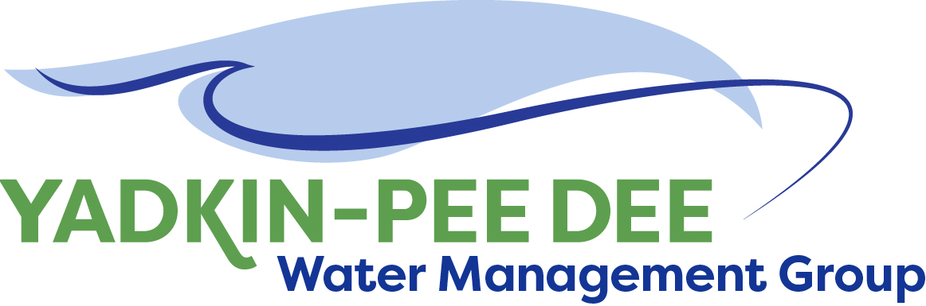
AGENDA
Yadkin-Pee Dee Water Management Group
12:00PM – 2:30PM, December 8, 2021
Hybrid: In-person at Salisbury-Rowan Utilities & via Zoom
City of Albemarle
Water & Sewer Authority of Cabarrus County
Charlotte Water
City of Concord
Cube Yadkin Generation
Davidson County
Davidson Water, Inc.
Davie County
Duke Energy
City of Kannapolis
City of Monroe
Montgomery County
Rowan County
Salisbury-Rowan Utilities
City of Statesville
Union County Water
Town of Wilkesboro
Winston-Salem/
Forsyth County Utilities

Welcome J. Behmer/ All
Roundtable Discussion J. Behmer/ All
Approval of October Meeting Minutes J. Behmer/ All
Chair & Vice Chair Nominations & Vote W. Miller/ All
- Current Chair Nominations: Aubrey Lofton (Union County)
- Current Vice-Chair Nominations: Rusty Campbell (Concord)
Duke Energy Additional Contribution J. Behmer
HDR Scope of Work J. Williams/J. Behmer/ All
Review 2021 Annual Report W. Miller/ All
Nonprofit Subcommittee W. Miller/ All
If time permits: 1-2 year tactical goals J. Behmer/ W. Miller/ All

