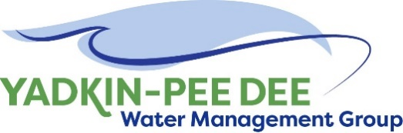
Yadkin-Pee Dee Water Management Group

Meeting Notes
Yadkin-Pee Dee Water Management Group
10:00 AM-12:30PM, December 1, 2022
Hybrid: Zoom & at Salisbury-Rowan Utilities
Agenda
- Welcome
- Approval of October Meeting Minutes
- Nonprofit Incorporation Update
- Chair/Vice-Chair Nominations
- Water Resources Plan Update
- SC River Basin Council Update
- Roundtable Discussion
- Next Steps & Adjourn
Welcome
Chair Aubrey Lofton welcomed participants, briefly reviewed the agenda, thanked Jim Behmer and Salisbury-Rowan Utilities for hosting.
August Meeting Minutes Approval
Next, Chair Lofton asked for a motion to the approval of minutes from the Group’s October meeting. The minutes were approved unanimously.
Nonprofit Incorporation Update
Maddie Shea of Fountainworks updated the Group on the nonprofit incorporation process. Fountainworks had previously met with Barry Gullet, who was involved in the formation of the Catawba-Wateree Water Management Group. Gullett provided valuable advice, which includes the creation of a memo from all involved attorneys that 1.) outlines the work that’s been done so far, 2.) references the bylaws and articles of incorporation, and 3.) recommends no additional changes to the wording. Gullet also recommended that the Group create a draft resolution, which references the attorney memo, to be passed by each member in order to join the new, incorporated version of the YPDWMG.

The Steering Committee agreed on an aggressive timeline to move this effort forward before the June 30, 2023, deadline from Winston-Salem. Shea reviewed the timeline, shown below:

- Thurs. December 1, 2022: Share timeline at YPDWMG meeting
- Fri. December 2, 2022: Share bylaws (with comments from Winston-Salem and Duke Energy) via Google Doc, request comments from additional member attorneys by December 16, 2022
  - 2 week deadline
  - If we do not receive comments, the Group will move forward with the assumption that members are satisfied with the content of the bylaws and the overall proceedings.
- Fri. December 16, 2022: Comments on bylaws due
- Over holidays/early January: Fountainworks to reconcile comments
- Week of Mon. January 16, 2023:
  - Conference call with all attorneys to resolve any remaining issues & get concurrence
  - File articles of incorporation
- Fri. January 27, 2023: Share
  - Articles of incorporation
  - Draft attorney memo
    - 3 week deadline to collect signatures
    - Signed by February 17, 2023
  - Circulate draft resolution
    - 9 week deadline
    - Approval by March 31, 2023
- Fri. February 17, 2023: Attorney memo signed by all involved attorneys
- Fri, March 31, 2023: Resolution approved by all members
- Fri. June 30, 2023: Ultimate deadline to incorporate

Lofton reiterated the importance of members getting involved and pushing this effort forward, noting that the deadline will be here before we know it. Several other Group members echoed her statement.

Fountainworks will support the coordination of this effort and has shared draft email language for each member to send to their respective attorneys. For questions, please contact maddie@fountainworks.com.
Chair/Vice Chair Nominations
Shea continued by noting that at the end of each calendar year, the Group chooses a Chair and Vice Chair for the following term. Since, however, the Group is in a transition phase and expects to look different in six months, the Steering Committee had discussed the possibility of Aubrey Lofton extending her term as Chair. Jim Behmer offered to serve as Vice Chair, since former Vice Chair Rusty Campbell recently left his position with Concord for a new opportunity with Garver. Shea reminded the Group there is precedent for extended leadership terms but still invited additional nominations.

Ron Sink made a motion for Lofton and Behmer to serve as Chair and Vice Chair, respectively, until the end of the fiscal year. Bill Brewer seconded the motion. With all in favor and none opposed, Aubrey Lofton and Jim Behmer were elected Chair and Vice Chair through June 30, 2023.
Water Resources Plan Update- HDR
Sara Yeh of HDR then provided several brief updates on HDR’s ongoing work. Yeh’s slides were emailed out following the meeting. Phase 4a of the Water Resources Plan involves conducting the initial group of future planning scenario analysis, along with ongoing stakeholder communication and outreach.
After delays, the OASIS model is now available on a public server. To gain access, submit a request to dwr-yadkinlumberstaff@ncdenr.gov or neelufa.sarwar@ncdenr.gov.
Yeh noted that there is a possibility of making updates to the model based on House Bill 951, and passed the meeting discussion to Ed Bruce of Duke Energy, who provided an overview of what’s motivating the changes. Bruce explained that since the scenarios were first developed in 2019, much has changed, including Duke Energy moving toward carbon-free generation. HB 951 requires Duke Energy to show how it will meet its goals. Small modular nuclear reactors (SMRs) are the primary way in which the utility plans to meet its net-zero carbon goals. The following slide outlines the proposed changes.
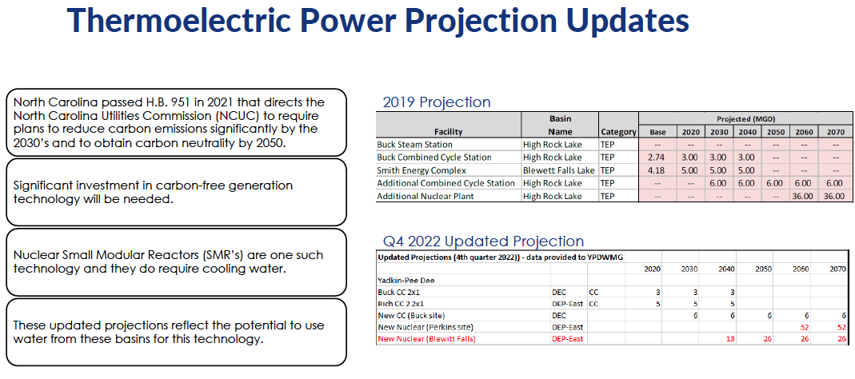
After a few clarifying questions, the Group agreed that HDR should add these updated projections into the model. Yeh noted HDR looks forward to sharing initial results in February 2023. A brief discussion followed her presentation.
SC River Basin Council Update
John Crutchfield of Duke Energy provided an update on the SC River Basin Council. Meetings so far have been primarily formational and informational but are now getting into the methodology for demand water projections. Aubrey Lofton noted that SCDNR had reached out to her as the Chair of the YPDWMG, along with Sara Yeh of HDR and Steve Nebiker of Hazen and Sawyer about how to use outputs from HDR’s modeling efforts as an input for South Carolina’s own modeling. SCDNR will be directly contracting with HDR to do this work, hoping for results in January/February.
Roundtable
Next, Lofton opened the meeting up for the Group’s roundtable discussion. Not all comments were captured, but a few highlights are captured below:
- Lofton noted that Union County is undergoing a political transition, and new board members may be looking to roll back rate increases that were recently approved.
- Jim Behmer noted that Salisbury is seeing a slowdown of the number of spec buildings being built in the area.
- Jonathan Williams noted that he had recently hired Rusty Campbell at Garver.
- Bill Brewer of Winston-Salem noted that his organized has a 20-25% vacancy rate. He also shared that the upgrade to the Neilson Water Treatment Plant is going well.
- Andy Smith of Statesville shared that his organization is also working with FEMA after a storm took out some motors and pumps. Smith also shared that many townhouses are being built in the area.
- Ron Sink of Davidson Water has noticed a little pullback on subdivision development. He remarked on the industrial development frenzy coming to North Carolina with the announcement of the Toyota battery plant and Vinfast. Because they don’t want to compete for labor, suppliers of these giant plants may not be directly next door but will be built in neighboring areas.
- Sara Yeh noted that HDR would be presenting at the One Water Conference.
- Edgar Miller shared that the Yadkin Riverkeeper has produced a detailed map of access points on the Yadkin River. He noted that he is involved the in High Rock Lake Nutrient Rulemaking process on the Steering Committee and shared that local government and drinking water interests are not particularly well represented. Miller also noted that High Rock Lake has been drawn down for repairs.
- Johnny Lambert noted that bids for a new water treatment plant in Davie County came in much higher than anticipated. Like Andy Smith, Lambert is also seeing lots of townhomes being built.
- David Saunders of HDR shared a few brief slides on the High Rock Lake Nutrient Rulemaking process, noting that stormwater interests could also use more representation.
- John Crutchfield of Duke Energy noted for those on the Tillery Plant tour at the last meeting that two hydro unit runners are being replaced with aerating runners, along with other updates to infrastructure, including migratory fish passage facilities at the Blewett Falls Hydro Plant.
Next Steps and Closing Announcements
Before the meeting closed, Aubrey Lofton reminded members of the importance of the nonprofit incorporation process and that more direct involvement would be required of members. Meeting dates for February, April, and June of next year will soon be sent out. The meeting adjourned at 1:45 PM.
Meeting Attendees
Joyce Foster, Cube Yadkin
Ron Sink, Davidson Water
Johnny Lambert, Davie County
Ed Bruce, Duke Energy
John Crutchfield, Duke Energy
Gerald Faulkner, City of Kannapolis
Andy Smith, City of Statesville
Jim Behmer, Salisbury-Rowan Utilities
Josh Canup, Rowan County
Aubrey Lofton, Union County
Hyong Yi, Union County
Bill Brewer, City of Winston-Salem

Non-Member Attendees:
Maddie Shea, Fountainworks
Rusty Campbell, Garver
Jonathan Williams, Garver
David Saunders, HDR
Sara Yeh, HDR
Edgar Miller, Yadkin Riverkeeper

