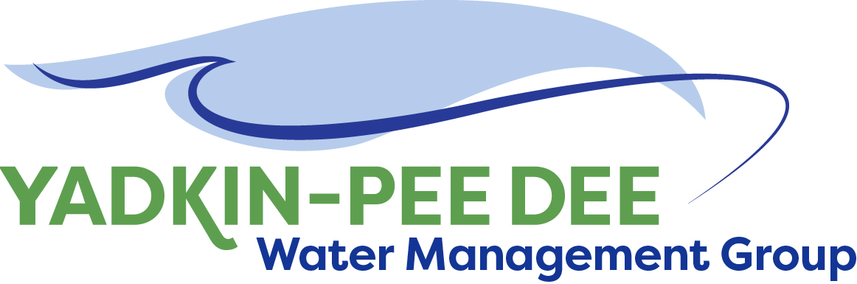
Yadkin-Pee Dee Water Management Group
Meeting Notes
Yadkin-Pee Dee Water Management Group Meeting
12:00PM to 2:30PM, December 8, 2021
Hybrid Meeting (In-person & via Zoom)

Agenda
- Welcome & Review of Agenda
- Roundtable Discussion
- Approval of October Meeting Minutes
- Chair & Vice Chair Nominations & Vote
- Duke Energy Additional Contribution
- HDR Scope of Work
- Review 2021 Annual Report
- Nonprofit Incorporation
- If time permits: 1-2 year tactical goals

Welcome & Review
Chair Jim Behmer of Salisbury-Rowan Utilities opened the meeting and thanked participants for joining today, both virtually and in-person. Behmer then discussed the agenda for the day (see above).

Roundtable Discussion
Next, Jim Behmer opened the group to bring any items to a roundtable discussion.
- Jim Amaral of Salisbury-Rowan Utilities (SRU) shared that SRU has created additional roles for their water plants, and that the organization is creating internal certifications to use as a recruitment tool.
- Alex Anderson of City of Kannapolis shared that the city has open positions that need to be filled.
- Andy Smith of City of Statesville shared that Statesville is working with FEMA on the Yadkin on getting equipment. His utility is fully staffed and has recently completed some new hires.
- Johnny Lambert of Davie County shared that the county has recently filled two positions. Davie County is beginning to hire uncertified operators and then raining them. The organization is wrapping up a large project to send wastewater to Winston-Salem. Its water treatment plant project is being handled by Hazen & Sawyer. Lambert noted he is paying close attention to the impacts of the Infrastructure Investment and Jobs Act (IIJA) for utilities.
- Ron Sink shared that his utility, Davidson Water, is currently managing a number of projects. The largest current project is bleach conversion, which is being extended due to plastic resins and other parts that are delayed several months. Sink expressed concern for the supply of chlorine gas disinfectant. A letter about this topic was recently sent to the hierarchy of AWWA, and its security council is monitoring the status of the supply. Sink noted the value of industry association. Sink noted he foresees lots of growth in the region over the next 20 years, especially with the recent announcement of the Toyota battery facility
- Jonathan Williams of HDR echoed others’ struggles with the current workforce. In his role at mayor of the Town of Spencer, he noted the town opened its new town hall and police department and is moving forward with the Yadkin River trailhead.
- Aubrey Lofton of Union County Water shared that Union County is building 40 miles of pipe and is out of sewer capacity in most of its service areas. The utility has approved its AMI project, which is fully funded and moving forward with implementation over the next 18-24 months.
- Jim Behmer of SRU announced his move to Director of Raleigh Water. Jason Wilson will serve as interim Director for SRU, and Jim Amaral will be involved in the YPDWMG.
- Russell Colbath of City of Monroe noted that David Rankin has been named alternate for YPDWMG as Colbath moves toward retirement. Monroe is experiencing a balanced growth in new industry, commercial, and residential. The city currently has three master planning processes occurring simultaneously. Monroe is working with Union County on a potential partnership, as both governing boards have expressed interest creating a 50-60 year agreement.
- Ed Bruce of Duke Energy shared that Blues Lake will be drawn down for most of 2022 for project work. He also shared that it appears that Yadkin Pee-Dee Basin, like the Catawba, is nearing low inflow protocols.
- Joyce Foster of Cube Yadkin echoed Bruce’s comments about low inflow protocols.
- Bill Brewer of Winston-Salem shared challenges with a plant upgrade.
- Edgar Miller of Yadkin Riverkeeper stated that his organization is focused on fundraising this fall. The Riverkeeper has hired a new employee, Grace Fuchs. Miller shared project updates including a stakeholder process, acquisition of the Shallowford site, and access improvements to the river trail from Wilkes County to Lake Tillery.
Ron Sink moved to approve the October meeting minutes. The motion was seconded by Aubrey Lofton and unanimously approved by the Group.

Chair and Vice Chair Nominations & Vote
Next, Jim Behmer invited the group to propose nominations for chair and vice chair positions. No additional nominations were made besides the existing nominations. Aubrey Lofton of Union County was nominated for Chair; Rusty Campbell of City of Concord was nominated for Vice-Chair. Johnny Lambert made a motion to approve the nominations; the motion was seconded and unanimously approved. Aubrey Lofton and Rusty Campbell now serve as Chair and Vice-Chair of the Group, respectively.
Warren Miller of Fountainworks highlighted Jim Behmer’s contribution to the YPDWMG over his extended term. Behmer shared that he was proud of the Group’s recent collaboration with the Yadkin-Pee Dee River Basin Association. Behmer presented Lofton with a gift from the Duke Energy Water Resources Fund.

Duke Energy Additional Contribution
Next, Behmer shared that Duke Energy had graciously agreed to contribute an additional $5,000 toward project work in accordance with the Group’s MOU. Several other organizations have made verbal commitments to help match this contribution.

HDR Scope of Work
Next, HDR provided updates on the Stakeholder Advisory Committee and its Proposed Scope of Services.

Stakeholder Advisory Committee Update
Sara Yeh of HDR shared that the Stakeholder Advisory Committee (SAC) met on December 7th. The primary topic was the evaluation of model results and determining performance measures for once the model is complete. These performance metrics are measures of comparison between the base case of how water flows within the basin compared to various planning scenarios chosen by the Group last year. HDR presented a few alternatives for performance measure categories.

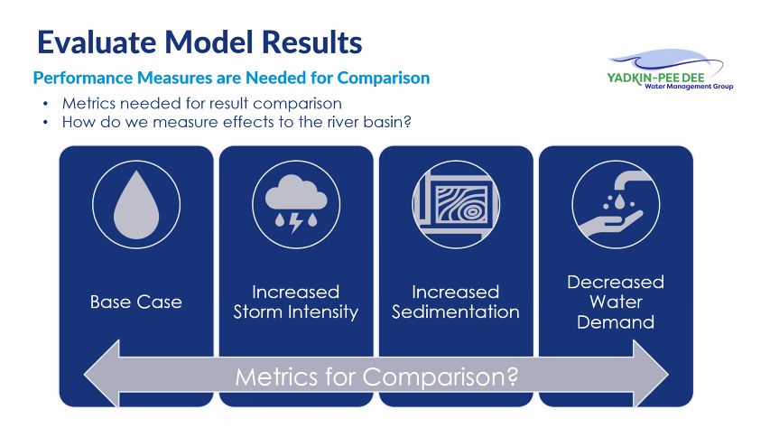

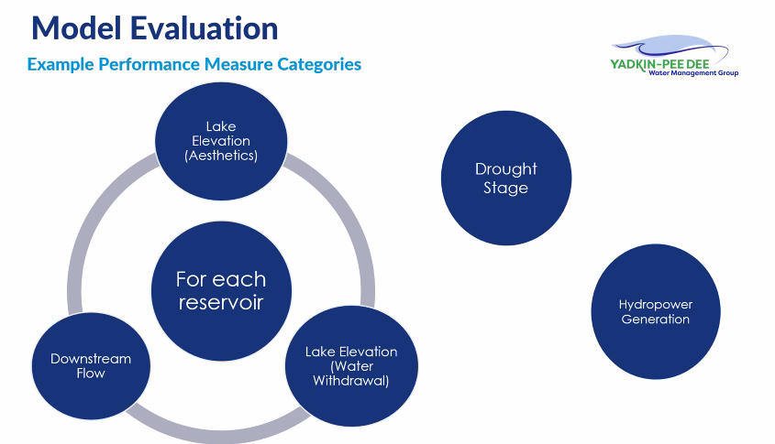
Example performance measure categories revolve for each reservoir. They also include drought stage and impacts toward hydropower generation. The measures would serve as ways to evaluate future planning scenarios. Additional performance measure categories include recreational use, algal bloom/HABs, tributary flows, fishery resources/aquatic habitat, and flooding impacts.

At the December 7th SAC meeting, stakeholders discussed initial categories and HDR conducted a pulse check about what is most important for the model evaluation. The initial results are shown below. Yeh noted that the last two items (algal blooms and recreational flows) were added after the exercise.
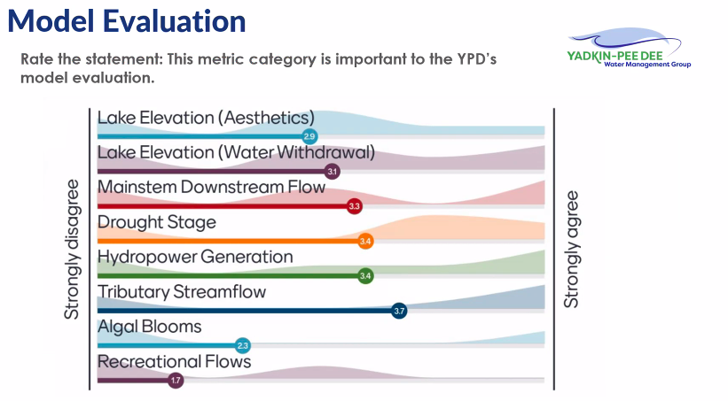

The next steps are to gain additional feedback from SAC members, develop draft performance measures and metric criteria with YPDWMG, and review the draft measures with the SAC.

Task Order Update
Jonathan Williams of HDR noted that of the 15 scenarios, some are water quality and some are water quantity based. Over next year, the state OASIS model is focused on water quantity. Components of the model involve the baseline case. The model compares the baseline case to future water supply demands. HDR seeks to evaluate the sustainable water yield within the basin. As noted above, HDR is also working to develop performance metrics to measure scenarios against the baseline to develop an impact analysis. The proposed scope of services has been sent via email to Group members.

Williams reviewed a proposal for 2022 that would allow HDR to move forward and interpret results of the model. The next steps are to get agreement with metrics, conduct modeling, and compare results.
In addition to modeling support, HDR also has proposed a continuation of its Strategic Communications work. Sabrina Colón’s team at HDR would need to periodically update the resource library kit. If the scope of services is approved, the next SAC meeting would be in March 2022.

Pam Behm of DEQ expects to be able to move forward with model hosting in the near future, but shared that it may be helpful if a letter is sent to the Division director that indicates the YPDWMG’s desire to move forward.

Jeff Lineberger noted that the state’s upgraded server is based on a new platform, and it is upgrading old models to the new server. HDR expressed that they can break their scope of work into phases throughout the current and next fiscal years based on funding availability.

The Steering Committee will prepare a letter to the state by the end of the year. Based on the response from the state.

Review 2021 Annual Report
In the spring, Group members expressed interest in creating an annual report to share with managers and governing boards. In August, Fountainworks presented an initial draft of the Next, Warren Miller reviewed the updated draft report, which has been shared via email with all participants.
Johnathan Williams noted feedback on the timeline and other initiatives past Phase 3 (Water Supply Study). Jeff Lineberger noted that it would be helpful to have a graphic that shows the entirety of the Basin, which would emphasize the Group’s impact on such a large portion of North Carolina’s population.
Fountainworks will incorporate this feedback and send out an updated version for final feedback.

Nonprofit Incorporation
Warren Miller noted that the expressed intention of the Group is to incorporate as a nonprofit. Over the summer, the YPDWMG extended its MOU for five years to buy time to incorporate but may do so earlier. At the October meeting, Ed Bruce, Bill Brewer, and Aubrey Lofton volunteered to participate in a subcommittee that will explore the decisions and steps needed for the Group to incorporate. Miller noted that the subcommittee will begin meeting in January, and that other members are welcome.
Jeff Lineberger recounted the incorporation of the Catawba Wateree Water Management Group (CWWMG). The two groups have significant overlap in membership, and Lineberger noted this works to the YPDWMG’s advantage if it uses the CWWMG’s documents as a starting place for its own incorporation.

1-2 Year Tactical Goals
Toward the end of the meeting, Jim Behmer opened up the discussion and asked what the Group seeks to accomplish in the coming months. Jeff Lineberger shared that unlike the state of North Carolina, South Carolina does water supply planning. South Carolina has a River Basin Council (RBC) that has broad representation. The RBC has up to 25 total members. Interested organizations must apply; there is a state-level committee that makes recommendations based on applications, and SC DNR makes the final decision on which organizations will become members of the council. Currently, only the Edisto committee is underway. Lineberger expects a draft river basin plan to be ready in mid-2022. SC DNR has received additional funding and will pursue two more committees, for the Broad & Pee Dee rivers.
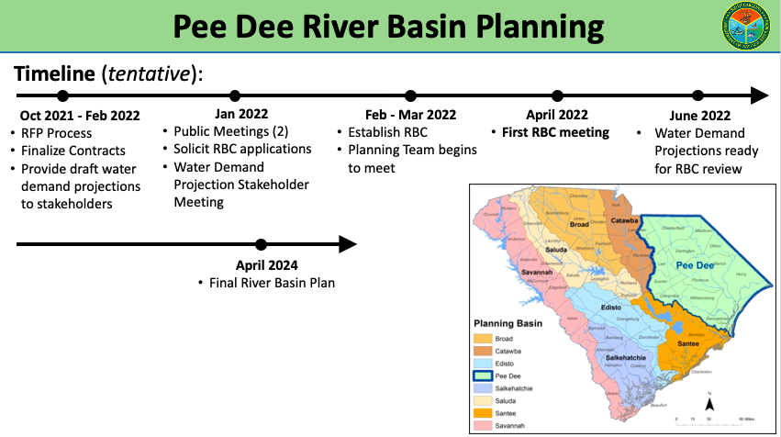
Lineberger noted that the public meetings are well-attended and well-run. If organizations are interested in serving on the Pee-Dee committee, it is nearing time to submit applications. Lineberger noted the Department has completed water demand projections across the state, which were done with good engineering and science behind them. The council will be established in spring 2022 and begin meeting in April.
To become a council member, one must live in river basin, work at facility in river basin, or represent an organization that has substantial interest in water in basin. Based on the criteria, the YPDWMG cannot have official voting representative on RBC, but it can have an advisory member. Lineberger anticipates that Duke Energy will apply and get a seat and could help voice group’s concern. He recommends setting up a rotation of other YPDWMG members to attend some of the meetings. The meetings will likely be in-person, occur monthly and take up most of a full day. Lineberger is not yet sure where the Pee Dee meetings will be held. For more information, visit this link.
Jim Behmer noted that the YPDWMG still has an interest in interstate efforts and eventual recruitment. Lineberger added that the Group has a lot to offer. Ron Sink and Johnny Lambert expressed interest in being involved in River Basin Council.

Next Steps & Adjourn
Fountainworks will use template and work with Steering Committee and HDR to draft letter to the state about OASIS model. Fountainworks will also send more information on the South Carolina River Basin Council.
The Group once again thanked Jim Behmer for his leadership and wished him well in his new position. A motion to adjourn was made and passed unanimously.

Meeting Attendees

Member Attendees:
Jim Amaral, Salisbury-Rowan Utilities
Alex Anderson, City of Kannapolis
Rusty Campbell, City of Concord
David Rankin, City of Concord
Joyce Foster, Cube Yadkin
Jason Martin, Davidson County
Ron Sink, Davidson Water
Johnny Lambert, Davie County
Ed Bruce, Duke Energy
Jeff Lineberger, Duke Energy
Russell Colbath, City of Monroe
Jim Behmer, Salisbury-Rowan Utilities
Andy Smith, City of Statesville
Aubrey Lofton, Union County
Hyong Yi, Union County
Bill Brewer, City of Winston-Salem

Non-Member Attendees:
Warren Miller, Fountainworks
Maddie Shea, Fountainworks
Jonathan Williams, HDR
Sarah Yeh, HDR
Edgar Miller, Yadkin Riverkeeper

