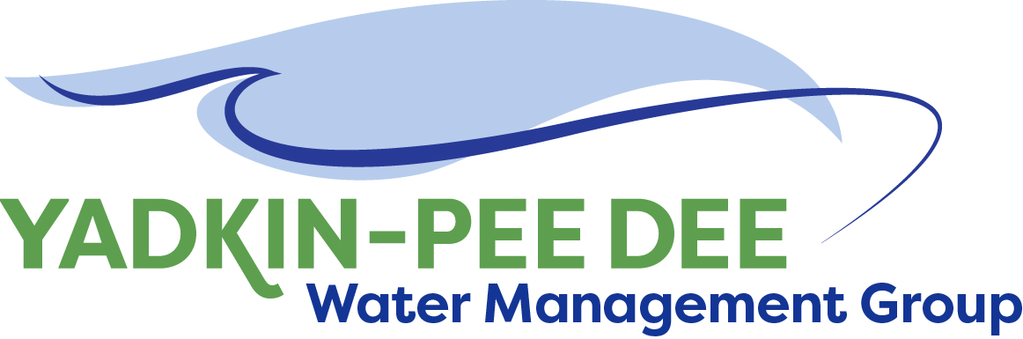
Yadkin-Pee Dee Water Management Group

AGENDA
Yadkin-Pee Dee Water Management Group Meeting
1:00PM to 2:30PM, December 11, 2020
via Zoom: Link
City of Albemarle
Water & Sewer Authority of Cabarrus County
City of Charlotte
City of Concord
Cube Yadkin Generation
Davidson County
Davidson Water, Inc.
Davie County
Duke Energy
City of Kannapolis
City of Monroe
Montgomery County
Rowan County
Salisbury-Rowan Utilities
City of Statesville
Union County
Town of Wilkesboro
City of Winston-Salem/
Forsyth County

Welcome and Review of Agenda Jim Behmer, Chair

YPDWMG Roundtable All

Administrative Items Jim Behmer/ All
- Approve minutes from August and October meetings
- Extending Chair and Vice Chair’s terms
- HDR and Fountainworks proposals

HDR and State Model Update Jonathan Williams

Preview of Structure Committee Warren Miller/ All

Yadkin-Pee Dee River Basin Association Jim Behmer

Adjourn

