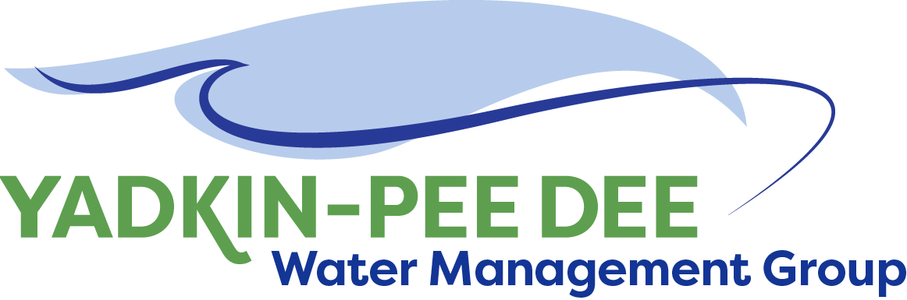
Yadkin-Pee Dee Water Management Group

AGENDA
Yadkin-Pee Dee Water Management Group Meeting
12PM to 2:30PM, December 12, 2019
Salisbury – Rowan Utilities
City of Albemarle
Water & Sewer Authority of Cabarrus County
City of Charlotte
City of Concord
Cube Yadkin Generation
Davidson County
Davidson Water, Inc.
Davie County
Duke Energy
City of Kannapolis
City of Monroe
Montgomery County
Town of Norwood
Rowan County
Salisbury-Rowan Utilities
City of Statesville
Union County
Town of Wilkesboro
City of Winston-Salem/
Forsyth County

1 Water Street, Salisbury, NC

Welcome and Review of Agenda Bill Brewer, Chair
- Lunch will be provided
- Approve minutes from October 2019 meeting

Election of Officers Bill Brewer/All

Update on DEQ Progress on Modeling Warren Miller/All

HDR Presentations – Communications Plan
and Stakeholder Advisory Group J. Williams & N. Hill

Preliminary Discussion on 2020 Strategic Priorities Warren Miller/All

New Member Outreach Updates Warren Miller/All

Administrative Items Bill Brewer/All
- YPDWMG financial update
- YPDWMG meeting structure discussion
- Discussion of schedule for 2020 meetings

Group Member and Other Updates Bill Brewer/All

Discussion of Next Meeting Agenda All

