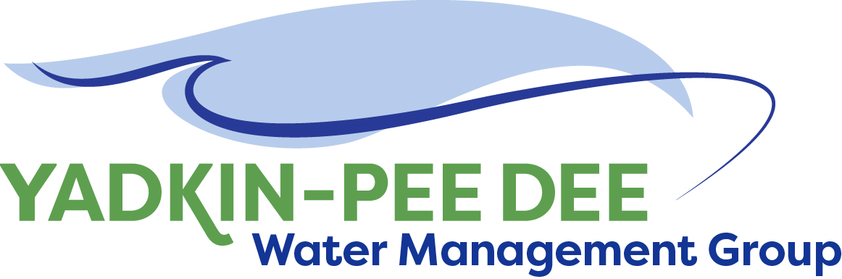
Yadkin-Pee Dee Water Management Group

Meeting Notes
Yadkin-Pee Dee Water Management Group
12:00 PM-2:30 PM, February 24, 2022
Virtual Meeting (Zoom)

Agenda
- Welcome
- Roundtable Discussion
- Approval of December Meeting Minutes
- SC River Basin Council Update
- HDR Scope of Work
- Nonprofit Committee Update
- Next Steps & Adjourn

Introduction
Chair Aubrey Lofton of Union County began the meeting by thanking everyone and briefly reviewed the agenda for the meeting. Before beginning the roundtable discussion, Lofton noted that with the uncertainty surrounding the events in Eastern Europe, utilities should be on heightened alert for cybersecurity attacks. She stated that there has been an uptick in attempted security breaches in the last six months and it is expected to rise.

Roundtable
Next, Lofton opened the meeting up for the Group’s roundtable discussion.

- Ed Bruce of Duke Energy introduced Jeff Lineberger, also of Duke Energy, to provide an update on Duke’s plans and timeline to move away from coal produced energy. Lineberger noted that this work is heavily underway, especially in the Yadkin Pee-Dee Basin; and that Duke is expected to be producing only 5% of their energy from coal by 2030, and 0% by 2035. This process will ultimately involve small nuclear power generators that will still require the use of water, meaning water from the river basin will still be needed but Duke’s needs will change. These new projections have been included in the water use projections Duke provided to HDR for their work with the OASIS model.
  - Ron Sink asked about Duke’s ability to supply enough power for the future needs of electric vehicles. Jeff Lineberger responded that him and Ed Bruce are not the right people to provide the most accurate information on that point, however it is being talked about at Duke and they would be happy to see if someone from Duke could join a future meeting to share those plans.
- Jeff Lineberger then provided an update on the creation of the South Carolina Pee Dee River Basin Council. The Department of Natural Resources (SCDNR) has responsibility over water supplies in eight basins in the state. They have drafted a plan that calls for a council in each basin to work with stakeholders and develop a long-range River Basin Plan. While YPDWMG cannot serve on the council as a member, interaction between the groups will be crucial. Two public meetings to discuss the council and identify members are set for 6pm-8pm on March 21st at Coastal Carolina University in Conway, SC, and March 22nd at Clemson University’s Pee Dee Research and Education Center in Florence, SC.
  - Aubrey Lofton and Ron Sink volunteered to be the initial YPDWMG contact points. Jeff Lineberger stated that it would be helpful for someone to attend at least one of the meetings in South Carolina.
  - Jim Behmer noted that with the SC council moving forward it may be a good time to start reaching out to stakeholders and recruiting some organizations to join YPDWMG.
- Edgar Miller of Yadkin Riverkeeper noted that NCDEQ’s 2022 Yadkin Pee-Dee Basin Plan is open to public comment currently (comment deadline is March 11), and the Group may want to pool comments as an entity.
  - Maddie Shea of Fountainworks confirmed that an email was sent out with instructions on how to provide comments.
- Edgar Miller also provided an update on the fertilizer plant fire in Winston-Salem. There are still outstanding questions regarding water quality and environmental impacts from the basin, but the investigation is ongoing.
  - Ron Sink of Davidson Water commented that they are still awaiting a full chemical inventory from the plant and that their report is forthcoming but cannot be completed yet.

December Meeting Minutes Approval
Next, Chair Lofton moved to the approval of minutes from the Group’s December meeting. Lofton asked for comments on the minutes. Ed Bruce suggested two small changes that the group agreed on. Rusty Campbell motioned to approve the minutes, seconded by Ron Hargrove. The Minutes were approved unanimously.

HDR Scope of Work
Next, Chair Lofton turned it over to Warren Miller of Fountainworks to provide an update on HDR’s scope of work for the group. Miller provided an overview of the scope of work, including $3,500 for strategic communications and stakeholder advisory committee meetings, and $44,000 for future scenario analyses. Chair Lofton noted that the current scope only includes scenarios that the Steering Committee views as essential to the Group’s work. Ron Sink made a motion to approve the scope of work and it was approved unanimously.

Following the vote, Lofton noted that the NCDEQ still has not released the OASIS model but is hoping that the approval of the scope of work will provide some pressure. Jonathan Williams of HDR commented that YPDWMG could request offline access to the model as opposed to the shared server version which is currently being waited on. It was agreed that reaching out to DEQ again is a good idea and Williams agreed to draft a letter for Lofton’s review.

Grants Update
Next, Jonathan Williams of HDR provided an update on the grant proposal processes that HDR is conducting on behalf of the Group. Williams relayed information from Bill Brewer of Winston-Salem, that the City is not comfortable taking on any other financial management responsibilities at this time. As Winston-Salem is the Administrative Agency for the Group and their willingness to manage the grant is crucial, Williams recommended pulling back on the NC Land and Water Fund grant until next year.

Williams then explained that the Steering Committee recommended pulling back on the Roberston Family Foundation grant because of the small dollar amount that it would provide. Williams recommended holding all grant proposals until next year when the Group has established itself as a nonprofit. This would give the Group its own authority over the management of grants and provide a better outlook for receiving both the Coco-Cola and NC Land and Water Fund grants.

Nonprofit Committee Update
Finally, Chair Lofton shifted to discussing the status of the Nonprofit Committee’s work. The Committee is in the process of drafting bylaws and expects to be finished before the April YPDWMG meeting to present to the Group. The Committee is using the Catawba-Wateree Water Management Group’s bylaws as a template but is making important changes to reflect YPDWMG’s needs.

Meeting Attendees
Ron Hargrove, City of Charlotte
Rusty Campbell, City of Concord
Gerald Faulkner, City of Kannapolis
David Rankin, City of Monroe
Joyce Foster, Cube Yadkin
Ron Sink, Davidson Water
Ed Bruce, Duke Energy
Jeff Lineberger, Duke Energy
John Crutchfield, Duke Energy
Jim Behmer, Salisbury-Rowan Utilities
Aubrey Lofton, Union County

Non-Member Attendees:
Sam Cathcart, Fountainworks
Warren Miller, Fountainworks
Maddie Shea, Fountainworks
Sara Yeh, HDR
Jonathan Williams, HDR
Zachary Jarvis, Linequest
Edgar Miller, Yadkin Riverkeeper
Brent Hill, organization not identified

