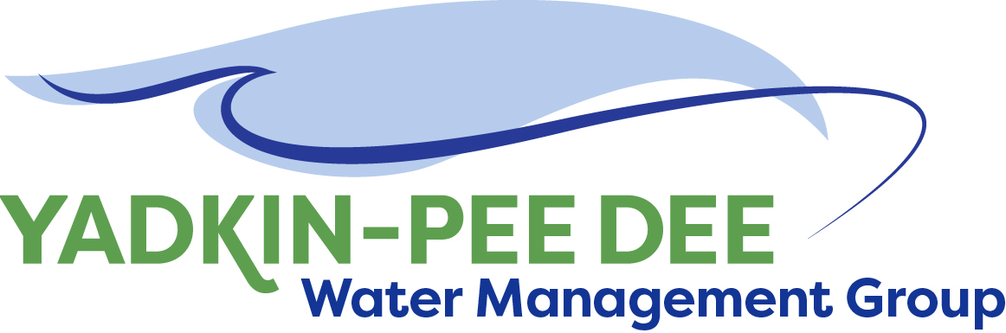
Yadkin-Pee Dee Water Management Group

AGENDA
Yadkin-Pee Dee Water Management Group Meeting
11:00AM to 12:30PM, April 1, 2021
via Zoom: Link
City of Albemarle
Water & Sewer Authority of Cabarrus County
City of Charlotte
City of Concord
Cube Yadkin Generation
Davidson County
Davidson Water, Inc.
Davie County
Duke Energy
City of Kannapolis
City of Monroe
Montgomery County
Rowan County
Salisbury-Rowan Utilities
City of Statesville
Union County
Town of Wilkesboro
City of Winston-Salem/
Forsyth County

Welcome and Review of Agenda Jim Behmer, Chair
- Approve minutes from February meeting
- Roundtable discussion

Outreach J. Behmer / All

Update from NCRWA Daniel Wilson
- NCRWA Conference
- State & national issues

HDR Update Jonathan Williams

Structure Recommendations Structure Committee / All
- Extend MOU by 5 years/completion of Water Resources Plan
  - Prepare to incorporate as a nonprofit
- Increase membership dues for mainstem reservoir operators & 10+ MGD systems

Meetings for Remainder of 2021 W. Miller / All

Working with YPDRBA Moving Forward J. Behmer / All

Adjourn

