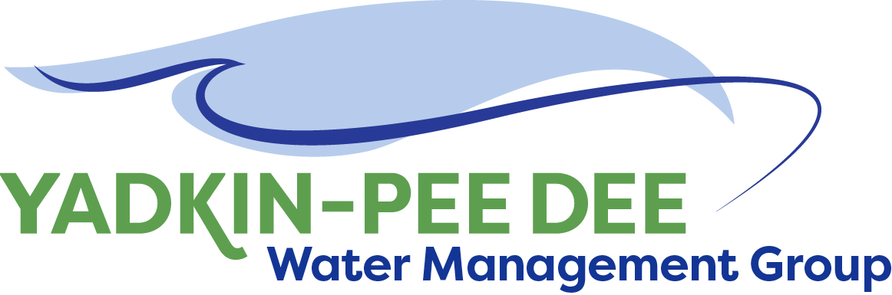
Yadkin-Pee Dee Water Management Group

AGENDA
Yadkin-Pee Dee Water Management Group Meeting
Special Meeting
1:00PM to 2:00PM, April 22, 2021
via Zoom: Link
City of Albemarle
Water & Sewer Authority of Cabarrus County
City of Charlotte
City of Concord
Cube Yadkin Generation
Davidson County
Davidson Water, Inc.
Davie County
Duke Energy
City of Kannapolis
City of Monroe
Montgomery County
Rowan County
Salisbury-Rowan Utilities
City of Statesville
Union County
Town of Wilkesboro
City of Winston-Salem/
Forsyth County

Welcome and Introduction Jim Behmer, Chair

Structure Recommendations Structure Committee / All
- Extend MOU by 5 years/completion of Water Resources Plan
  - Prepare to incorporate as a nonprofit
- Optional additional project-based fees

Adjourn

