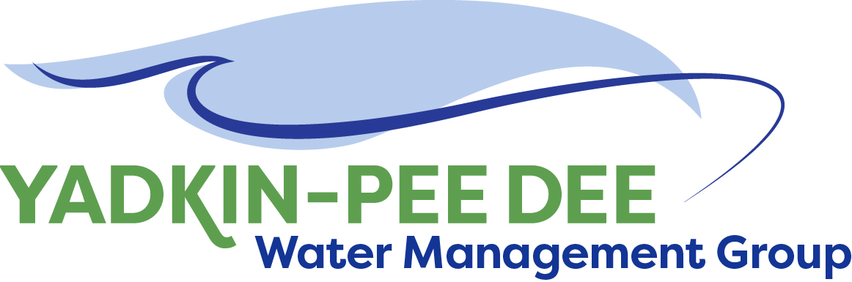
AGENDA
Yadkin-Pee Dee Water Management Group
12:00PM – 2:30PM, April 28, 2022
Union County Human Services Building
2330 Concord Ave | Monroe, NC 28110
City of Albemarle
Water & Sewer Authority of Cabarrus County
Charlotte Water
City of Concord
Cube Yadkin Generation
Davidson County
Davidson Water, Inc.
Davie County
Duke Energy
City of Kannapolis
City of Monroe
Montgomery County
Rowan County
Salisbury-Rowan Utilities
City of Statesville
Union County Water
Town of Wilkesboro
Winston-Salem/
Forsyth County Utilities

Welcome A. Lofton/ All
Roundtable Discussion A. Lofton/ All
Approval of February Meeting Minutes A. Lofton/ All
HDR: Performance Measures J. Williams/ S. Yeh/ All
Nonprofit Subcommittee Update W. Miller/ All
SC River Basin Council Update A. Lofton/ R. Sink/ All
Next Steps & Adjourn A. Lofton/ All
Post-Meeting: Yadkin Regional Water Treatment Plant Construction Site Tour

