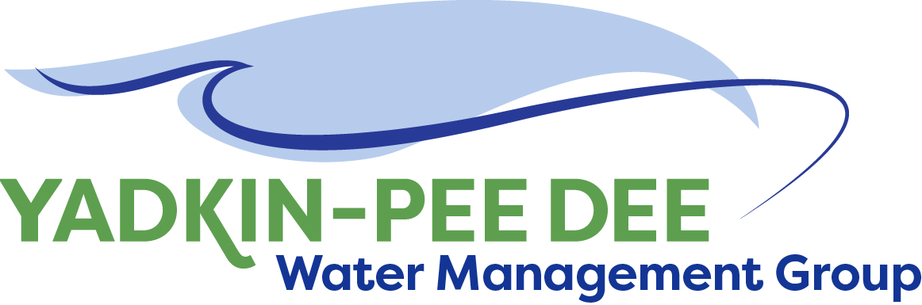
Yadkin-Pee Dee Water Management Group

Meeting Notes
Yadkin-Pee Dee Water Management Group
12:00 PM-2:30 PM, April 28, 2022
2330 Concord Avenue, Monroe, NC 28110 & via Zoom

Agenda
- Welcome
- Roundtable Discussion
- Approval of February Meeting Minutes
- HDR: Performance Measures
- Nonprofit Committee Update
- SC River Basin Council Update
- Next Steps & Adjourn
- Post Meeting: Yadkin Regional Water Treatment Plant Construction Site Tour

Welcome
Chair Aubrey Lofton of Union County began the meeting by thanking everyone and briefly reviewed the agenda for the meeting. Lofton noted that following the meeting, there would be a tour of the Yadkin Regional Water Treatment Plant construction site, and that the Group’s last site tour was in 2019.

Roundtable
Next, Lofton began roll call and opened the meeting up for the Group’s roundtable discussion.
- Gerald Faulkner of Kannapolis stated that his organization currently has several evaluations underway to look at rates, fees, and future capacity.
- Ron Sink of Davidson Water added his organization just converted a plant and will be shifting way from residential and more toward industrial. Davidson Water finished its changeover last week to a chlorine bleach cylinder. He noted that chemical markets are quite volatile right now.
- Jim Behmer shared that Salisbury-Rowan Utilities is finishing up a facility and adjusting for the results of a pay rate study. Behmer asked the Group for a “pulse check” on rate increases, noting that inflation and chemical costs have affected the cost of operations. Hyong Yi noted that Union County Water is planning to spend two half-days with its Board of Commissioners and is bringing rate consultant to present the case. Ron Sink noted that Davidson Water is considering rate increases as well.
- Jeff Lineberger of Duke Energy also shared an example of increased costs. Duke Energy’s Nantahala Hydroelectric Project had two transformers, each about 80 years old, that had been through annual testing and working just fine. One transformer finally failed, and it took an international search to find a replacement. The expected cost was about $180,000-200,000, but the transformer ended up costing over a million dollars. The hydro station is back up and running, and the replacement transformer will now be able to handle full capacity. Ron Sink shared that he anticipates these higher costs to last at least through the rest of the year.
- Hyong Yi of Union County Water noted that his organization is in early stages of finding a site and buying land in the northern part of the county. He shared that the county, like many others, is facing staffing challenges and trying to be competitive with salaries, benefits, offering flexibility when it can.
- Jeff Lineberger of Duke Energy thanked Ron Sink and Aubrey Lofton for their participation in the South Carolina River Basin Council (SCRBC) meetings last month. The SCRBC will develop a long-range river basin plan for the Pee Dee River. Lineberger noted that both meetings were well-attended and participants seemed engaged. John Crutchfield, also of Duke Energy, has applied to represent their organization on the Council.
- John Crutchfield of Duke Energy noted that Blewett Falls Lake is being drawn down.
- Aubrey Lofton noted that Union County is doing an AMI project, but it is behind schedule because of supply chain issues.
- Edgar Miller of Yadkin Riverkeeper noted his organization is working with the state parks on the Yadkin River State Trail and releasing new river trail maps soon.
- Jonathan Williams of HDR noted that, in his role as mayor of Town of Spencer, they are partnering with Davidson County to extend Yadkin River Park into the Town of Spencer.
- Bill Brewer of City of Winston-Salem noted that the City’s Nielsen Water Treatment Plant is undergoing large upgrades, but there are long lead times with supply chain issues.
- Joyce Foster of Cube Yadkin noted that her organization is gearing up for DOCs and monitoring seasons.

February Meeting Minutes Approval
Next, Chair Lofton moved to the approval of minutes from the Group’s February meeting. Lofton asked for comments on the minutes. Jim Behmer made motioned to approve the minutes, seconded by Ron Sink. The minutes were approved unanimously.

HDR: Performance Measures
In February, the Group approved the next phase of work for HDR. Chair Lofton turned it over to Jonathan Williams and Sara Yeh of HDR to provide an update on performance measures. Yeh noted that HDR anticipates getting a draft copy of the OASIS model from the state in the next week or so, which would allow HDR to begin its modeling work before the full version is available on public servers.

These performance measures will be part of what HDR uses for Water Resources Plan, serving as a basis for metrics of comparison for what comes out the modeling results. Yeh provided an overview of the performance metric categories. For each reservoir, downstream flow, lake elevation (aesthetically), and lake elevation (water withdrawal) would be measured. Additional metric categories include drought stage, hydropower generation, recreation, and tributary stream flow. The last two categories were additional suggestions from the Stakeholder Advisory Committee.

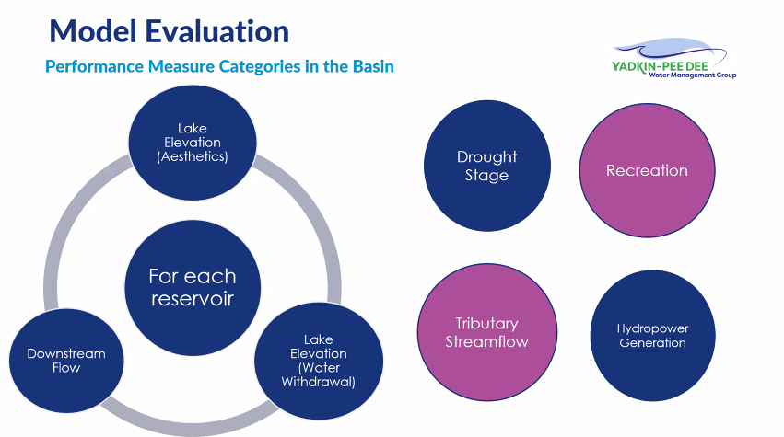
Yeh then described key criteria for each of these metric categories.
- For each reservoir:
  - Lake Elevation (Aesthetics)
    - Adherence to
      - Full pond elevation
      - Normal winter minimums
      - Normal summer minimums
    - To quantify: % of time at the end of the day the reservoir level is within 3 feet of full pond elevation
  - Downstream Flow
    - # of days at or below fish spawning flow (X cfs)
    - # of days at or below minimum flow (X cfs)
    - # of days at or below continuous flow targets
    - Lowest daily avg flow
  - Lake elevation (Water Withdrawal)
    - Evaluated when lake located intake operation is restricted
    - # of days reservoir elevation below critical level – where shallowest PWS or hydropower intake operation impacted. This would be either hydropower or utility itself, depending on the reservoir.
- Drought Stage proposed metrics tie neatly to low inflow protocol (LIP) definitions:
  - % of time in normal conditions
  - Number year attaining LIP Stage 0, 1, 2, 3, and 4
  - Number of years with more than 60 days in LIP Stage 0, 1, 2, 3, and 4
  - Aubrey Lofton asked about variability of going through stage
  - Bill Brewer noted that W. Kerr Scott does not have low inflow protocol. Jonathan Williams of HDR responded that the model will account for outflows that would impact the entire basin; LIP being applicable for all of hydropower projects with exception of W. Kerr Scott. HDR will be evaluating that through a scenario looking at different drought management plan changes. He also noted that the order does not necessarily matter for the model.
- Hydropower Generation:
  - Effect of Eagle Creek (formerly ALCOA) Hydropower Generation
  - Effect on Duke Power Generation
    - Average MWh/yearr of hydropower produced
    - Average equivalent of homes/year that could be powered
- Recreation:
  - Reservoir elevations for docks/ramps
  - In-stream recreational flows
- Tributary Streamflow:
  - # of days tributary intakes impacted
  - # of tributary intakes impacted
    - Impacted operation, reduced capacity
    - Below intake elevation
  - Low flow metric – WWTP discharge impact
    - # of days below 7Q10
  - Impact on agriculture
  - We ask:
    - Which tributaries are most important?
    - All tributaries with known water withdrawals with structural intakes?
    - Where there are wastewater dischargers?

Yeh noted that HDR seeks particular feedback around which tributaries are most important – all with known water withdrawals and structural intakes, or where there are wastewater discharges? After receiving feedback from the YPDWMG, HDR will present its feedback to the SAC.

Nonprofit Committee Update
Next, Maddie Shea of Fountainworks shifted to discussing the Group’s efforts to hopefully incorporate as a nonprofit entity. As the Group worked in 2020-2021 to examine its structure, it decided to extend the MOU to give itself more time, but the general agreement was that incorporating as a nonprofit entity would give this group a better sense of permanence, provide access to more funding opportunities, and help it to be more sustainable over the long-term. Over the past several months, a committee has been meeting to help work through a set of draft bylaws. These bylaws were modeled after those of the Catawba Wateree Water Management Group (CWWMG)’s, as many YPDWMG members have already approved the CWWMG’s. The nonprofit committee used the YPDWMG’s current MOU and existing documentation to help customize the bylaws.

A set of draft bylaws were presented to the Group. The intention is to give YPDWMG members one month to review the bylaws and provide feedback. After the feedback is incorporated, the Group would solicit help from a handful of members’ attorneys to refine the bylaws over the summer/early fall.

Aubrey Lofton, Warren Miller, and Maddie Shea introduced the proposed different fee structure. The numbers are based on an analysis of the Group’s current finances and anticipated future project expenses. With the proposed increases in fees, the YPDWMG would become more financially sustainable.

Ed Bruce of Duke Energy noted that starting from the while having the CWWMG’s bylaws as a template was useful, the CWWMG originated from a much different perspective – that group was more oriented toward Duke Energy and water supply intake on the lake. Due to the different focuses, many sections of the original template were removed.
Lofton then discussed the proposed fee structure. There would be three tiers:
- Members with ≥19,000 metered connections, and mainstem reservoir operators:
  - $15,000 per year.
- Members with <19,000 and >1700 metered connections:
  - $7,500 per year
- Members with ≤1700 metered connections:
  - $2,500 per year
These tiers were based on verbal agreement from larger members and reservoir operators last year to increase their contributions, an adjustment for inflation for the majority of members, and maintaining a lower tier designed in 2017 to attract smaller members.

Lofton noted the committee suggests more stratification so that larger entities can help support the cost of projects at a higher level and the still retain its purchasing power. Warren Miller of Fountainworks noted that the numbers are based on the Group’s five-year workplan. Miller then conducted a quick “pulse check” about fees; members were generally satisfied with the suggested tiers.

Bill Brewer noted that it is becoming increasingly more difficult for Winston-Salem to manage the Group’s finances, and it is good that we can show progress toward incorporation. Incorporation will take financial liability away from the City of Winston-Salem.

Jim Behmer of Salisbury-Rowan Utilities suggested adding voluntary membership for non-voting members. Edgar Miller noted the value of being able to sit in on YPDWMG meetings and expressed that Yadkin Riverkeeper would consider a nominal fee to the Group. The draft bylaws will be updated to reflect this suggestion.

Lofton noted that by incorporating, the Group would be its moving governance structure to a board similar to the CWWMG’s, which will probably lead to more engagement (similar to the Group’s current Steering Committee, but more formalized).

In order to incorporate, each member would need to get approval. This will be a hurdle, but Jeff Lineberger noted when the CWWMG was formed, Duke Energy developed a resolution template and presentation as members sought approval from their boards. A workgroup of member attorneys will need to review and refine the bylaws. Duke Energy, Union County, and a few others noted they would be able to get their attorneys’ support.

The Group intends to review the draft bylaws through the end of May and provide feedback. Then, by the June meeting, the Group intends to move forward with voting to officially move toward incorporation and getting the attorney workgroup set up. Fountainworks offered to support the development of a project schedule to incentivize member approval toward the end of this year.

SC River Basin Council Update
The South Carolina Department of Natural Resources (SCDNR) has responsibility over water supplies in eight basins in the state. They have drafted a plan that calls for a council in each basin to work with stakeholders and develop a long-range River Basin Plan. While YPDWMG cannot serve on the Yadkin River Basin Council as a member, interaction between the groups will be crucial. Two public meetings were held in March to discuss the council and identify members. Two YPDWMG members each attended one of two public kickoff meetings in March to discuss the Council.

Ron Sink of Davidson Water attended the March 21st meeting in Conway, SC. He noted that he is glad Jeff Lineberger of Duke Energy is a member of the YPDWMG; at the meeting in Conway, Lineberger highlighted the importance and opportunity for SCDNR to create a river basin plan. Sink noted he is unsure that being a part of the river basin plan process will help to recruit members from South Carolina.

Aubrey Lofton attended the March 22nd meeting in Florence, SC. Lofton noted that the creation of the River Basin Council is good and proactive, stating that we want to plan when things aren’t bad. Both meetings had an estimated 50-60 attendees.

Jeff Lineberger noted that South Carolina Department of Natural Resources will invite a YPDWMG member to be advisory member.

Next Steps
As next steps, Fountainworks will edit the draft bylaws based on the Group’s feedback and re-send the document for comments. To provide feedback on the draft nonprofit bylaws, please comment directly in the Google document.

The slide deck from HDR on performance measures has been distributed via email for feedback. Please send comments to Sara Yeh (sara.yeh@hdrinc.com) by Friday, May 13th. After feedback is received, it will be presented at the next Stakeholder Advisory Committee meeting.

The next meeting is scheduled for Thursday, June 9th. The meeting location is yet to be determined.

The meeting adjourned at 2:05 PM.

Meeting Attendees
Alex Anderson, City of Kannapolis
Gerald Faulkner, City of Kannapolis
David Rankin, City of Monroe
Joyce Foster, Cube Yadkin
Ron Sink, Davidson Water
Ed Bruce, Duke Energy
Jeff Lineberger, Duke Energy
John Crutchfield, Duke Energy
Jim Behmer, Salisbury-Rowan Utilities
Bill Brewer, Winston-Salem/Forsyth County Utilities
Aubrey Lofton, Union County
Amy McCaskill, Union County
John Shutak, Union County
Alex Sitar, Union County
Hyong Yi, Union County

Non-Member Attendees:
Warren Miller, Fountainworks
Maddie Shea, Fountainworks
Sara Yeh, HDR
Jonathan Williams, HDR
Edgar Miller, Yadkin Riverkeeper

