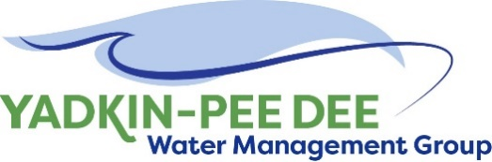
Yadkin-Pee Dee Water Management Group

Meeting Notes
Yadkin-Pee Dee Water Management Group
10:00 AM-12:30PM, April 6, 2023
Hybrid: Zoom & at Salisbury-Rowan Utilities
Agenda
- Welcome
- Approval of February Meeting Minutes
- Nonprofit Incorporation Update
- Water Resources Plan Update
- SC River Basin Council Update
- EPA’s Proposed MCLS and MCLGs for PFOS/PFOA & UCMR5
- Roundtable Discussion
- Next Steps & Adjourn
Welcome
Chair Aubrey Lofton welcomed participants, briefly reviewed the agenda, and thanked Jim Behmer and Salisbury-Rowan Utilities for hosting.
FebruaryMeeting Minutes Approval
Next, Chair Lofton asked for a motion to the approval of minutes from the Group’s February 2023 meeting. The minutes were approved unanimously.
Nonprofit Incorporation Update
Maddie Shea of Fountainworks updated the Group on the nonprofit incorporation process. She reminded the members of the aggressive timeline to move this effort forward before the June 30, 2023, deadline from Winston-Salem.

Shea noted that the following documents will be sent to members as soon as Fountainworks receives confirmation from one of the involved attorneys:
- Attorney’s memo
- Manager’s memo
- Final bylaws
- Draft resolution to be passed by members
These documents were emailed to members on April 12th, along with instructions. Please send any questions to maddie@fountainworks.com.
Water Resources Plan Update
Next, Sara Yeh of HDR provided an update on the Water Resources Plan. Yeh noted that the Stakeholder Advisory Committee (SAC) had met on March 21st, with 12 attendees representing 7 organizations. Topics during the SAC meeting included member updates and current activities of the YPDWMG, but the meeting primarily focused on reviewing draft modeling results.
Yeh noted that the SAC members asked many clarifying questions, and that Tony Young (representing the Army Corps of Engineers) did not provide any comments. HDR also received feedback on metrics, particularly minimum flows, and is working to incorporate this feedback.
Next, she shared key takeaways across variations of the preliminary results:
- General water availability in the main reservoirs during rapid increases in population
- Climate impacts modify reservoir behavior and capability on longer time-scales
- Non-built (operational) infrastructure management strategies impact Basin water supply
- Minor variations in estimates for sedimentation rates do not cause large changes in the main reservoirs
Yeh concluded by sharing a highlight from a 2-pager HDR prepared: preliminary modeling results in the Yadkin–Pee Dee River Basin indicate future long-term water availability will be stressed, but not dramatically limited, in the main stem of the Basin within North Carolina. The Group members noted this document will be helpful in explaining the YPDWMG’s work to non-water experts, including local government leadership.
Yeh’s slides, along with the 2-pager of preliminary results, were emailed to the members following the meeting.
EPA’s Proposed MCLS and MCLGs for PFOS/PFOA & UCMR5
Dr. Haley White, Water Treatment Specialist at HDR, presented on the EPA’s proposed MCLS and MCLGs for PFOS/PFOA and UCMR5. White began her presentation with an overview of terminology and detection levels.
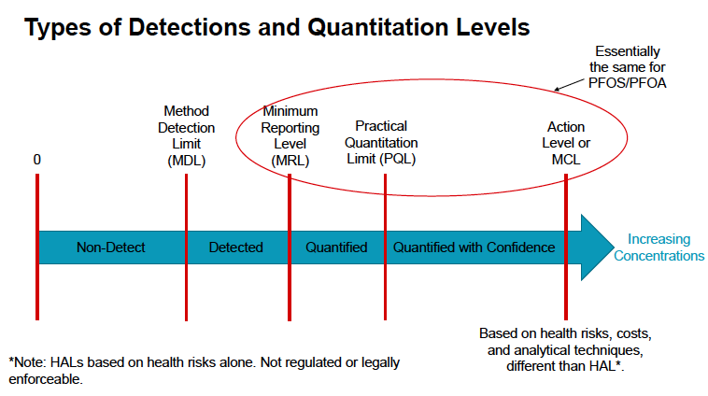
She then explained the major components of the EPA’s proposal to limit PFAS in drinking water:
- An enforceable MCL for PFOA and PFOS
- An enforceable limit on a combination of PFNA, PFHxS, PFBS, and GenX Hazard Index
- Monitoring for six PFAS
  - Monitoring frequency depends on previous PFAS sampling results
  - Includes flexibilities allowing systems with previous data to satisfy initial monitoring requirements
- Public notification required within 30 days if PFAS levels > standards
  - Results must be included in Consumer Confidence Reports
- Treatment: Required to act if PFAS levels > standards
White explained the rulemaking process and the EPA’s next steps. A final rule is expected by the end of the calendar year, with compliance anticipated within 3-5 years of the final rule.
In the meantime, White noted that organizations can prepare by sampling and conducting a PFAS treatability study. She noted using powdered activated carbon can be effective for low PFAS levels. For high PFAS levels, White recommended conducting bench- or pilot-scale testing. As she concluded the presentation, she reminded the Group about downstream effects, and to prepare for more regulations in the future.
Several Group members asked detailed follow-up questions, and many expressed their gratitude for the helpful information.
White’s slides, as well as a “PFAS 101” document, were emailed to the members following the meeting.
SC River Basin Council Update
Aubrey Lofton provided a brief update on the SC River Basin Council (RBC). She was unable to attend the last meeting, but reiterated that the Council is a very committed group working on an aggressive timeline. She shared that the group is transitioning from background research into modeling. The RBC also receives significant support from the South Carolina Department of Natural Resources, which helps the group to meet its objectives.
Roundtable
Next, Lofton opened the meeting up for the Group’s roundtable discussion. Not all comments were captured, but a few highlights are captured below:
- Hyong Yi noted Union County is close to completing its new water plant this year, and will start receiving water from Lake Tillery on May 18th through a 30-mile pipe. He noted that all YPDWMG members are invited to the planned ribbon cutting ceremony in August.
- Alan Fowler noted Winston-Salem’s modernization of the Nielsen Water Treatment Plant is going well and entering Phase 2. He noted the City is monitoring quarterly for PFAS and PFOA, which have been nondetectable leaving each plant.
- Jim Behmer noted Salisbury has sent consultation letters for a river pump station relocation. He also suggested that the Group members look up SB 317 regarding developers.
- Johnny Lambert shared that Davie County broke ground on a water treatment plant.
Next Steps and Closing Announcements
Before closing, Maddie Shea reminded members to work on getting leadership approval to join the nonprofit. The next meeting is June 8. The meeting adjourned at 1:45 PM.
Meeting Attendees
Brian Hinston, City of Albemarle
Joyce Foster, Cube Yadkin
Johnny Lambert, Davie County
Ed Bruce, Duke Energy
David Rankin, City of Monroe
Jim Behmer, Salisbury-Rowan Utilities
Josh Canup, Rowan County
Aubrey Lofton, Union County
Hyong Yi, Union County
Bill Brewer, City of Winston-Salem
Alan Fowler, City of Winston-Salem

Non-Member Attendees:
Warren Miller, Fountainworks
Maddie Shea, Fountainworks
Rusty Campbell, Garver
Jonathan Williams, Garver
Haley White, HDR
Sara Yeh, HDR
Edgar Miller, Yadkin Riverkeeper

