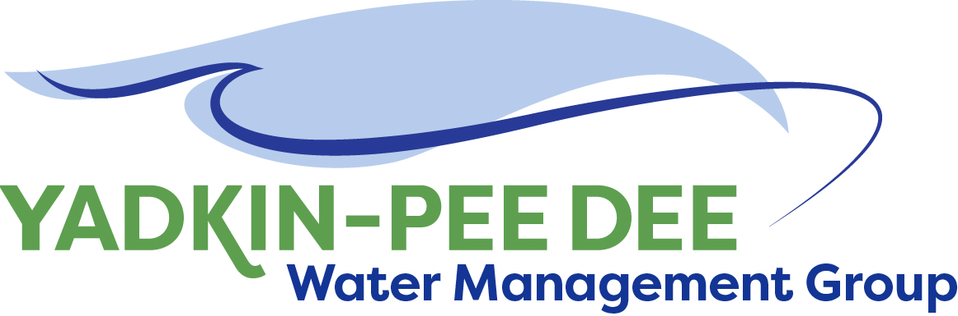
Yadkin-Pee Dee Water Management Group

AGENDA
Yadkin-Pee Dee Water Management Group Meeting
1:00PM to 2:30PM, June 24, 2021
via Zoom: Link
City of Albemarle
Water & Sewer Authority of Cabarrus County
City of Charlotte
City of Concord
Cube Yadkin Generation
Davidson County
Davidson Water, Inc.
Davie County
Duke Energy
City of Kannapolis
City of Monroe
Montgomery County
Rowan County
Salisbury-Rowan Utilities
City of Statesville
Union County
Town of Wilkesboro
City of Winston-Salem/
Forsyth County

Welcome and Review of Agenda Jim Behmer, Chair
- Approve minutes from April 1st and 22nd meetings

Roundtable Updates All

Vote on MOU Extension Amendment J. Behmer / All
- Extend MOU by 5 years

HDR Update Sara Yeh
- W. Kerr Scott Evaluation
- Grant applications & Timeline

Outreach Update J. Behmer / All

Meetings for Remainder of 2021 W. Miller / All

Adjourn

