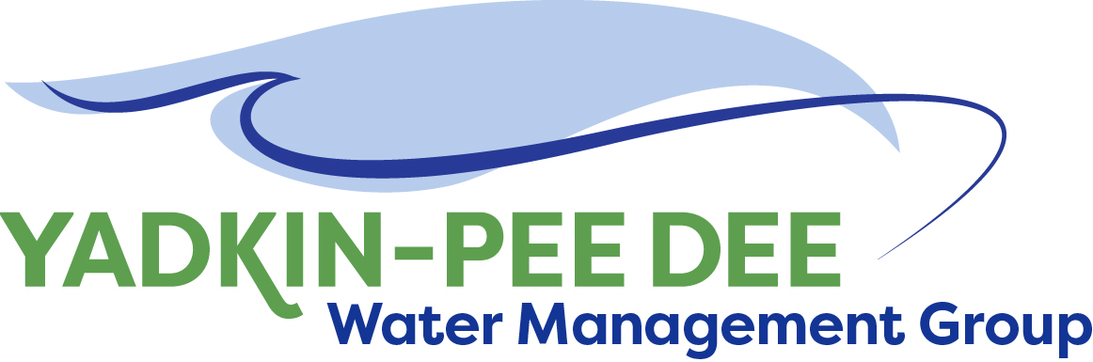
AGENDA
Yadkin-Pee Dee Water Management Group
12:00PM – 2:30PM, June 8, 2023
Hybrid: Zoom & at Salisbury-Rowan Utilities
1 Water Street | Salisbury, NC 28144
City of Albemarle
Water & Sewer Authority of Cabarrus County
Charlotte Water
City of Concord
Cube Yadkin Generation
Davidson County
Davidson Water, Inc.
Davie County
Duke Energy
City of Kannapolis
City of Monroe
Montgomery County
Rowan County
Salisbury-Rowan Utilities
City of Statesville
Union County Water
Town of Wilkesboro
Winston-Salem/
Forsyth County Utilities

Welcome | A. Lofton/ All
Approval of April Meeting Minutes | A. Lofton/ All
Nonprofit Incorporation Update | A. Lofton/ W. Miller/ All
Transition Plan | W. Miller/ All
Water Resources Plan Update | S. Yeh/ All
SC River Basin Council Update | A. Lofton/ All
Roundtable Discussion | A. Lofton/ All
Next Steps & Adjourn | A. Lofton/ W. Miller/ All
Post Meeting: Tour of SRU’s Centrifuge | J. Behmer/ All

