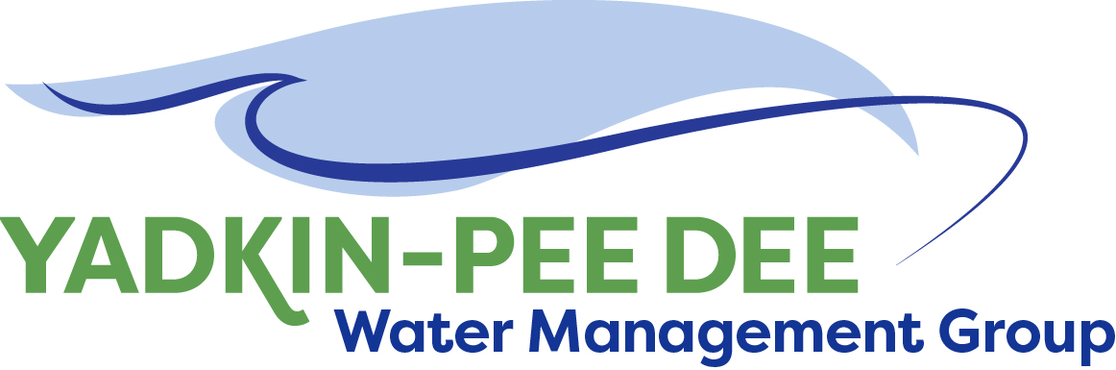
Yadkin-Pee Dee Water Management Group

Meeting Notes
Yadkin-Pee Dee Water Management Group Meeting
1:00PM to 2:30PM, June 24, 2021
Virtual Meeting (Zoom)

Agenda
- Welcome & Review of Agenda
- Roundtable and Updates
- MOU Vote
- HDR Update
- Grant Update and Outreach
- Meetings for Remainder of 2021

Welcome & Review
Chair Jim Behmer of Salisbury-Rowan Utilities opened the meeting, thanking participants for their attendance and commitment to the Group.

Roundtable Updates
- Jim Behmer asked about others’ budgets and confirmed that most budgets are nearly finished.
- Ron Sink of Davidson shared that some employees are being recruited by private industry. Many of these jobs are high paying but harder work so some employees that left are coming back.
  - Jim Behmer noted that Salisbury-Rowan Utilities is trying to highlight the benefits packages and advertise those heavily, so the public sector jobs are more attractive to employees.
- Johnny Lambert and Andy Smith shared their respective experiences working with FEMA on repairing some damaged infrastructure.
- Hyong Yi stated that Union County Public Works has officially changed their name to Union County Water.
- Dan Worl shared that the City of Albemarle is looking for a new Water Superintendent.

MOU Vote
Next, Jim Behmer introduced the proposal to extend the Group’s MOU to June 30, 2026. This extension would give YPDWMG more time to accomplish identified goals.
The proposal passed unanimously; all 14 present Members voted Yes to extend the MOU.

Update from HDR – Jonathan Williams and Sara Yeh
Next, Sara Yeh of HDR provided an update on HDR’s work on behalf of the Group. This presentation focused on the current study that has identified 4 possible alternatives.

As an overview, the current task order focuses on:
- Funding, specifically preparing grant applications on the Group’ behalf to help supplement funding
- Ongoing strategic communications support
- A preliminary study for W. Kerr Scott Reservoir Water Supply Alternatives

W. Kerr Scott Reservoir
Yeh provided an overview of four possible alternatives that can be proposed. This study will soon be shared with the Army Corps of Engineers to assess and review. Below is an overview of the four alternatives, and a summary graphic that Yeh shared with the Group.

Alternative 1: Reallocate Reservoir Storage
- Increase reservoir allocation for water supply storage, increase the allocation which would increase the reservoir height
- Benefits
  - Most secured additional water supply
  - Increase reliability for ecological purposes, this effectively increase reliability for downstream flows
- Drawbacks
  - Extensive regulatory process
  - This would change the surrounding area, including the potential for recreation opportunities near the reservoir
- Actions and Cost
  - Requires congressional allocation of funding that USACE would advocate for. There is $3 Million cap, 50% of which must be paid by a non-federal entity, and 25% of that cost can be in-kind.
Alternative 2: Expanded Drought Mitigation Plan
- Develop expanded drought plan to outline pre-set conditions to trigger changes in reservoir rates and target elevations, this would create conditions that trigger changes in water supply usage.
- Benefits
  - Enhance regional collaboration
  - Direct reaction to droughts
  - No flood control impact
  - Flexible
- Drawbacks
  - Limited in additional storage
  - Reactive
- Actions and Cost
  - More simple process, can be enacted by ordinary revision to water control plan
  - The current drought plan was last updated in 1991
  - $75K - $150K environmental assessment
Alternative 3: Inflow Dependent Releases
- This alternative would modify operational releases during periods of drought so that inflow and outflow rates match.
- Benefits
  - Matches natural water flow
  - Very operationally simple
- Drawbacks
  - Limited additional storage
  - Reactive
  - Short-term
- Actions and Cost
  - Also simple timeline, almost identical to one above, core regulatory steps are the same
  - $75K - $150K environmental assessment
Alternative 4: FIRO (Forecast Informed Reservoir Operations)
- FIRO creates dynamic decision-making process on releases based on forecasted rainfall and runoff models
- Benefits
  - Flexible, exciting, collaborative
  - Adaptable to future environmental changes
  - Public outreach
- Drawback
  - Involves forecasting, so this involves some risk, can be complex
  - Flood risk, actual and perceived
  - Newer methodology so it’s not as strong
- Timeline
  - Longer timeline (around 7 years)
  - Years 1, 2, and 3 – Different phases of viability assessment, this is a scientific study to determine if this option is a good choice for the reservoir.
  - Next, test FIRO and implement viability assessment for 3 years
  - The biggest financial commitment would be during the first 3 years for the viability assessment
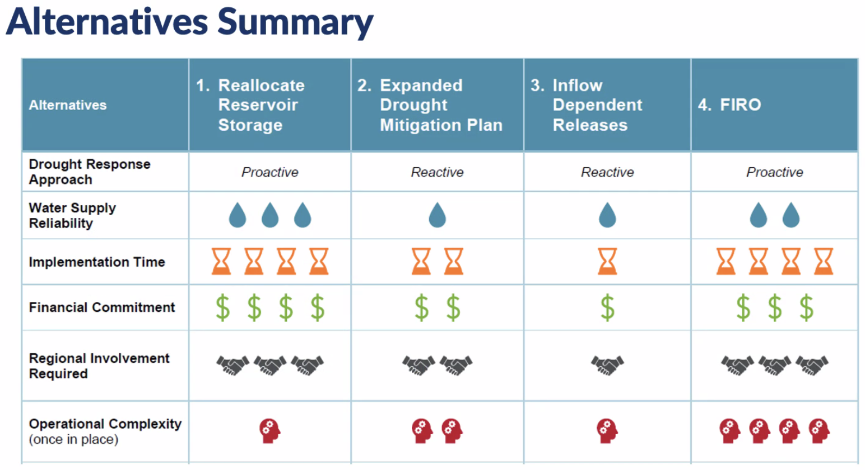

Funding Assistance Update
Next, Sara Yeh and Jonathan Williams of HDR updated the Group on the funding assistance component. They have identified the Duke Energy Foundation: Powerful Communities Grant as the best option for YPDWMG.

Duke Energy Foundation: Powerful Communities Grant
- The application is due at the end of July, and responses are due back from Duke Energy in September.
- YPDWMG should create three main project goals and aim for a $100,000 grant
  - Goal 1: Future planning scenarios analysis: evaluation of scenarios within DWR hydrologic model – includes downstream impacts of various scenario changes
  - Goal 2: Water demand management and conservation
  - Goal 3: Watershed protection opportunities
- Application Components
  - There is a calculation component that measures the total populations that are both directly and indirectly impacted. This is compared to the total cost to measure a ratio of dollar amount per impacted individual
  - HDR will request letters of support from the Yadkin Riverkeeper and Bill Holman with The Conservation Fund

Outreach Updates
Jim Behmer and Jonathan Williams will be presenting at the South Carolina American Water Works Association (AWWA) conference in South Carolina and invited others to attend if they would like.

Meetings for Remainder of 2021
Next meeting will in August, October, and December of 2021.
Jim Behmer is offering to host the August meeting in person. Further discussions need to be had regarding a potential hybrid model for the next meeting.

Adjourn
The meeting adjourned at 2:30 PM

Meeting Attendees
Member Attendees:
Dan Worl, City of Albemarle
Ron Sink, Davidson Water
Ed Bruce, Duke Energy
Gerald Faulkner, City of Kannapolis
Jim Behmer, Salisbury-Rowan Utilities
Andy Smith, City of Statesville
Josh Canup, Rowan County
Hyong Yi, Union County
Sam Call, Town of Wilkesboro
Rusty Campbell, City of Concord
Johnny Lambert, Davie County
Courtney Driver, City of Winston-Salem
John Crutchfield, Duke Energy
Jason Martin, Davidson County

Non-Member Attendees:
Warren Miller, Fountainworks
Maddie Shea, Fountainworks
Sam Cathcart, Fountainworks
Jonathan Williams, HDR
Sara Yeh, HDR
Edgar Miller, Yadkin Riverkeeper

