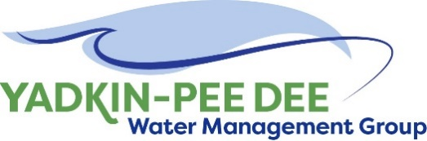
Yadkin-Pee Dee Water Management Group

Meeting Notes
Yadkin-Pee Dee Water Management Group
12:00 PM - 2:30PM, June 8, 2023
Hybrid: Zoom & at Salisbury-Rowan Utilities
Agenda
- Welcome
- Approval of April Meeting Minutes
- Nonprofit Incorporation Update
- Transition Plan
- Water Resources Plan Update
- SC River Basin Council Update
- Roundtable Discussion
- Next Steps & Adjourn
- Post-Meeting: Centrifuge Tour
Welcome
Chair Aubrey Lofton welcomed participants, briefly reviewed the agenda, and thanked Jim Behmer and Salisbury-Rowan Utilities for hosting. Chair Lofton expressed excitement about the higher turnout of members at the meeting.
April Meeting Minutes Approval
Next, Chair Lofton asked for a motion for the approval of minutes from the Group’s April 2023 meeting. The minutes were approved unanimously.
Nonprofit Incorporation Update
Chair Lofton discussed the history of the group and noted that the Memorandum of Understanding (MOU) structure between all parties is how the group has operated up to this point. This structure has worked well, but it limits opportunities for receiving grant funding. The City of Winston-Salem, which currently manages the group’s finances, has also indicated that another entity would be better positioned to take on this role going forward. Chair Lofton noted that the MOU structure was always a steppingstone to a more formalized arrangement. As a result, incorporating the group as a nonprofit was determined to be the proper approach.
Transition Plan
Warren Miller and Maddie Shea of Fountainworks discussed the transition plan for the group. Miller noted that this meeting marks an exciting time for the group as it reaches this important inflection point. Shea presented information on the new structure of the group going forward and reiterated the increased availability of external funding opportunities due to the new 501(c)(3) status. She reminded the group of the need for the establishment of a Board of Directors, including a Treasurer. The goal is to select the people who will serve on the Board of Directors by August.

Group members discussed several other aspects of the transition process, including the following items:

- Insurance for the group will need to be established
- Several members have already passed or will soon pass official governing board resolutions in support of the new organizational structure
- The financial transition with the City of Winston-Salem is a priority. Going forward, dues payments will be made to the Group itself. Dues payments will not be made until several administrative tasks such as setting up a bank account and insurance for the organization have been completed.

During a closed session, the group voted to approve Fountainworks’ contract. The scope of this contract includes facilitating the nonprofit transition process and help the Group identify a firm who will manage the Group on a permanent basis going forward.

Next steps include the following tasks:

- Send out dues payment invoices ASAP
- Convene a special virtual meeting in July to discuss the RFP for the management firm who will ultimately manage the group after Fountainworks assists with the transition process
- Issue the RFP following the July virtual meeting
Water Resources Plan Update
Next, Sara Yeh of HDR provided an update on the Water Resources Plan. Her presentation focused on the Phase 4a activities including the hydrologic model evaluations. At the Group’s previous meeting, Yeh shared the draft results from the modeling process. At this meeting, she presented a solidified results table that compiles all various performance metrics from those run scenarios. The results are available to view here and have been sent via email.
Yeh then presented on the next steps in the evaluations, as shown below:
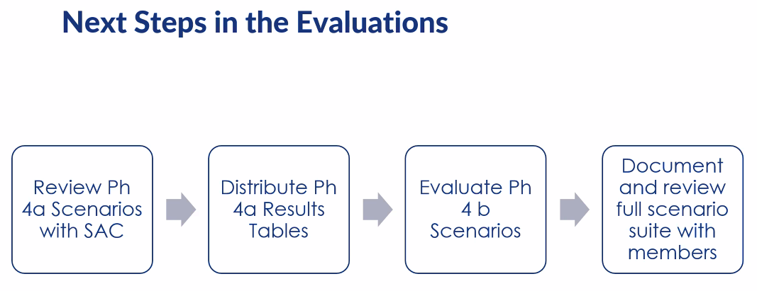
Phase 4b is up next and will provide more insight into agriculture, policy changes, industrial uses, and public behavioral shifts. This phase will also include thirteen modifications to inter-basin transfers, which is timely because at one point there was a bill in process in the state legislature that included changes to inter-basin transfers. Specific Phase 4b tasks are shown below:
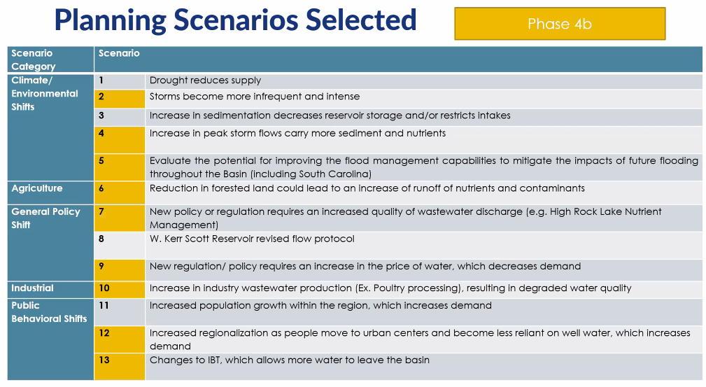
SC River Basin Council Update
Chair Lofton provided a brief update on the South Carolina River Basin Council (SC RBC). She informed the group that since March and April, the Council has met to review the surface water modeling results. The scenarios that were modeled were current, 50/70 moderate demand, and high demand based on drought of record. Generally, the modeling results have shown very infrequent shortages in the basin of South Carolina. The next few meetings will be focused on groundwater modeling and cones of depression around areas such as Florence and Myrtle Beach.
Roundtable
Chair Lofton then opened up the meeting for the group’s roundtable discussion. Not all comments were captured, but a few highlights are captured below:
- Chair Lofton updated the group on an exciting milestone with the Yadkin River Water Supply project. Water from Lake Tillery is now flowing through Union County’s system. Substantial completion of the project is anticipated by July
- Supply chain issues for electrical equipment continue to cause problems for some members. These issues have improved from the consumer side but not on the industry side
- The drawdown of Lake Tillery, which is required every five years by license, will begin on October 16. A drawdown of six to eight feet is anticipated by October 23, and the lake will return to its previous level on November 10. Communication regarding these activities is key, and relevant officials have already taken steps on this front such as sending mailers and emails to all residents and posting signage at recreation areas. Press releases will be issued as well
- Charlotte Water recently began its Water Distribution Master Plan. This process will last approximately two years.
Next Steps and Closing Announcements
Before closing, Chair Lofton reviewed next steps for the group which include the following items:
- Fountainworks staff will send dues invoices to all members (which will be paid to the Group itself, not Winston-Salem or Fountainworks)
- Fountainworks staff will work with relevant entities to set up a bank account, tax ID, and insurance for the Group
- Fountainworks staff will schedule the Group’s next meeting, which will be a virtual meeting in July. The main purpose of this meeting will be to discuss the RFP for the management firm and gather member input and feedback. There is an in-person meeting scheduled for August 10.
Meeting Attendees
Quorum confirmed with the following sixteen (16) representatives from twelve (12) member organizations in attendance:

- Jay Voyles, Albemarle
- Daniel Burbes, Charlotte Water
- Bhavana Swayampakala, Charlotte Water
- Kevin Plemmons, City of Concord
- Alex Anderson, City of Kannapolis
- David Rankin, City of Monroe
- Joyce Foster, Cube Yadkin
- Ron Sink, Davidson Water
- Johnny Lambert, Davie County
- Ed Bruce, Duke Energy
- John Crutchfield, Duke Energy
- Josh Canup, Rowan County
- Randy Cress, Rowan County
- Craig Powers, Rowan County
- Aubrey Lofton, Union County
- Alan Fowler, Winston-Salem/Forsyth County Utilities

Non-Member Attendees:
- Drew Finley, Fountainworks
- Warren Miller, Fountainworks
- Merrill Robinson, Fountainworks
- Maddie Shea, Fountainworks
- Rusty Campbell, Garver
- David Saunders, HDR
- Sara Yeh, HDR
- Edgar Miller, Yadkin Riverkeeper

